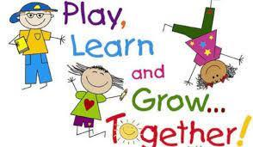

.

Colebrook Elementary
Invites you to
Ready, Set, Learn

May 4, 2023
12:30-2pm

Ready, Set, Learn

Welcome to Parents
and

- Support your child’s play with ways to explore and learn

- Receive a new book and a special surprise

- Enjoy Hands on Activities, Songs and Stories


Colebrook Elementary invites children 3-4 years old and their families to attend our Ready, Set, Learn event this spring. Please note, this event is not for children entering Kindergarten this coming September.

• Date: Thursday, May 4, 2023
• Time: 12:30pm-2pm
• Colebrook Elementary School
5404 125A Street
Surrey, BC
(604) 596-3221

Please email colebrook@surreyschools.ca to RSVP by April 17th

