To order lunch from munch-a-lunch please go to www.surreyschools.ca/newtonelem
Click on the main banner hover over ‘Our School’ and see the Hot Lunch page.
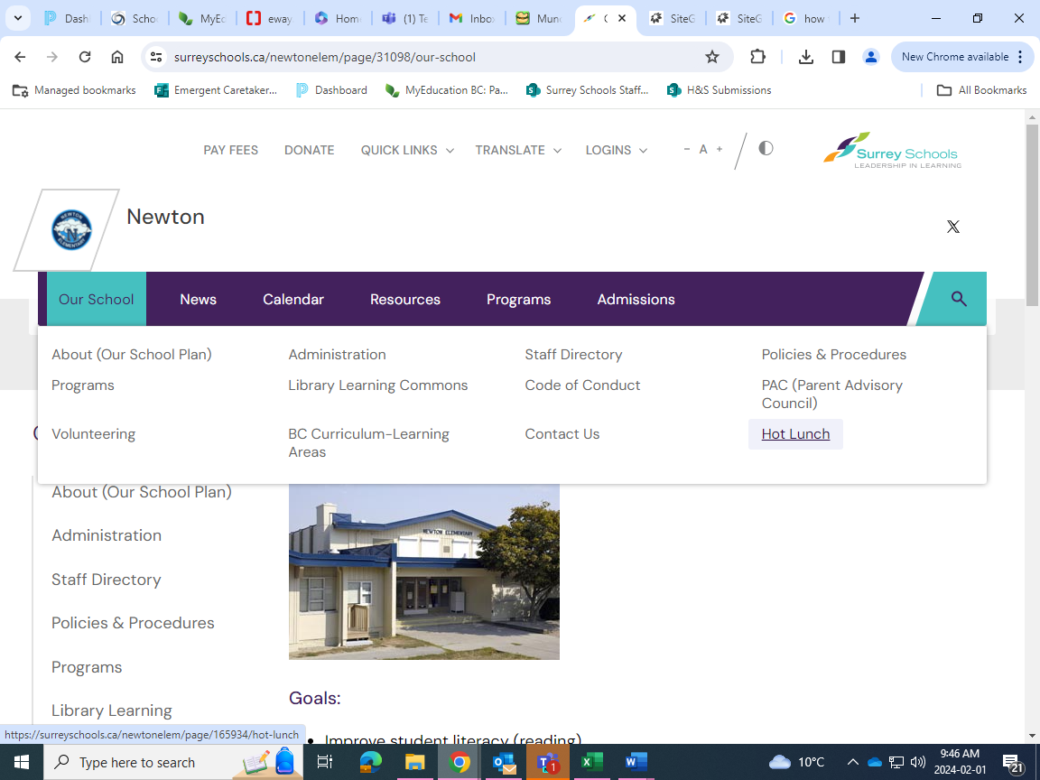
Click on the munch-a-lunch link and log on using your account you have created, or if you have not created an account, click register.

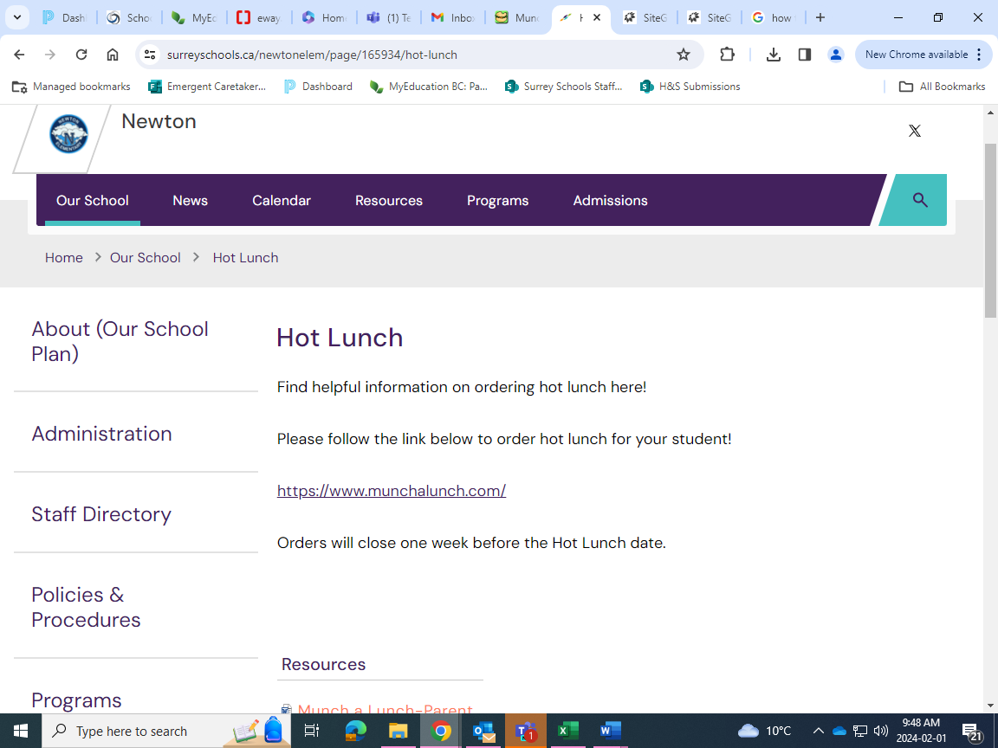

After logging on click ‘Order Lunch’
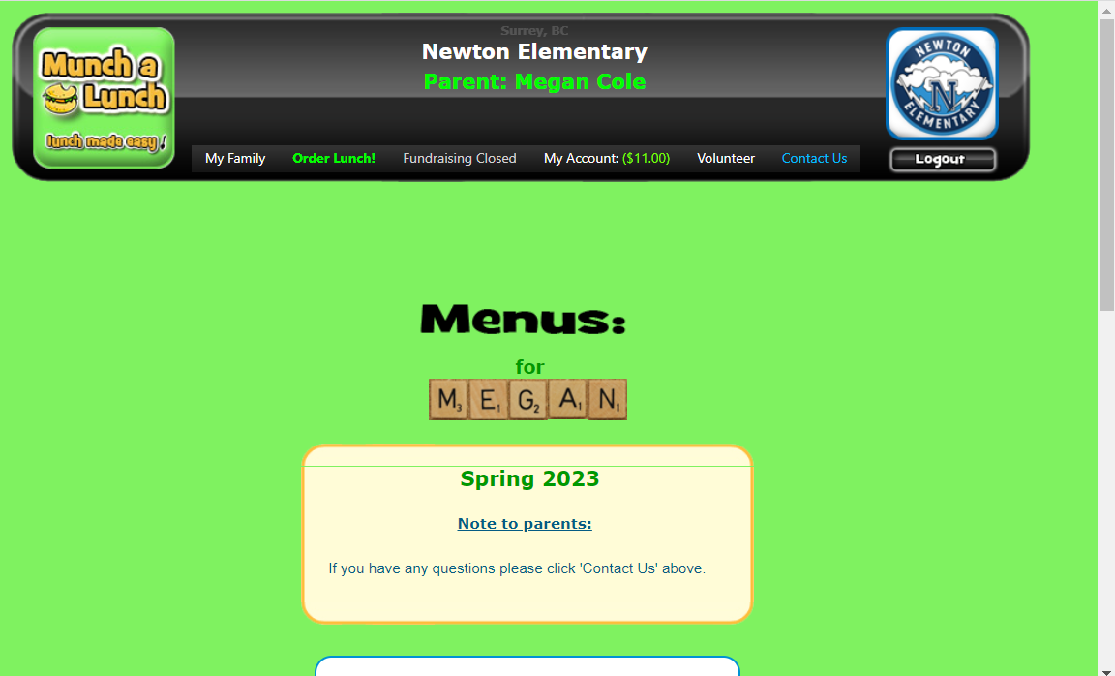

Scroll to the bottom of the page and click ‘Next’
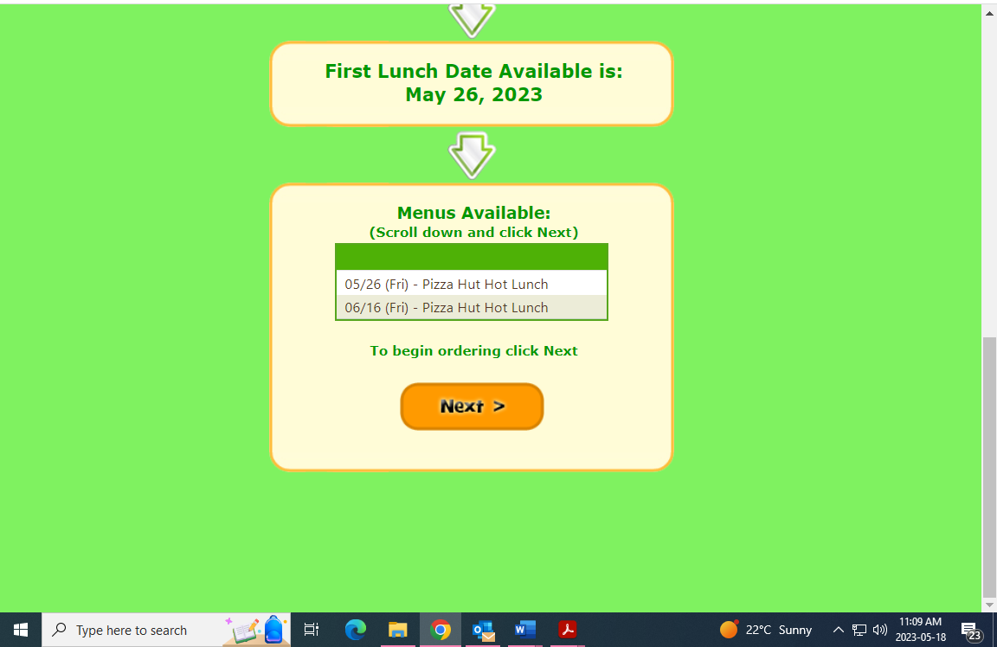

Select items you would like to order from the list on the left by clicking on them.
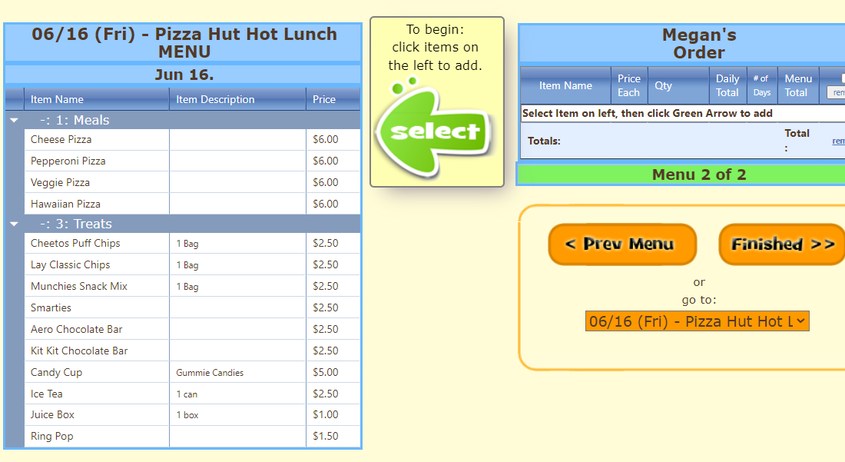

After you have selected your items click the add button. Once complete, click ‘finished’.
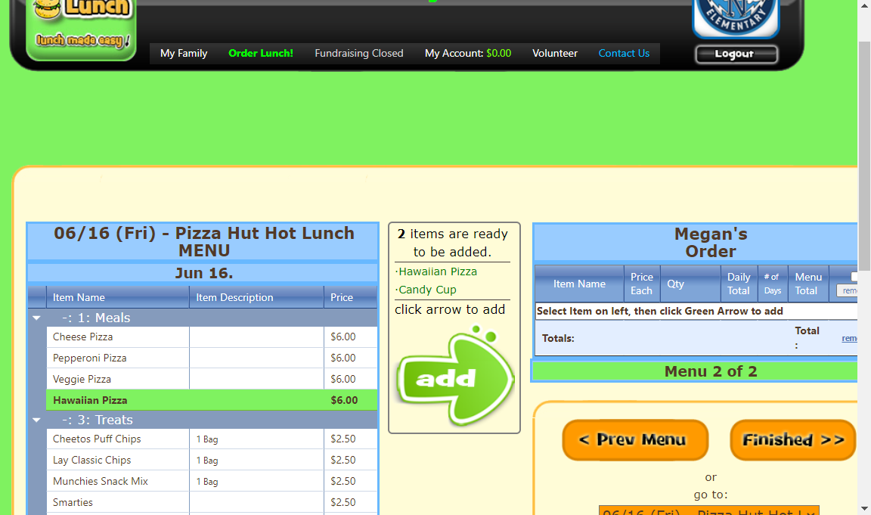
Scroll to the bottom of the page and click ‘Next’
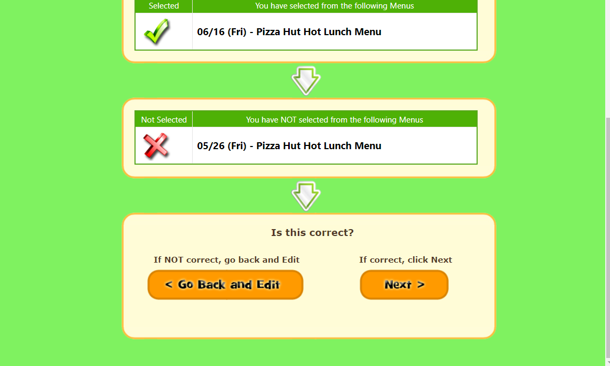
Scroll to the bottom of the page again and click ‘Next’
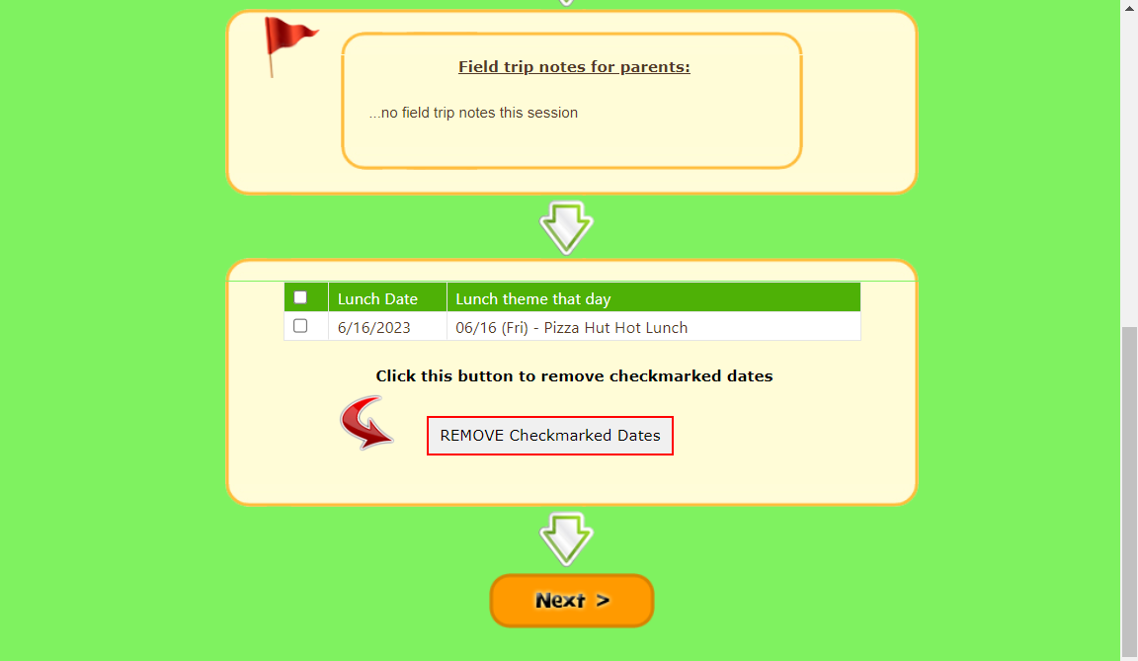
Confirm your order total is correct and then click ‘Yes, This is correct’
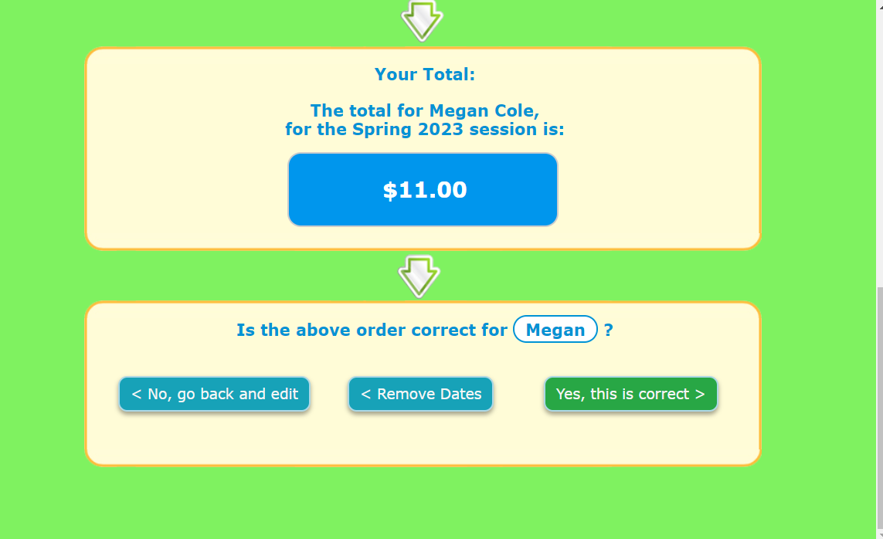

Click ‘Checkout’ This DOES NOT yet confirm your order
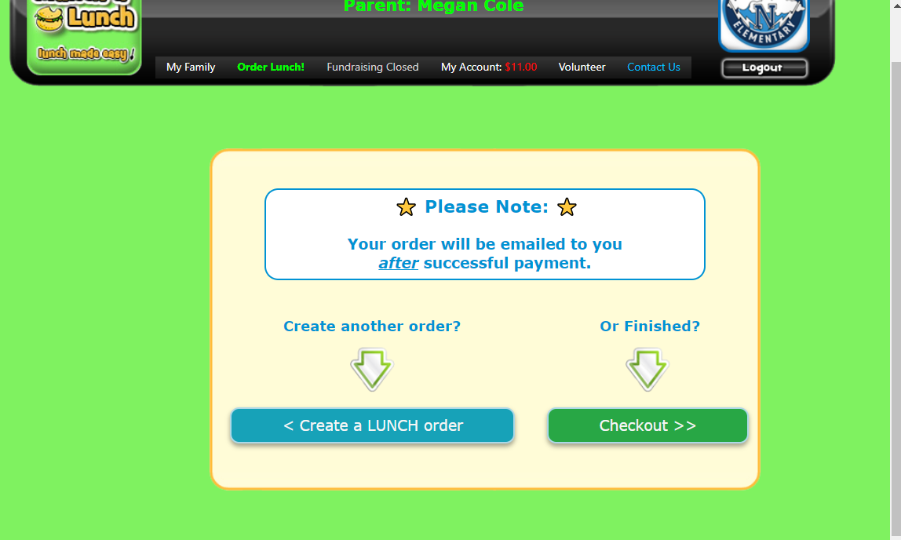
This will then take you to the final step where you need to enter your credit card information. Scroll to the bottom of the page and click ‘Pay Now’
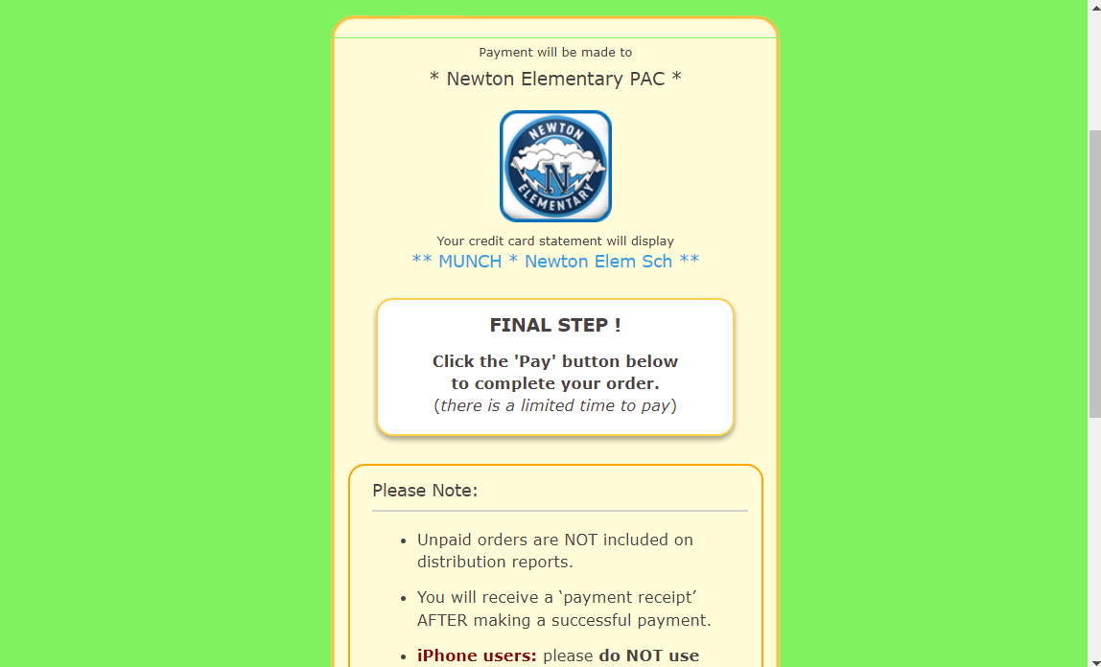

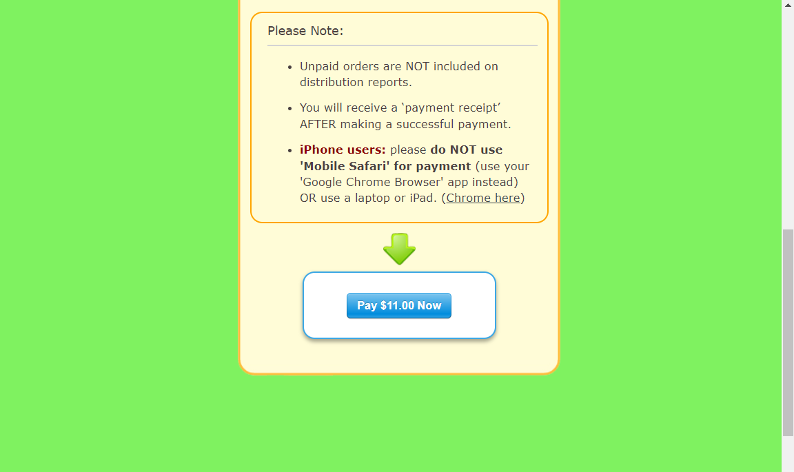

Enter your credit card information in the pop up box and click ‘Pay CAD’
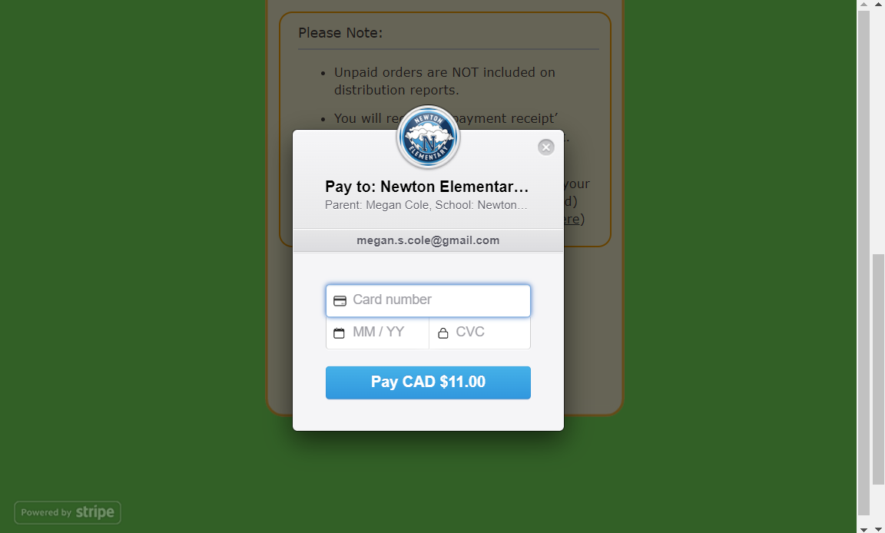
This will then take you to the confirmation page. You should see a ‘Success your payment is complete’ If you do not see this, your order has not gone through.
