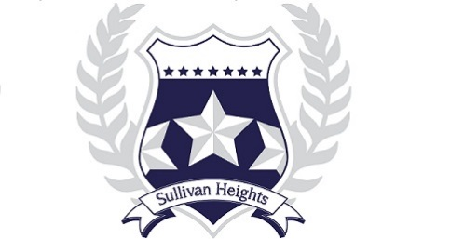

Sullivan Heights Secondary
2024-2025 COURSE REQUEST PLAN
Grade 11

NAME: STUDENT #:
DATE:

All students working toward a B.C. Certificate of Graduation (“Dogwood Diploma”), must successfully complete at least 4 credits in Indigenous-focused coursework.

Students can meet this graduation requirement through a variety of course options between Grade 11 and 12. Some of these courses also satisfy Language Arts or Social Studies graduation requirements.

Choose ONE English course:  - CREATIVE WRITING 11  - LITERARY STUDIES 11  - NEW MEDIA 11  - PRE-AP LITERARY STUDIES 11  - EFP LITERARY STUDIES/WRITING 11  - EFP LITERARY STUDIES/NEW MEDIA 11  Choose ONE Science course:  - SCIENCE FOR CITIZENS 11  - ENVIRONMENTAL SCIENCE 11  - EARTH SCIENCE 11  - LIFE SCIENCES 11  - CHEMISTRY 11  - PHYSICS 11  Choose CLE 11 (Mandatory for graduation):  - CLE 11 | Choose ONE Math course:  - FOUNDATIONS OF MATHEMATICS 11  - PRE-CALCULUS 11  - WORKPLACE MATH 11  Choose ONE Social Studies course:  - 20TH CENTURY WORLD HISTORY 12  - BC FIRST PEOPLES 12  - COMPARATIVE CULTURES 12  - CONTEMPORARY INDIGENOUS STUDIES 12  - GENOCIDE STUDIES 12  - HUMAN GEOGRAPHY 12  - LAW STUDIES 12  - PHILOSOPHY 12  - PHYSICAL GEOGRAPHY 12  - POLITICAL STUDIES 12  - SOCIAL JUSTICE 12  - URBAN STUDIES 12

**CAREER LIFE CONNECTION is a requirement for Graduation. Students can choose to
take this course in either Grade 11 or Grade 12. Please make a careful graduation
program plan with your counsellors to help you decide where to place CLE 11 and CLC 12.

Choose 3 Elective Courses:

*Alternates must be different courses from those three electives requested above.

Chose 2 Alternates:

