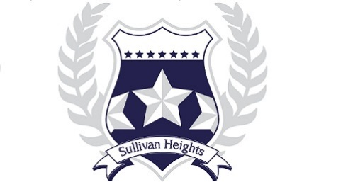

Sullivan Heights Secondary
2024-2025 COURSE REQUEST PLAN
Grade 12

NAME: STUDENT #:

DATE:

All students working toward a B.C. Certificate of Graduation (“Dogwood Diploma”), must successfully complete at least 4 credits in Indigenous-focused coursework.

Students can meet this graduation requirement through a variety of course options between Grade 10-12. Some of these courses also satisfy Language Arts or Social Studies graduation requirements.

Students must take Career Life Connections 12 in order to Graduate. If you did not take Career Life Education in Grade 11, you must select it for Grade 12.

Select an English 12 If you have not completed CLC 12
request it here

ENGLISH STUDIES 12 CAREER LIFE CONNECTIONS 12

EFP ENGLISH STUDIES 12

AP LITERARY STUDIES 12 &ENGLISH STUDIES 12

Choose 7 Elective Courses Choose 6 Elective Courses
*Alternates must be different courses from those three electives requested above.

Choose 2 Alternate Courses:

