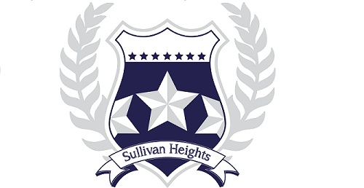

Sullivan Heights Secondary
2024-2025 COURSE REQUEST PLAN
Grade 8

CURRENT SCHOOL:

NAME: DATE:

DO YOU HAVE A SIBLING CURRENTLY ATTENDING SULLIVAN HEIGHTS: YES NO

IF YES, NAME & GRADE OF SIBLING:

CORE COURSES:
Students in Grade 8 will be assigned the following courses:

HUMANITIES 8 (ENGLISH & SOCIAL STUDIES)
FRENCH 08
MATH 08
SCIENCE 08
PHYSICAL AND HEALTH EDUCATION 08

ELECTIVE COURSE OPTIONS:

Choose an ADST Rotation:

 |  | ADST #1  ROTATION |  | OR |  |  |  | ADST #2  ROTATION |  | OR |  |  | ADST #3  ROTATION – see page 57 in Technology section
 |  | FOODS 08 |  |  |  |  |  | ROBOTICS 08 |  |  |  |  | STEM 08
 |  | TEXTILES 08 |  |  |  |  |  | DRAFTING 08 |  |  |  |  | (Science/Tech,
 |  | WOODWORK 08 |  |  |  |  |  | ENTREPRENEURSHIP 08 |  |  |  |  | Engineering & Math)
 |  | METALWORK 08 |  |  |  |  |  | DIGITAL LITERACY 08 |  |  |  |  | INQUIRY 08

Choose One Fine Arts Option
FINE ARTS
ROTATION

ART 08
DRAMA 08
MUSIC 08

ART 08

OR

OR
DRAMA 08

BAND 08

OR
Note: Depending on the teacher or the timetable placement, music may be drumming, guitar, singing, band, or a combination.

OR
DANCE 08

These courses may be chosen in addition to the courses above but will be outside of the regular
school day (before and/or after school):

 | JAZZ BAND 08 |  |  | CHOIR 08

