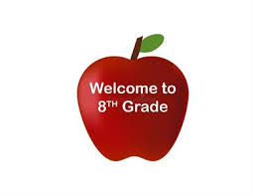

**Grade 8 Parent Night**

**Wednesday September 17th, 2025**

**6:00-7:15pm**

**Enver Creek Theatre**

***Please Join Us!***

***Parents/Guardians and your grade 8 child are all welcome.***

**The night includes:**

Welcome to Enver Creek

Administration and Staff Introductions

Grade 8 Information

Grade 8 Courses and Departments

Student Led Tours

Questions

