Newton Elementary PAC
General PAC Meeting Minutes
Tuesday June 4 2024 5pm-6pm
Meeting called to order at 5pm.
In attendance-Varinder Gill, Amrit Gill, Amy Newman, Elisha Gill + Parents
Agenda adopted and overview of May minutes provided to attendees.
Principal Report (please refer to Appendix A)
Currently 10, 715.00 in PAC general account. Disbursements pending include hot lunch payment, and payment for food items for sports day and treat days.
PAC paid for juice/cookies for school immunizations. Cost approx. 40.00
Munch a Lunch will be continued into the coming school year. Cost will be 336.00. Invoice pending
Gaming Account balance is 18491.00. Payment of hip hop lessons was made to the vendor. Gaming account pending disbursements include Grade 7 grad, and costs of trophies.
PAC paid 2600.00 for school canopies-these were used at the track meet and were appreciated by students and staff.
Tech Tuesdays have been well received by students-approx. 900.00 has been raised for technology.
Sports Day sales for treats and Pizza are ongoing until June 7th.
PAC elections for the upcoming school year were discussed with parents in attendance. An overview of PAC and PAC roles was provided. Currently, no parents in attendance are interested in an executive position.
Discussion regarding cross walk guards was also had by parents. It was suggested that parents could fill this role. Ms. Newman will follow up to see if this is a possibility.
Ms. Newman advised that parking/driving changes will be happening around the school area to keep students safe. This work should commence towards the end of June and be complete for the upcoming school year.
Appendix A
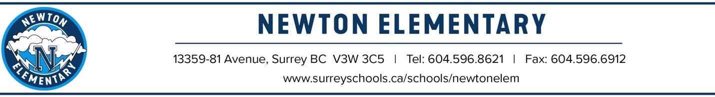
PAC Meeting
Principal’s Report June 4, 2024

Appreciations

We’d like to express our gratitude to the PAC executive for your dedication to enriching the educational experiences for students and staff at Newton. We are running with hot lunch and Tech Tuesday…You supported numerous field trips and in class presentations. Your support allowed us to have numerous Fine Arts performances and experiences – currently doing K-7 Hip Hop Classes. The PAC purchased new PE equipment and beautiful new tents that we used today at our Track and Field Meet. We were by far the classiest school!

On Sports Day you are proving special treats as well as hot lunch. Thank you so much for organizing all the successful fundraisers for the school. We are very grateful for the support of every one of you!

Grade 7 Leaving Ceremony
Our grade 7 Leaving Assembly is Tuesday June 25 at 10:30am. This is for grade 7 parents and our Intermediate students will attend the event. Each family will get 3 tickets. After the ceremony at 12:30 we will drive the 7s to Boston Pizza for lunch and parents can pick them up from the restaurant at 2pm.

Calendar

June 11– Entrepreneur fair
June 14 – Sports Day
June 19 – Bear Creek Swimming Day
June 20 – catch up immunizations for grade 6s
June 25 – Grade 7 Farewell Assembly @10:30am
June 26 – Year End Assembly@10:30
June 27 – Last day of school! Term 3 Reports go home
June 28 p – Admin Day (No School)

In addition to all that you have done, it has been a real privilege to work with all of you.

We have a small gift of appreciation for each of the outgoing executive members.
Thank you.

