# **What is SpacesEDU?**

SpacesEDU is the digital portfolio that we are using to document our Core Competencies.

# **How do I get started?**

1. ****Download the app on your device
2. Login using your Surrey Email and Password, or use the QR code provided by your classroom teacher

# **How do I access my portfolio?**

1. Click the Home button in the top right corner
2. From your Dashboard, click Portfolios in the top navigation
3. Click into your Portfolio “Core Competencies

Self-Assessment”. Click on the Communication (February) folder.

1. Review the instructions and links that will support you in creating your ﬁrst artifact
2. When you're ready, click Get Started in the top right

# **How do I create artifacts or copy posts from my class into my portfolio?**

If you’d like to create a post, simply:

1. Click **Create** in the bottom right
2. Add your title, description, and up to 10 media artifacts
3. Conﬁrm which Section you want the post to be under (i.e. Personal & Social in October)

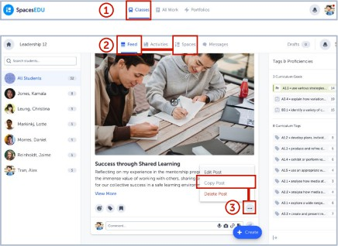**If you’d like to copy a post from one of your classes, simply:**

1. Click Home and select Classes, then click into the Class where you did the post you’d like to use
2. Find the post in your Feed
3. Click the three dots on the post and select Copy
4. Update the Post Selections to the Portfolio and Section you want the post to fall under (i.e. Personal & Social)