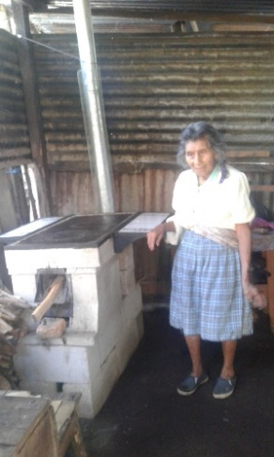
Desserts for a Cause

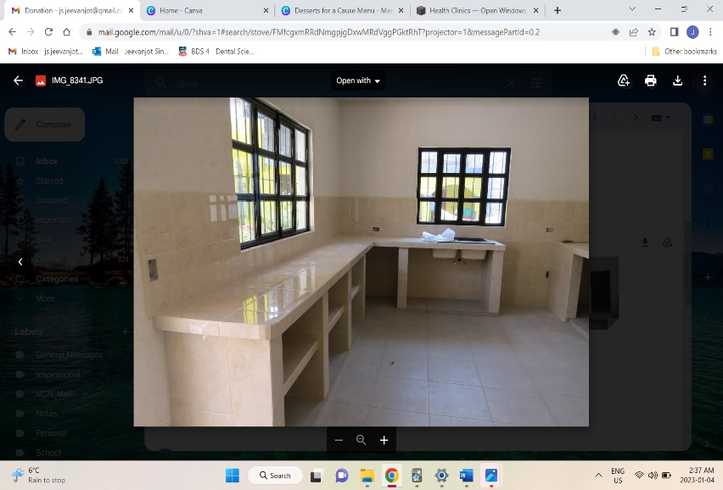
Colebrook Elementary and the Colebrook Cares leadership team are supporting the Open Windows Foundation, a non-profit organization which runs a community center in rural Guatemala for children and youth living in poverty.



In the past Canadians have supported the center by helping construct a community kitchen and purchasing solar stoves which help feed anyone in need attending the community center!



Open Windows is introducing a Scholarship Program for these children to attend junior high-school. Help us make this possible by participating in our Desserts for a Cause Fundraiser!



Enjoy handcrafted and delicious cake-pops, cupcakes, and cake cups! All proceeds will be donated to Open Windows Foundation to sponsor the education of Junior High School Students for 1 year. We will be collecting orders from May 1st to May 12th. The delivery will be on May 30th


Order Form
Name of Student
Teacher
Division
Desserts |  | Price | Quantity |  |  | Total
Chocolate Mousse Cup |  | $3.00
Chocolate Mousse Cup Half Dozen |  | $15.00
Chocolate Mousse Cup Full Dozen |  | $30.00
Mango Mousse Cup |  | $3.00
Mango Mousse Cup Half Dozen |  | $15.00
Mango Mousse Cup Full Dozen |  | $30.00
Cookies n’ Creme Cup |  | $3.00
Cookies n’ Creme Cup Half Dozen |  | $15.00
Cookies n’ Creme Cup Full Dozen |  | $30.00
Funfetti Cake Pop |  | $3.00
Funfetti Cake Pop Half Dozen |  | $15.00
Funfetti Cake Pop Full Dozen |  | $30.00
Chocolate Cake Pop |  | $3.00
Chocolate Cake Pop Half Dozen |  | $15.00
Chocolate Cake Pop Full Dozen |  | $30.00
Oreo Cake Pop |  | $3.00
Oreo Cake Pop Half Dozen |  | $15.00
Oreo Cake Pop Full Dozen |  | $30.00
Vanilla Cupcake |  | $3.00
Vanilla Cupcake Half Dozen |  | $15.00
Vanilla Cupcake Full Dozen |  | $30.00
Chocolate Cupcake |  | $3.00
Chocolate Cupcake Half Dozen |  | $15.00
Chocolate Cupcake Full Dozen |  | $30.00
Marble Cupcake |  | $3.00
Marble Cupcake Half Dozen |  | $15.00
Marble Cupcake Full Dozen |  | $30.00
Grand Total

Please return this form after you have filled it out. Payments will be accepted through School Cash Online or Cash/Check.

