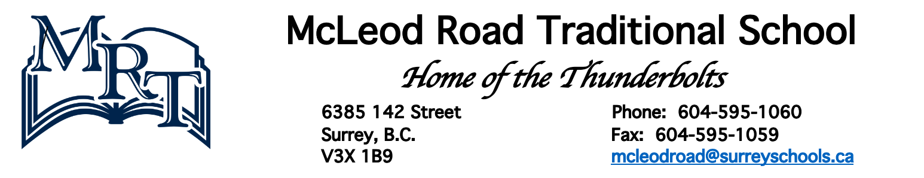
Dear MRT Families,
Each year, as part of our district’s annual budget process, the Surrey Board of Education seeks community input on budget priorities for the next school year via an online survey.
Please complete the survey and share your priority areas for the Surrey School District’s 2024-25 school year operating budget.
The survey is available in English, Arabic, Simplified Chinese, Punjabi, Spanish and Tagalog.
Participants can share their feedback by completing the online survey, or reach out through email (consultations@surreyschools.ca), traditional mail (14033 92 Ave., Surrey, BC, V3V 0B7) or our school’s Parent Advisory Council representative.
The deadline to provide input is midnight on March 6, 2024.
We hope you can participate in this consultation process and share the priorities that are important to you and your family.
Thank you for your continued involvement and support!
Sincerely,
Mrs. Carin Porcellato
Proud Principal of MRT

