October 16, 2023
Dear Caregivers,
As several parents have reached out to share concerns about the construction project, I want to share a few updates. Today we had a visit from our Capital Projects Director and Assistant Superintendent to review safety concerns, including the use of heavy machinery. Starting tomorrow, the construction team will implement the following changes. Please refer to the image below.
Area 1:
The work for the irrigation lines is complete and no further work will happen in this area until final hardscape is done. This is scheduled towards the end of the project in Summer 2024. In the meantime, the area will be delineated with cones and caution tape as a reminder to the trades that no work with heavy machinery will take place here.

Area 2:
This is setup for erosion and sediment control and will remain in this state until we get closer to completion of the project. Like Area 1, it will be complete when students are out of school. This area acts as an additional barrier for machines.

Area 3:
The fencing will be adjusted to increase the distance to the excavators. In addition to this, the general contractor will have a full time safety officer experienced in heavy civil work onsite. At any time when an excavator is working close to the fence, they will be on the student side of the fence to guide the community as appropriate.
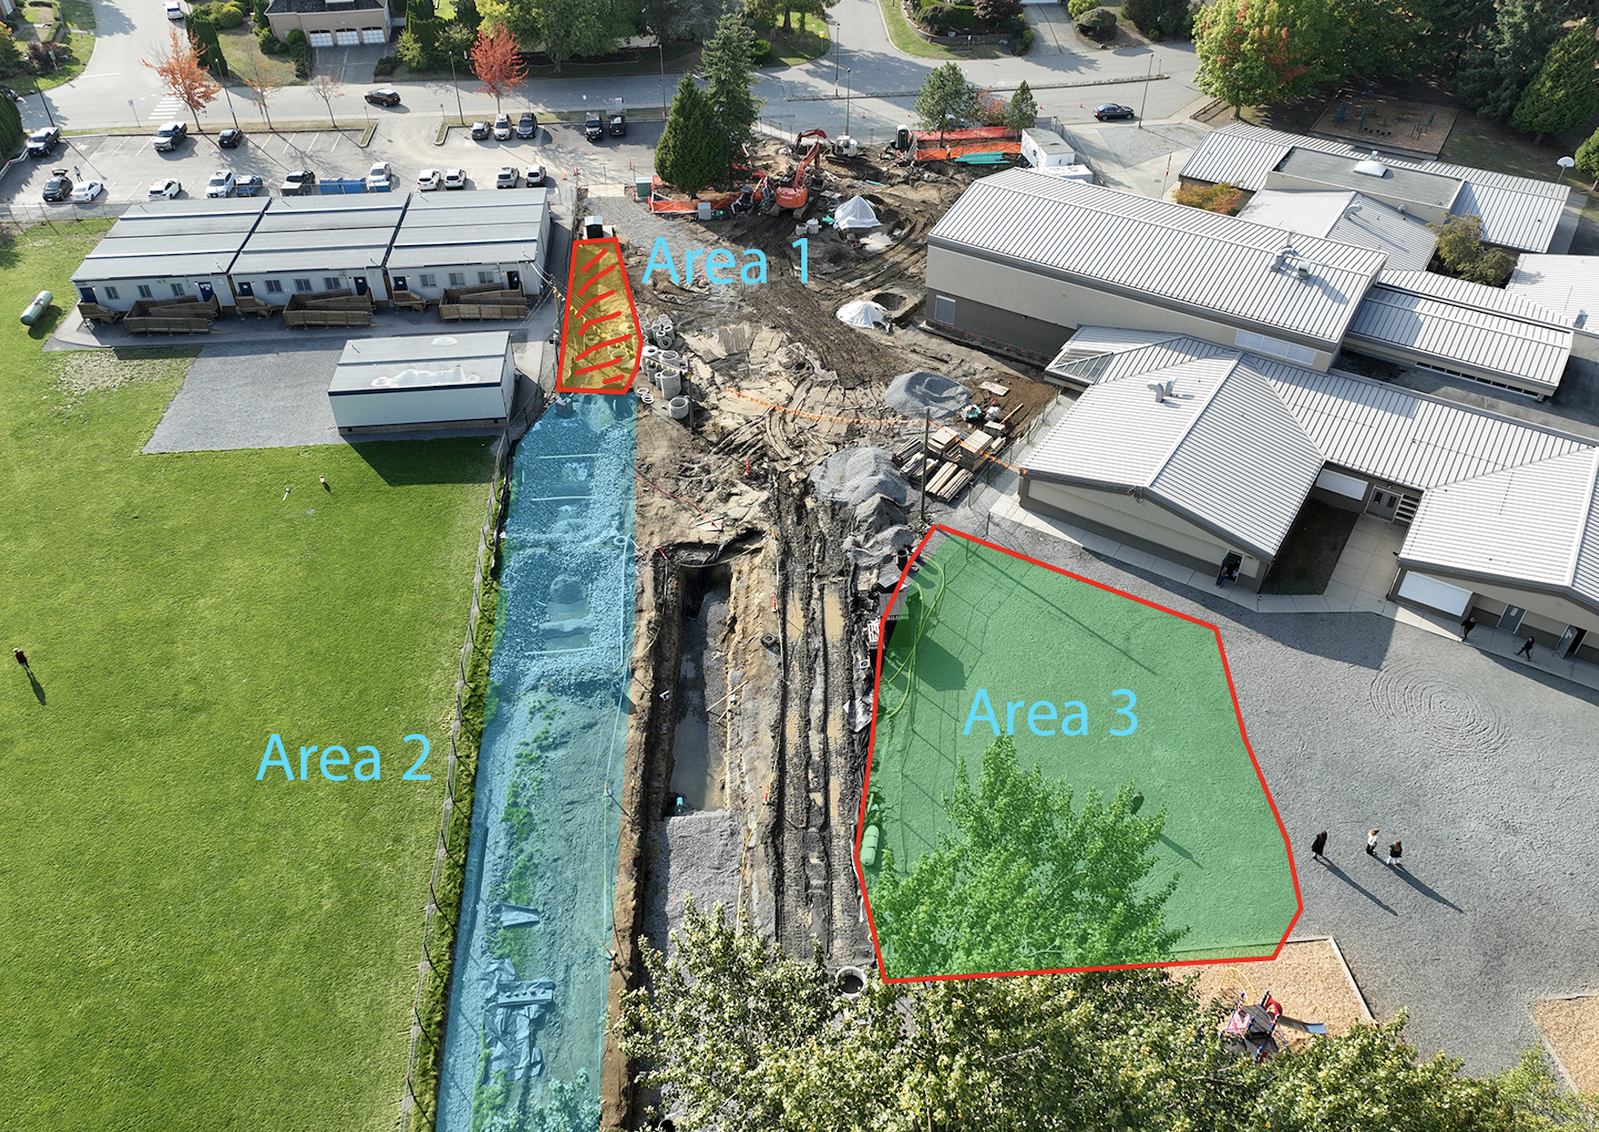

We look forward to the completion of phase one this fall as it will open up a path from the portables to the outside doors by the gym. For now, we do have a clearly marked path and experienced flaggers guiding students into and from the building.
Your feedback and patience as we navigate the construction of this new addition is deeply appreciated. If you have any questions or concerns regarding the construction, or any other school-related matters, please do not hesitate to reach out to me.
Sincerely,
Karen Fadum

