Daily Construction Safety Considerations
Q: What is the daily process to ensure safety during contruction?

A: While we are eager to see the opening of our new 10 classroom expansion safety for staff and students is our primary concern.
- Halse Martin completes a Daily Hazard Report.
Samples:
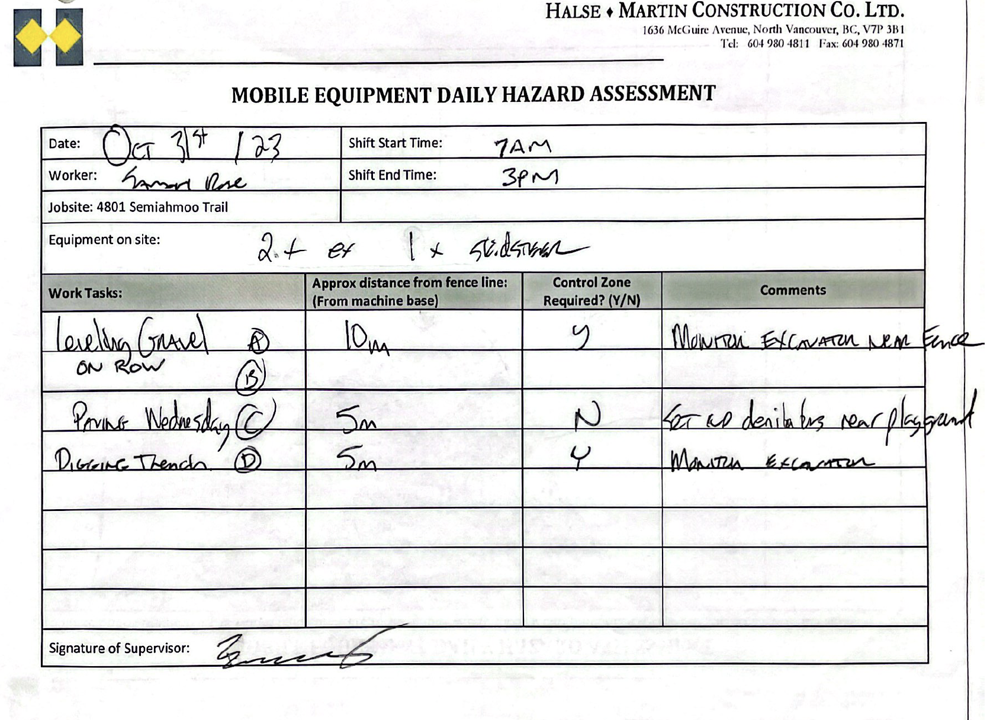
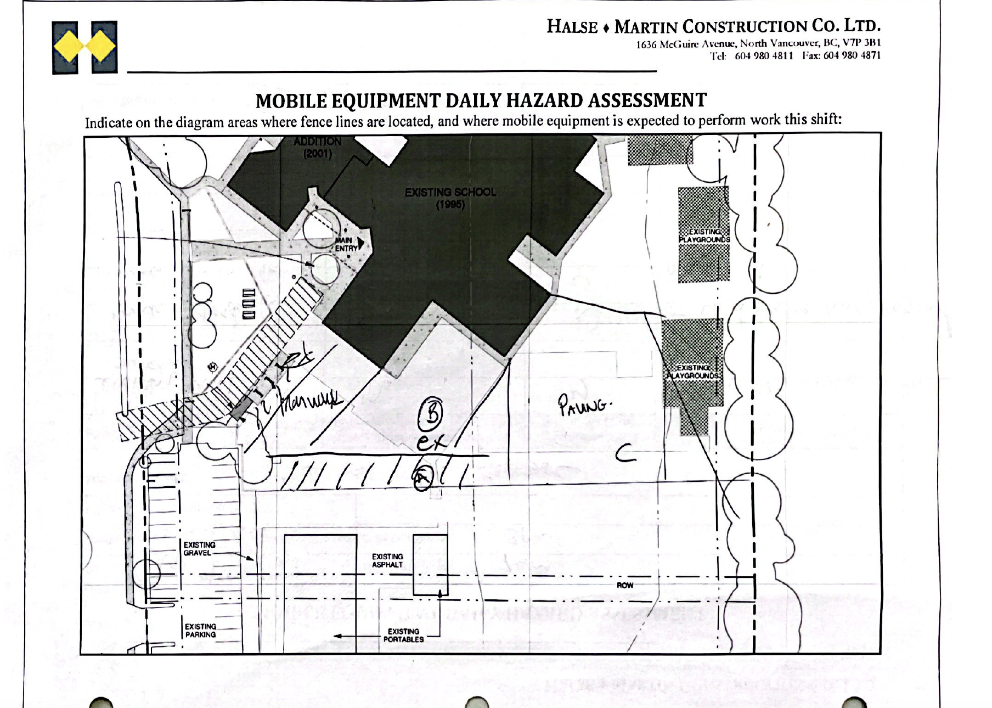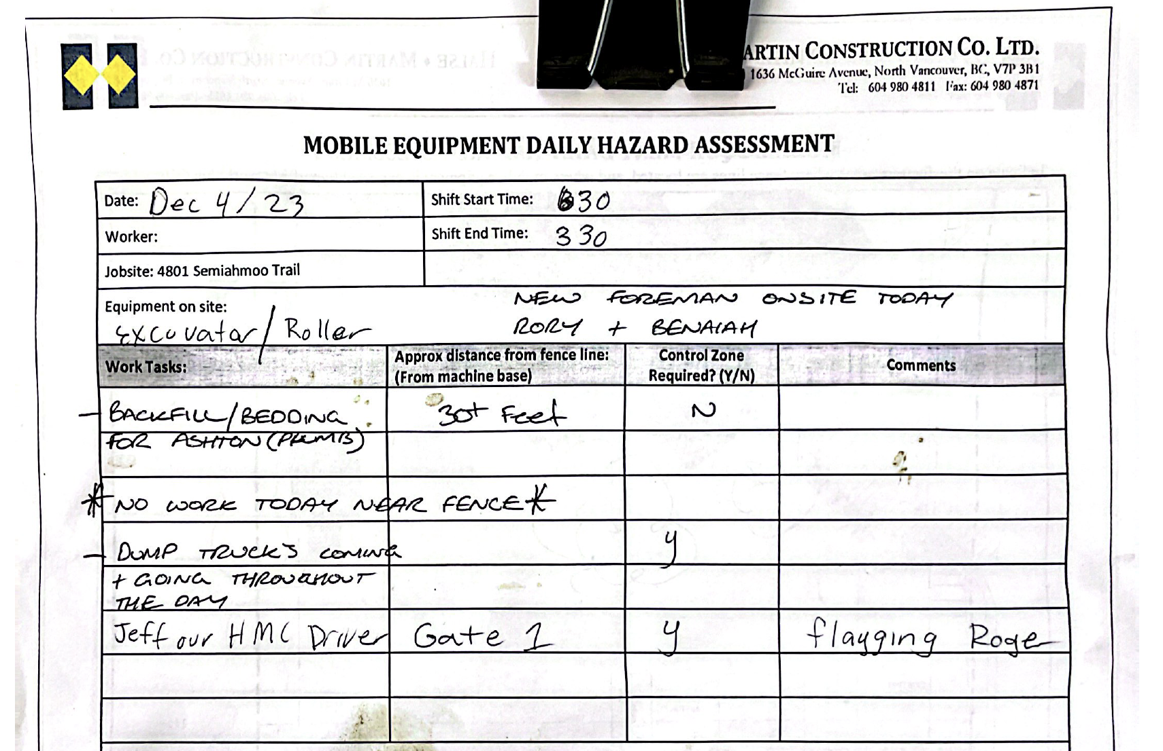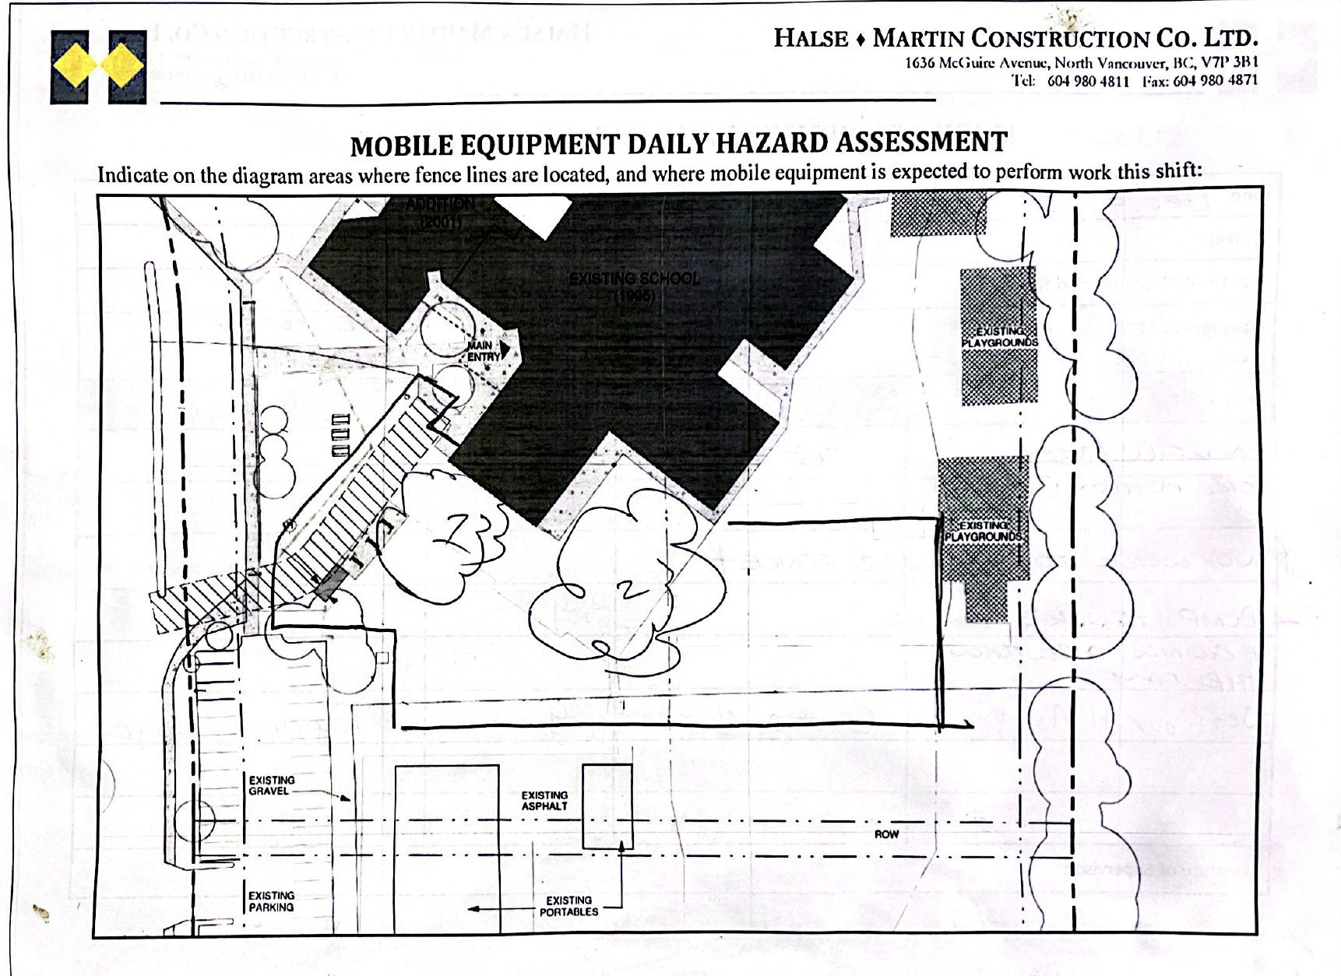

- P/VP morning walk around to check for open gates etc. Text or physical check-in with construction lead to see if there are any updates of possible concern.

- During heavy rain, snow or wind P/VP walk around before recess and lunch to check paths, gates etc.

- Construction team advises P/VP in advance if there will be large equipment, many trucks etc. so reminders can be sent out to teachers in portables about students not walking in front of school (not supposed to use this route anymore but we offer reminders throughout the week and if particularly busy with construction)

- Teachers remind students daily to be aware outside and look/listen for any possible hazards. A safety presentation will be delivered by classroom teachers in early January.

Although our site does have constraints the team has made the best decisions for its location and adjacency to other structures. All of this information was planned and reviewed by industry professionals, including architects and engineers, for both school operations and constructability and traffic flow.

The site supervisor has daily contact with P/VP and shares updates on work planned and completed. The work that is happening now is primarily taking place in the center core of the fenced area. When there is a sense that there might be any safety concerns, we have plans in place to move students into the building for that time period,

