Communication Example: Science 9
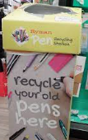
Title: Group Inquiry- Human Interactions with Earth’s Spheres
- The example that I chose is from an Inquiry Project in my Science 9 class to address the problem of use of plastics. Our goal was to work together to increase the awareness about plastic and encourage recycling. We demonstrated communication and collaboration in the project. More specifically, this example shows that I can work with other effectively to solve problems and encourage other voices to share their ideas.
- My strength is giving and adding onto other people’s ideas when we were collaborating together. One example is one day my group was trying to find a way to find out how we were going to recycle- what we could do, and how to do it. I gave the idea of being able to one day get pens and markers, then the next day taking ink out of them so that they could be recycled. Another member of my group was able to add to this by giving ideas of where to put the recycling stations around the school. We then realized we needed to raise awareness for recycling of pens so that people don’t throw them in the garbage can. I even asked a quieter member of our group to suggest ways to advertise and they came up with a great idea!
- I can continue to improve on the communication core competency by getting better at keeping my group on task during collaboration. To do this, I need to stay more focussed. I can also keep lists of what we need to do and help remind others to stay focussed.

Example: Communication- Culinary Arts
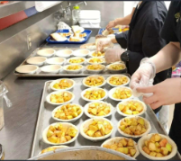
The example that I chose of cooking in my culinary arts class shows that I can work with others to achieve a common goal. I show this everyday that my classmates and I work together to create something. We show respectful behaviour, kindness, and help each other when we need it. I have shown growth in my ability to work with different people at different times, which has gotten me out of my comfort zone. I can continue to work on my communication skills by being able to better act on constructive feedback to improve my skills. To do this, I will make sure that I understand the feedback, by stating it back, and asking the teacher questions if I am unsure of what to do to improve.

Example: Personal and Social: Volunteering for School Events
My example shows that I can contribute to the community and the environment to make positive change. I contributed to the school community in a positive way by helping out with the Terry Fox run and Gr. 8 day which are 2 very important events in our school that both require a lot of effort to help succeed in. These events take a lot of valuable time to help in doing well in.
For volunteering during the Terry Fox run I was assigned to make posters and cheer people on as they run. With volunteering during Gr. 8 day I helped make groups for the pancake breakfast and we ran the scavenger hunt for 2 blocks which was very tiring but our class managed to do it and did very well. Volunteering as a class was very fun because you basically just work with your friends and it's impactful on our environment.
This example demonstrates growth because I didn't volunteer or help with many events in Gr. 9 but I've become more involved in the student body since being in Gr. 10. I am proud of this because I feel like I've grown since and become more mature with helping out in important events. I've realized how important it is to be apart of helping out with events and how fun it is when doing so.
My goal is to volunteer with as many events as I can and to make Student Council for next year. I can try to succeed in this goal by working as hard as I can and trying not take as many volunteering opportunities as I possibly can. I want to develop another goal where I can balance both things in a way that I can come in the middle and make space for volunteering, academics, and my other interests!
Example: Personal and Social: Involvement in the Semiahmoo Community
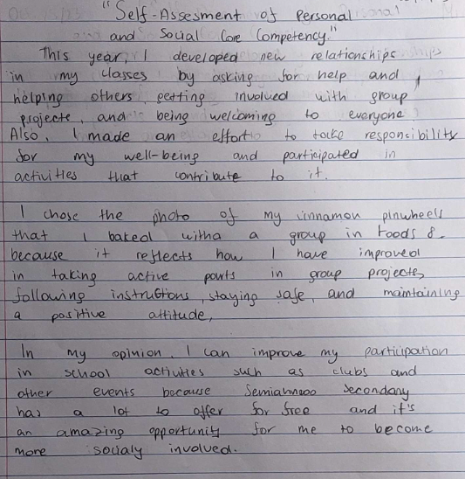

Example: Personal and Social: Volunteering
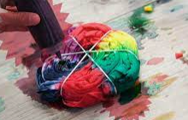
The example I chose is volunteering at the school for the Terry Fox Run and Grade Eight Day because it shows that I can help my school and help make my school a better place.
I showed this by helping the grade 8s feel welcomed at Semiahmoo as they made tie dye Thunderbird tshirts! I also got to support the runners in the Terry Fox run, which helps students feel like they are a part of the school and raise awareness and fundraising to help end cancer.
I can continue to work on my personal and social competency by volunteering with different groups and joining the Student Council next year. I'll work hard and take on as many opportunities as I can. I also want to find a balance between volunteering, schoolwork, and my other interests. It is important that I take time to relax too!

Example: Communication- Science 9 Project
The example I chose is from my Science 9 class project about plastic use because it shows that I can talk and work together with others. This means we can solve problems and make sure everyone’s ideas are heard.
I showed strength in collaboration because I'm good at adding ideas to the group when we work together. Once, my group wanted to figure out how to recycle pens. I suggested a plan. Another person in my group said we should put recycling bins in different places at school. We realized we also needed to tell people about recycling pens so they don't throw them away. I asked a quieter group member for ideas on how to tell everyone, and they had a great idea!
I can continue to improve on my communication by keeping my group focused when we work together. To do this, I'll try to stay more focused myself. I can also make lists of what we need to do and remind others to stay on track. This will help me improve in communicating with my group.

Example: Thinking
In my Social Studies class, I demonstrated the Thinking Core Competency by combining information from textbooks, primary sources, historical analyses, and documentaries, to analyze the causes of World War I. I am proud of how I brought together different perspectives to create a detailed essay. I have uploaded my list of sources and essay to my portfolio as my exemplar.
I want to improve my ability to critically evaluate the reliability of sources by cross-referencing more scholarly articles and conducting deeper source analysis. I will achieve this by setting aside extra time for thorough research and seeking feedback from my teachers on my source evaluation skills.

Example: Thinking
My example of success in my thinking core competency is from my math class. We had a project about exploring patterns in various situations. For our project, we chose to investigate patterns in the stock market over the past decade. I demonstrated my creative thinking by finding innovative ways to analyze the data we gathered. Instead of just graphing stock prices over time, I looked for connections between economic events and stock price changes. I then created a timeline highlighting major events like economic recessions, political elections, and global crises, and analyzed how these events impacted stock prices. By examining the data differently, I discovered new insights. I have taken a picture of my timeline and uploaded it to my portfolio as evidence of what I can do.
Next year, I aim to further develop my creative thinking skills in math by exploring alternative problem-solving strategies. I will continue to actively engage with my peers, listen to other perspectives, and try new approaches.

