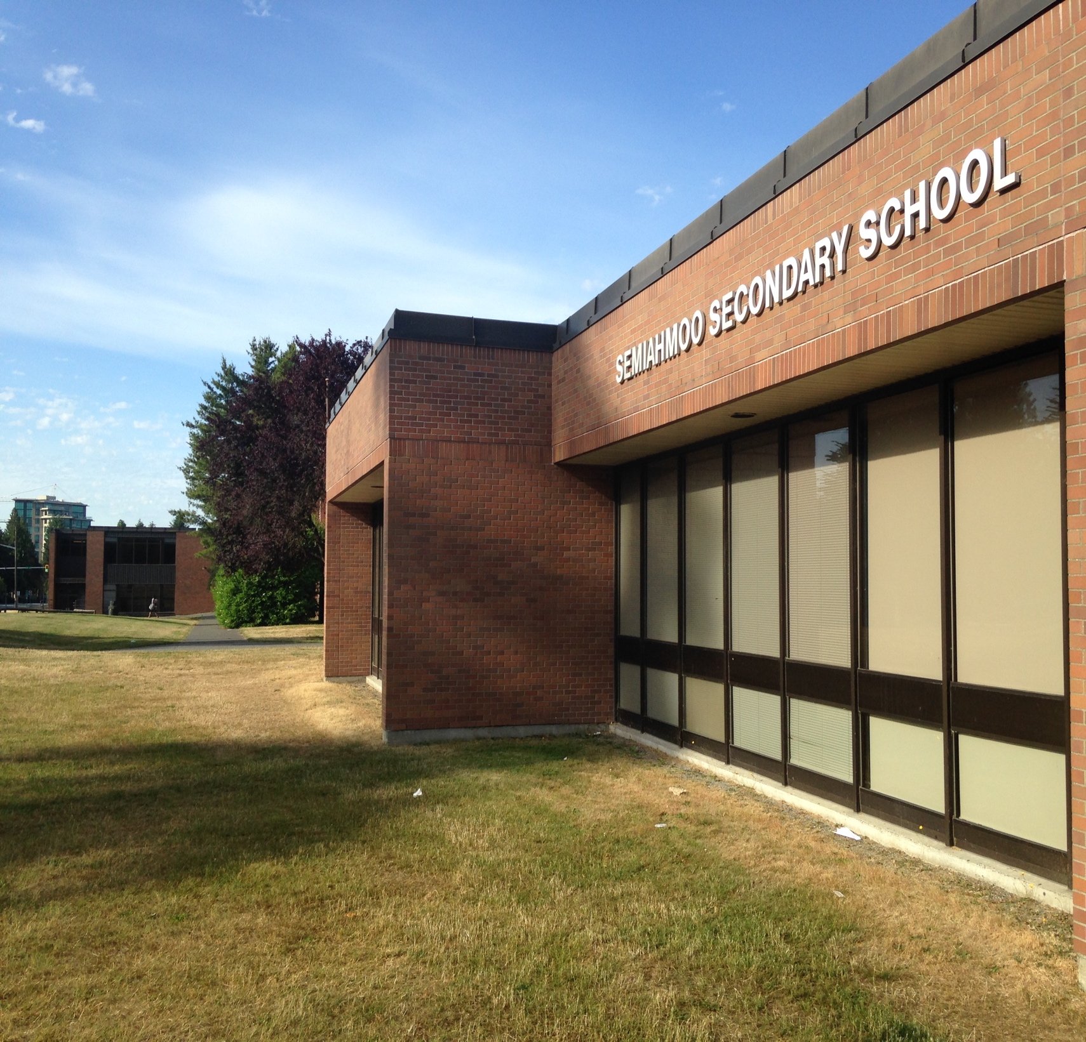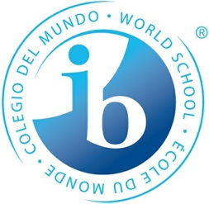

SEMIAHMOO SECONDARY

GRADES 10 - 12

2023-24

COURSE REQUEST BOOKLET

Our Mission is to educate every student to meet the challenges of a changing global society.

“Semiahmoo… We are the future”

**Welcome to Semiahmoo Secondary**

The courses offered at Semiahmoo Secondary follow guidelines set out by the Ministry of Education and the Surrey School Board. Programs consist of a combination of required courses and elective courses. The courses you choose may help you to learn life skills, explore new fields, and discover capabilities and interests of which you may have been unaware.

Selecting elective courses is an important process and should be carried out in consultation with parents and counsellors. Courses with insufficient enrolment to justify a class grouping will not be offered. It is important, therefore, that you make thoughtful and careful decisions. Certain elective combinations will influence future pathways as well. For example, if French is dropped in Grade 10, students are unable to enroll in French class in Grade 11. Student course requests determine what courses will be offered the next school year. It takes several months to build the master timetable and requests for changes are not usually accommodated. Please take care when request your courses for the coming year!

It is recommended that students and parents review the contents of this booklet. If you have any questions or concerns, please speak to a school counsellor.

We wish all our students a rewarding and positive school year. Happy planning!

**Administration**

Mr. Baljit Ranu Principal

Ms. Jana White Vice Principal

Mr. Zack Lund Vice Principal

**Department Heads**

Ms. Ramirez International Languages

Mr. Clunas Math

Ms. Correia LST

Mr. Cox Technology Education

Mr. Brown BASES

Ms. Fernandes ELL

Mr. Memmott Visual Arts

Ms. Burwash English

Mr. Kenny IB

Mr. Hoven Info Tech/Business Ed

Mr. McCallum Social Studies

Ms. Pajic Careers Education

Mr. Lowe Music

Ms. McDonough Learning Commons

Ms. Poelzer & Cross Physical & Health Education

Ms. Nelson Home Economics

Mr. McGimpsey Culinary Arts

Ms. Ross CLE/CLC

Ms. Blackwell Counselling

Mr. Yeung Science

Ms. Slater Communicating Student Learning

**Counsellors**

Ms. Hamilton (A – Dadivas)

Ms. Wilson (Dag - Hibbert)

Ms. Jamieson (Higgs - Liao )

Ms. Barclay (Lin – Sran)

Ms. Blackwell (Stahl – Z)

Table of Contents

* Graduation Requirements
* **GRADE 10 Required Courses**
* **GRADE 10 Elective Courses**
* International Baccalaureate (IB) Program
* **GRADE 11-12 Required Courses**
* **GRADE 11-12 Elective Courses**
* Academic Support
* Counselling
* Learning Commons
* Triple A Program
* ELL Department
* BASES Department
* CAREER Department

Graduation Requirements

**Grade 10**

**Compulsory Courses**

* Language Arts 10 (4 credits)
* Math 10 (4 credits)
* Science 10 (4 credits)
* Social Studies 10 (4 credits)
* Physical and Health Education 10 (4 credits)
* Career Life Education 10 (4 credits)

**Elective**

* A Fine Arts and/or an Applied Skills 10, 11, or 12 (4 credits)

**Grade 11**

**Compulsory Courses**

* Language Arts 11 (4 credits
* Science 11 or 12 (4 credits)
* Social Studies 12 (4 credits)
* Mathematics 11 or 12 (4 credits)
* *Career Life Connection (4 Credits) * (not compulsory but recommended in Gr 11)

**Electives**

* __________________________________
* __________________________________
* __________________________________
* __________________________________

**Grade 12**

**Compulsory Courses**

* Language Arts 12 (4 Credits)
* Career Life Connection (4 Credits) (If not completed in gr 11)
* Literacy Assessment
* Numeracy Assessment
* 3 other grade 12 courses (a total of 4 grade 12 courses and CLC are required for grad)

**Electives**

* __________________________________
* __________________________________
* __________________________________
* __________________________________
* __________________________________
* __________________________________

**Course Selection Tips…**

* 16 credits must be at the Grade 12 level including English 12
* One Indigeous Studies courses must be taken in Grade 10-12
* Learning Assistance courses do not offer credits towards graduation
* Courses that are retaken do not give additional credits towards graduation
* A second language is not required for graduation, but direct entrance to many universities WITHIN BC does require a language at the Grade 11 level.

**A minimum of 80 credits is required for graduation**

Grade 10 Course Descriptions -   
Required Courses

**Language Arts **Students have a choice between the following two courses** all of which are paired with Composition**

**Literary Studies 10**

This course allows students to delve deeply into literature. Students can explore specific themes, periods, authors, or areas of the world through literary works (fiction and non-fiction) in a variety of media.

Focus

• close reading of appropriately challenging texts

• planning, drafting, and editing processes for a variety of writing tasks

• understanding of self and the world

• higher-level thinking and learning skills

**English First Peoples 10**

EFP Literary Studies 10 is designed for all students, Aboriginal and non-Aboriginal, who are interested in exploring First Peoples literature in a variety of contexts, genres, and media.  This area of choice provides students with opportunities to explore personal and cultural identities, histories, stories, and connections to land/place.  This course is grounded in the understanding of how texts are historically and culturally constructed.

The following are possible areas of focus within EFP Literary Studies 10:

* Examine the Semiahmoo Band's history and connection to the school
* Thematic study of First Peoples literature (e.g., family, humour, connection to land, resistance, belonging, identity)
* Locally developed First Peoples texts
* Specific First Nations, Métis, or Inuit author study
* First Peoples children’s literature
* Oral Storytelling and Storytelling in a First Peoples context

**Composition 10 (included with the above 2 courses)**

This course develops students’ written communication within a supportive community of writers. Students will work to create coherent, purposeful compositions.

Skills included:

* writing, planning, revising, and publishing
* presenting and reflecting on performances
* developing an understanding of traditional and contemporary forms
* citing sources, considering the credibility of evidence, and evaluating the quality and reliability of the sources

**SOCIAL STUDIES 10**

(Canada and the World 1914-Present) Focuses on the development of Canada as a Nation. It examines the social, political, and economic structure of our nation, regional geography and resources, development patterns and issues, it also focuses on local, national, and global conflict; the development of political organizations; political decision-making and societal change; as well as the development and perspective of Canadian society.

**SCIENCE 10**

Student will be inquiring the world around them through four major topics: genetics, chemistry, energy, and astronomy. The genetics section will be exploring how DNA is the basis for the diversity of living things. Chemistry builds upon student’s knowledge of chemical formula and reactions, as well as investigates the energy change required as atoms rearrange in chemical processes. Students will engage in energy and how it is conserved, and its transformation can affect living things and the environment. Lastly, students will study the formation of the universe and explain this process using the big bang theory. Science 10 is the final year before the science curriculum branches off into their respective focuses.

**CAREER LIFE EDUCATION 10 (CLE)**

CLE helps you relate your learning in school to the demands of the working world. The course provides opportunities for: developing personal financial literacy skills; learning employment skills such as résumé building, interviewing, and delivering presentations; exploring career and education options; developing skills related to health and well-being; and learning about the grad program. This course must be taken before enrolling in CLC 11.

**PHYSICAL AND HEALTH EDUCATION 10**

**\*\*Students have a choice between the following 4 courses:**

1. **HEALTH AND WELLNESS GIRLS 10**

Students will explore the importance of physical and mental well-being through a variety of fitness routines, games, outdoor pursuits, classroom wellness lessons, and workshops. They will be encouraged to create healthy living habits and explore activities that promote a life-long active lifestyle. Students will be able to create individual goals related to their personal health and wellness in a safe and nurturing environment. This course seeks to provide students with the opportunity to create and engage in a balanced approach to health and wellness.

1. 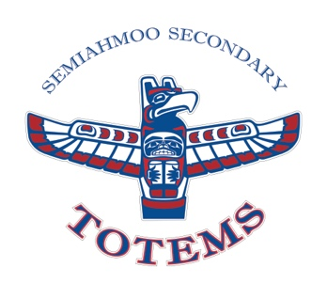**PHYSICAL AND HEALTH EDUCATION 10 - Learning**

The goal of our physical education program is to instill an appreciation for and an understanding of the benefits of an active, healthy lifestyle. The program will provide students with the opportunity to fulfill the following objectives: 1. To participate and enjoy a variety of performance and leisure-oriented activities. 2. To develop positive attitudes towards physical activities. 3. To be able to work cooperatively in group activities. 4. To acquire skills and knowledge necessary to develop an active and healthy lifestyle and set personal fitness goals.

1. **PHYSICAL AND HEALTH EDUCATION 10** - **Competitive**

The physical and health education program is designed to provide students with the opportunity to develop an appreciation for healthy and active living. Students will engage in a variety of sports, games, fitness activities, and wellness lessons. Students will be able to create and monitor personal healthy living goals, understand how healthy choices influence their physical, emotional, and mental well-being, build community health through positive social interactions, and describe and demonstrate physical literacy. The competitive PHE option is for students interested in being a part of a more challenging environment. This is for students with the highest level of engagement who want to actively compete.

1. **PE LEADERSHIP 10 (2 courses)**

Physical and Health Leadership 10 provides students with the opportunity to engage in after school volunteer experience to enhance leadership skills. Students will develop a deeper understanding for the rules, process, and planning involved in extra curricular sport. This is a linear course backed with CLE 10. Students will be required to apply for Leadership 10 and successful applicants will be selected.

**MATHEMATICS 10**

**\*\*Students have a choice between the following 2 courses:**

1. **WORKPLACE MATHEMATICS 10**

WM 10 provides students with skills necessary to be informed citizens, prepares them to become confident in using mathematics in the workplace and prepares them for a number of vocational and trade programs. Topics include algebra, geometry, measurement, number, statistics, and probability.

* *Upon successful completion of this course, students will enroll in* **Workplace Mathematics 11.**

1. **FOUNDATIONS OF MATHEMATICS AND PRE-CALCULUS 10**

Foundations of Mathematics and Pre-Calculus 10 provides a more theoretical focus than the other pathways, to prepare students for advanced studies in mathematics. Students intending to study mathematics, science, and/or engineering at the post-secondary level should take this course, as it is the prerequisite for both **Foundations of Mathematics 11** and **Pre-Calculus 11**.

**Grade 10 Course Descriptions**

**Elective Courses**

**FRENCH 10**

Students will continue developing their abilities to communicate effectively in French through listening, speaking, reading, and writing. Due to the cooperative nature of this course, regular attendance is very important.

**SPANISH 10**

As students gain proficiency in Spanish they will learn to communicate clearly and effectively in the target language. Students will be able to narrate stories orally and in writing, they will engage in short conversations and will be able to express themselves with growing fluency: ask and respond to a variety of questions, describe situations, express opinions on familiar topics, express hopes, and desires, among other things.

**STUDIO ARTS 10 2D**

Course is designed for grade 10 students wishing to deepen their understand and build their confidence in 2-dimensional art production. Students can expect to gain a strong foundation and build on the skills acquired in Studio Arts 9 2D in drawing and painting in this course (2D 9 is NOT a pre-requisite). Composition, the visual elements and principles of design, and the basic techniques and concepts of both drawing and painting will be covered. The end goals are to increase artistic self-confidence and develop understanding of the basics of drawing /painting and to produce successful explorative works. Students will investigate mark making, abstraction and realism. Learn to develop your skills of seeing and perception while using a variety of materials (acrylic, water colour, oil pastel, chalk, graphite, ink, pencil crayon).

**STUDIO ARTS 10 3D**

Course is designed for grade 10 students wishing to deepen their understand and build their confidence in 3-dimensional art production. Students can expect to gain a strong foundation and build on the skills acquired in Studio Arts 9 3D in drawing and painting in this course (3D 9 is NOT a pre-requisite) If you are interested in, and enjoy making things three dimensionally, this course is for you. Bring your imagination and creativity and we will explore the world of 3D Art.  Students will learn to manipulate space using materials and processes such as, paper mâché, cardboard construction, wire sculpture, fabric, found objects and clay works while learning the elements and principles of 3D design. If you are a 3D thinker who loves to manipulate materials.  Students in this course will continue to address skill development and the use of a variety of materials while exploring the impact of context, manipulation of design elements and principles as related to ceramics and sculpture.

**DRAMA 10**

This course is intended for those students who have a serious passion for the subject of theatre. The emphasis at this level is on the many roles (on stage and off stage) involved in running a successful show. For this reason, students should be able to work without direct supervision and work in partners or small groups. Those who exhibit these traits may be chosen to work with a student director on a script for the One Act Play Festival.

**INTRODUCTION TO PHOTOGRAPHY 10**

Introduction to photography basics, including composition, studio work, proper file management and editing with Adobe Lightroom. A variety of assignments and larger projects reflect learning growth. We work exclusively with digital photography. The aim of the course is to expose students to the artistry of photography and to develop a basic understanding of cameras and photographic techniques. All abilities and grades are welcome; no previous experience is required.

**YEARBOOK 10**

Students interested in photography, journalism, design, business, marketing, and leadership can practice all these skills in Yearbook. We create the school yearbook in an environment set up like a real business. We design pages, run marketing campaigns, run social media accounts, photograph school events, and publish a hardcover book. Students must be able to commit to significant afterschool time in addition to attending classes. No prerequisite course or experience is necessary; cameras and training are provided in class. Application forms must be approved by Ms. Ross before students can be officially registered in the course.

**VIDEO PRODUCTION 10**

Students with interest in journalism and previous experience in video production may apply to this student-directed course. Students plan, create, and produce a video series under the supervision of the Yearbook advisor. Students must have strong communication skills, self-regulation skills, and self-motivation. Seats are very limited. See Ms. Ross in Room 106 for more details.

**TEXTILES 10**

Interested in fashion or sewing your own clothes? Students will learn basic garment construction techniques, wardrobe planning, and the use of the serge, and sewing machine. You will create a variety of garments based on your skill level and interests. Beginners are welcome!

**FOODS AND NUTRITION 10**

In Foods 10 you will be going on an imaginary culinary road trip across North America, visiting various provinces, states, and cities. Along the way you'll be learning about everything from knife skills to food safety, from pastry to First Peoples food protocols, and there will be plenty of cooking and eating. This class builds on what you learned in Foods 8, but with more depth and more room for creativity.

**ENTREPRENEURSHIP AND MARKETING 10**

Introduction to business and marketing. This course will provide a foundation to move forward in studying business and marketing. The course will deal with entrepreneurship opportunities, customer needs, wants, and demands, characteristics of entrepreneurs, creative ways to add value to an existing idea or product, forms of marketing and online marketing concepts.

**PASTRY ARTS AND BAKING 10/11/12**

Do you love baking? Want to learn how to make the items you see in your local bakery? Pastry and Baking Arts focuses on more advanced skills and techniques in baking, from bread, to cookies, to chocolates, to cream puffs. Learn techniques and skills transferable to both the home kitchen and a professional bakery and have fun doing it!

**COMPUTER STUDIES 10**

We will explore the different mediums that we experience technology. We will become experts on how computers: Run/Operate, Affect our lives, and Interact with each other. Expect a variety of the following topics: Building Websites (with HTML and CSS), Image editing, Video editing (Adobe Premiere Pro / After Effects), Audio Recording and Editing (Audacity), Building a Computer, Animation, Graphical coding (Scratch + mBot robots), and Networking (WiFi Routers / Cables), Running a virtual machine, installing an operating system (Windows/Linux/Mac OS), running a web server (Apache), executing a project with an Internet of Things device (Arduino/Raspberry Pi)

**CULINARY ART 10**

Designed for students interested in the art and science of food preparation in a large commercial kitchen setting. Use of equipment, sanitation, safety, and a large variety of cooking skills increase opportunity to obtain employment in food industry.

**CONCERT BAND 10 (2 courses)**

Concert Band 10 is a linear course alternating with Social Studies 10. Course content includes advanced development of all music skills primarily focusing on tone, technique, and a general knowledge of composers and musical styles. Concert Band 10 students are part of the Senior Wind Ensemble (Gr. 10-11-12). Members have the opportunity to be part of the Music Department Tour.

**JAZZ BAND 10 (3 courses)**

Jazz Band student must also take Concert Band 10. Jazz Band 10 is a linear course with Science 10. This course includes developing the concepts of playing in a jazz ensemble as well as improving listening and improvisation skills. Students will be introduced to advanced ear training and jazz theory. *Student taking this course will also be taught CLE withing the Jazz Band class and thus do not need to sign up for CLE as its own course.*

**STUDENT LEADERSHIP 10 (2 courses)**

This course is designed to ignite students’ curiosity and provide them with the opportunity to practice valuable leadership and transferrable skills through a variety of curricular and extracurricular activities. The class will run yearlong and is backed with CLE 10. The goal of the course will be to facilitate and contribute to the well-being of the school and our community through the planning of special events, collaboration with senior leadership students and participation in district-run initiatives.

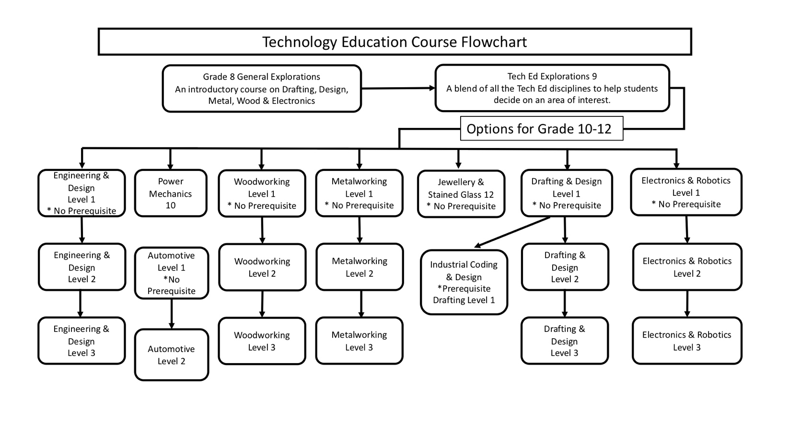**ELECTRONICS AND ROBOTICS LEVEL 1**This course will expose students to the principles of electronics and robotics through a combination of both practical and hands-on projects. Students will learn to identify components, use tools associated with the electronics and robotics field, as well as basic coding and construction of chassis and cases used for housing their creations. Projects will include, sumo-bots, M-bots, Arduino, audio amplifiers and many other projects that individual students may be interested in creating.

**DRAFTING & DESIGN - Level 1**

This is an introduction to the world of technical drawing and design thinking. This course will expose students to the various professions that involve technical drawing and design. As a class, we will look at the skills and educational requirements needed to have a career in the world of technical drawing and design. Most of the semester will take place in a computer lab, learning how to use the various drawing programs used in technical drawing. A portion of the semester will be dedicated to students working in a design workshop, building 3 dimensional prototypes of their own design, and making custom t-shirts!

**MECHANICS 10**

This is an introduction of the internal combustion engine and transmission of power. Students will learn about the systems, parts, tools, and skills that are needed to dismantle and rebuild a small engine. A portion of the course will focus on welding and metal joinery. Students will have the opportunity to expand into bicycle maintenance and automotive basics. There will also be an opportunity for students to bring in small engine projects from home.

**METAL ART - Level 1**

This introductory metal course will incorporate a number of key metal working concepts, procedures, and practices. Students will learn all facets of metal working including, jewelry, welding, fabricating, machining, casting, and sheet metal work. There will be a variety of projects from fine widgets to fabulous gadgets!

**ENGINEERING AND DESIGN – Level 1**

This course is for students with an interest in the application of engineering as it pertains to design. Students will be exposed to various engineering principles with an emphasis on applying these in the design of projects. Students will also learn the safe use of various tools and machines in the pursuit of creating engineering marvels. Projects could include but will not be limited to, CO2 dragsters, rockets, catapults, trebuchets, gravity cars, balsa wood gliders, Popsicle stick bridges…and many more. Students that are taking this course for a second time will have an opportunity to expand on what they have learned in previous years. The intent is these students will then design and construct projects of personal relevance and interest.

**WOOD WORKING - Level 1**

This is an extension of the woodwork portion of the Technology Education 9 Explorations course, although there is no prerequisite. This course is hands-on woodwork. Through drafting, design and active construction, students combine the safe use of tools, machines, and materials to construct introductory level projects made of wood.

**JEWELLERY AND STAINED GLASS 12**

Designed for both the beginner and experienced student, this is a fun, introductory course about jewellery and stained glass. Students will be using new & recycled metals as a medium to create original artwork. Students may learn to manipulate metal or construct artistic metal projects through the use of hand tools, oxy-acetylene welding/brazing/cutting. Projects could include silver rings, bracelets, pendants, earrings, necklaces, hair barrettes, wire/metal sculptures and metal signage. When working with glass, students will be using the Tiffany copper-foil technique. Safety is emphasized while learning the basics of pattern design, glass selection, cutting, shaping, foiling, soldering, and finishing techniques.

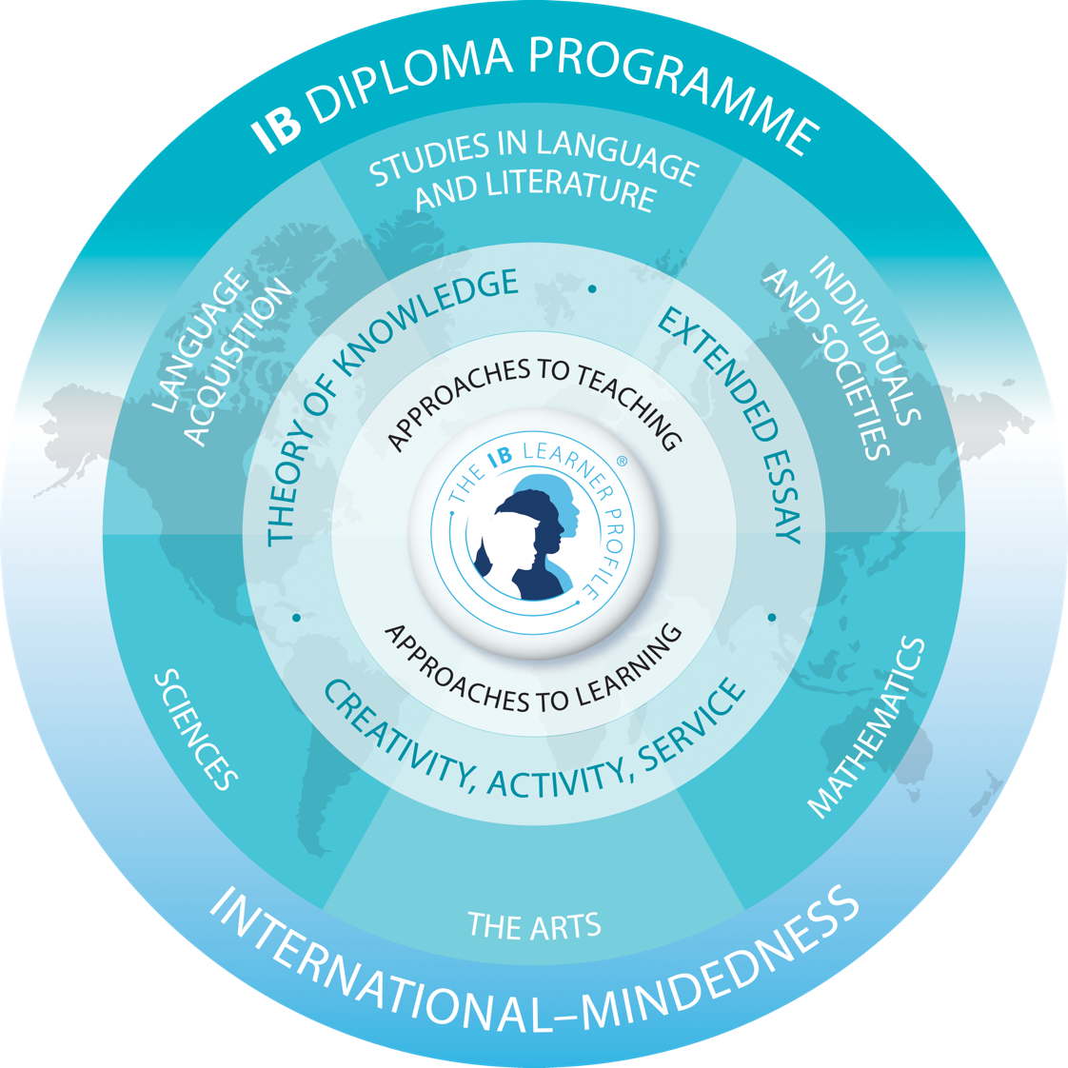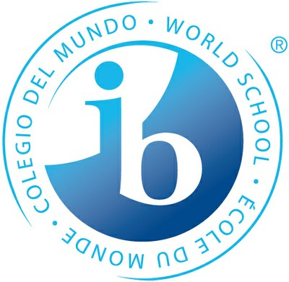International Baccalaureate (IB)

The IB Diploma Program (DP) is a rigorous, academically challenging, and balanced program of education designed to prepare students aged 16 to 19 for success at university and in life. The DP aims to encourage students to be knowledgeable, inquiring, caring, open-minded and to develop intercultural understanding and the attitudes necessary to appreciate a range of viewpoints.

The DP provides the opportunity to develop both disciplinary and inter- disciplinary knowledge that meets the rigorous standards set by institutions of higher learning around the world.

To ensure both breadth and depth of knowledge and understanding, students choose courses from the following subject groups: studies in literature; language acquisition; individuals and societies; sciences; mathematics; and the arts. Most subjects may be taken at either standard level (SL) or higher level (HL).

To earn the full diploma a student must take three subjects in HL and three subjects in SL. In addition, three core elements—the extended essay, theory of knowledge and creativity, activity, service—are compulsory and central to the philosophy of the program.

Program

**ADMISSION REQUIREMENTS:**

Students must fill in the application package and apply for enrollment in all IB courses at the school office. Application packages are available online at [www.IBSemiahmoo.ca/apply](http://www.IBSemiahmoo.ca/apply) Due to limited space, admission to the program may not be available, but a waitlist will be maintained.

General Admission Guidelines: Full Diploma – Early admission is late December and late admission is the end of January. Certificate Program admission is the end of January

Applicants must have credits for all Grade 10 required courses by the time they start the IB program. To prepare for admission to the IB Program, it is recommended that students gain a breadth of experience in community service, leadership, athletics, fine arts, and extracurricular academics, such as robotics camp, essay competitions, and science fairs.

**PROGRAM REQUIRMENTS:**

IB Diploma Students can select three Higher Level (HL) and three Standard Level (SL) courses from three Pathways of Choice. Pathways are intended to allow students to enroll in the IB courses for a given career path:

1. Natural Sciences: Engineering, Mathematics, Physics, Computer Science
2. Life Sciences: Biology, Biochemistry, Environmental Sciences, Pre-Medicine
3. Humanities: English, Languages, History, Fine Arts, Business, Pre-Law, Political Science

You can be more flexible and consider choosing subjects from different pathways depending on your strengths and weaknesses. However, you need to be aware of university entrance requirements. If a student is unsure of which courses to choose, they can make an appointment with the IB Coordinator to discuss the choice of subjects that best fits their aspirations.

The two-year course options within the pathways of choice are below. HL courses require three semesters over two years to complete and SL courses require two semesters over two years. Course students may select from one to three courses at a Higher Level as well as one optional language acquisition course (French or Spanish) at Standard Level.

**PATHWAYS OF CHOICE:**

|  |  |  |  |  |
| --- | --- | --- | --- | --- |
|  | **Group of subjects** | **Engineering/ Math/**  **Computer Science** | **Life Sciences/**  **Pre-Medicine/**  **Dentistry** | **Humanities/**  **Languages/**  **Pre-Law/**  **Business** |
| **1** | Language A | English A SL or HL | English A SL or HL | English A HL or  SL |
| **2** | Language Acquisition | French B SL  OR  Spanish B SL | French B SL  OR  Spanish B SL | French B SL  OR  Spanish B SL |
| **3** | Individuals  and Societies | Geography SL or HL  OR  History SL or HL | Geography SL or HL  OR  History SL or HL | History SL or HL  OR  Geography SL or HL |
| **4** | Experimental  Sciences | Both needed:  Physics HL  Chemistry HL | Both needed:  Biology HL  Chemistry HL | Biology SL |
| **5** | Math | Math A &A HL | Math A & A SL or HL | Math A & A SL (or Math A & A HL recommended for Business) |
| **6** | The Arts – Visual Arts (an elective course) |  |  |  |
| **CORE: TOK, Extended Essay, CAS** |  | CORE | CORE | CORE |

**COURSE DESCRIPTORS**

**GROUP 1**

**IB ENGLISH (SL/HL)**

IB English is a rigorous course that makes an in-depth examination of the major elements of literature. In it, students engage in independent literary criticism in a manner that reveals a personal response to literature. They learn to express ideas with clarity, coherence, and fluency in both written and oral communication as well as appreciate the similarities and differences between literary works from different time periods and cultures. The course prepares students for the demands that will be placed on their written and oral communication skills in the post-secondary system. Furthermore, the course is envisaged as a vehicle to enrich the international awareness of participants; to develop in them the attitudes of tolerance, empathy, and a genuine respect for perspectives different from their own.

**GROUP 2**

**IB FRENCH B (SL)**

IB French is a language-learning course designed for students with some previous learning of that language. The focus of the course is on language acquisition and development of language skills. These language skills should be developed through the study and use of a range of written and spoken material. Such material will extend from everyday oral exchanges to literary texts and is related to the culture concerned. The taught material will enable students to develop mastery of language skills and intercultural understanding. IB French B (SL) is completed within one year.

**IB SPANISH B (SL)**

IB Spanish is a combination of Spanish 11, 12, and first-year university. It is designed for students with a background in Spanish (Spanish 9 and 10 are highly recommended). The focus of the course is on language acquisition and development of language skills. The course is conducted entirely in Spanish and focuses on intercultural understanding. Students will learn to communicate effectively in Spanish, both orally and written, as well as read novels, texts, short stories, and articles in the target language. Commitment to reading is required. IB Spanish B (SL) is completed within one year.

**GROUP 3**

**IB GEOGRAPHY (SL/HL)**

IB Geography (Standard and Higher Level) is a two-year course that covers both physical and human geography. Topics include understanding and managing physical hazards such as earthquakes, hurricanes, and droughts. Students look at the challenges and opportunities for humans in extreme environments like deserts and the far North. Students analyze changing patterns in population, migration, gender issues, resource consumption, and wealth over time and between the developed and developing world. In HL Geography, there is also a focus on the advent of globalization with increasing integration of the global economy and the positive and negative socio-economic impacts.

**IB HISTORY (SL/HL)**

The IB History curriculum covers a wide range of events predominantly from 20th century history. Topics include Tsarist Russia through the revolution of 1917, both World Wars, and the Cold War. But the course is so much more. Not satisfied with only knowing what happened, we explore why and how by asking tough - even controversial - questions, and by challenging accepted beliefs. Over the two years of the program, we will make connections from the past, not only to identify immediate consequences, but to also learn how events of the past affect us today.

**GROUP 4**

**IB BIOLOGY (SL/HL)**

Students aim to question, investigate, and understand the living world at all levels using many different approaches and techniques. In year one, students explore molecular biology, the cell, genetics, evolution, ecology, and biodiversity. In year two, students further their understanding of the interconnectedness of the living world through the study of metabolism, human physiology, and plant biology. Students have opportunities to design investigations, collect data, develop manipulative skills, analyze results, collaborate with peers, and evaluate and communicate their findings. The nature of science, as an overarching theme, will allow students to appreciate the global context of scientific study.

**IB CHEMISTRY (HL)**

This course will introduce scientific techniques for Measurement and Data Processing. We will explore Stoichiometric Relationships, Atomic Structure, trends in Periodicity, Chemical Bonding, Energetics, Chemical Kinetics, Equilibrium, Acids and Bases, Electrochemistry and Organic Chemistry.  This two-year course combines academic study and the development of practical and investigational skills.  Students will use the scientific method, developing and testing hypotheses, critically analyzing their results, and concluding based on their experimental data.

**IB PHYSICS (HL)**

This two-year course will provide students with an understanding of the dual nature of Physics both theoretical and practical as well as increase their command of the use of Mathematics as the language of Physics. This course will explore concepts ranging from Newtonian mechanics up to modern Physics with heavy emphasis on laboratory work as an integral part of the learning process.

A main objective of the course is to challenge students to think about and analyze how physical principles have been applied to construct and alter our material world to suit our needs. This raises the issue of the impact of physics on society, the moral and ethical dilemmas, and the social, economic, and environmental implications of the work of physicists. Students will also explore the international context within which physics exists and examine issues from more than one side.

**GROUP 5**

**ANALYSIS AND APPROACHES (A&A) SL OR HL 11**

*Pre-Calculus 11 strongly recommended*

In the first year of the two-year Diploma Programme, students will enroll in either A&A Standard Level or A&A Higher Level. Both courses are one semester in length and cover much of what is covered in Pre-Calculus 12, but the Higher-Level course focuses on developing mathematical concepts in a more comprehensive, coherent, and rigorous way. In the second year of the Diploma Programme, students who complete A&A SL 11 will continue with A&A SL 12 which meets every other day all year. Students who successfully complete A&A HL 11 will continue with A&A HL 12 which meets every day all year. Students who struggle with A&A HL 11 may switch to A&A SL 12 at the start of the second year, keeping in mind that one of their other SL classes will need to switch to an HL class.

*Graphing calculator required.*

**ANALYSIS AND APPROACHES (A&A) SL 12**

*At least a 3 in IB Mathematics 11 SL strongly recommended*

The IB Diploma Programme mathematics standard level course is for students with knowledge of basic mathematical concepts who can apply simple mathematical techniques correctly. The course provides students with a sound mathematical background to prepare for future studies in subjects such as chemistry, economics, psychology, and business administration. Students will be introduced to important mathematical concepts through the development of mathematical techniques in a way that emphasizes subject comprehension rather than mathematical rigour. Students should, where possible, apply the acquired mathematical knowledge to solve realistic problems. Students will explore a topic of their own choosing and develop a reasoned and reflective paper called a Mathematical Exploration.

*Graphing calculator required.*

**ANALYSIS AND APPROACHES (A&A) HL 12**

*At least a 5 in IB Mathematics 11 HL strongly recommended*

The IB Diploma Programme A&A higher level course is for students with a strong background in mathematics and competence in a range of analytical and technical skills. Students will be likely to include mathematics as a major component of university studies—either in its own right or within courses such as physics, engineering, or technology. The course focuses on developing important mathematical concepts in a comprehensive, coherent, and rigorous way through a balanced approach. Students will explore a topic of their own choosing and develop a reasoned and reflective paper called a Mathematical Exploration.

*Graphing calculator required.*

**GROUP 6**

**IB VISUAL ARTS (HL)**

The IB Visual Arts course encourages students to challenge their own creative and cultural expectations and boundaries. It is a thought-provoking course in which students develop analytical skills in problem-solving and divergent thinking, while working towards technical proficiency and confidence as art-makers. In addition to exploring and comparing visual arts from different perspectives and in different contexts, students are expected to engage in, experiment with and critically reflect upon a wide range of contemporary practices and media. The course is designed for students who want to go on to further study of visual arts in higher education as well as for those who are seeking lifelong enrichment through visual arts.

**CORE**

**THEORY OF KNOWLEDGE (TOK)**

As a course, Theory of Knowledge is centered at the heart of the International Baccalaureate program. Students will reflect on themselves as knowers in the act of knowing. The core theme, therefore, is “Knowledge and the Knower” and will ask “What shapes my perspective?” This emphasis is supplemented with an investigation into two of the following optional themes: Knowledge and technology, Knowledge and language, Knowledge and Indigenous societies, Knowledge and politics and Knowledge and religion. Students are challenged to reflect critically and become increasingly aware of the complexity of their knowledge. They delve deeply into the foundations of knowledge, comparing, contrasting, and making connections between the five different areas of knowledge (AOK). These AOKs are subjects of critical inquiry in which students explore what it means to “know” in each area as well as examine the ethical issues entangled in each area.

**EXTENDED ESSAY (EE)**

The Extended Essay, a compulsory requirement of the IB Diploma Programme, is an independent research-based essay of maximum 4,000 words written under the guidance of a schoolteacher-supervisor. The Extended Essay demands an in-depth study of a student-chosen topic that is aligned with one of the IB Subject Areas. The aims of the EE are to provide students with the opportunity to:

* conduct independent research on a focused topic
* form a clear and arguable research question/thesis
* develop research, communication and writing skills
* develop critical and creative thinking
* learn how to properly document sources used in a scholarly paper
* experience the excitement of intellectual discovery

By completing the Extended Essay, Diploma Candidates become well prepared for the expectations of college or university for research and writing assignments.

**CREATIVITY, ACTIVITY, AND SERVICE (CAS)**

* Creativity: Exploring and extending ideas leading to an original or interpretative product or performance
* Activity: Physical exertion contributing to a healthy lifestyle
* Service: Collaborative and reciprocal engagement with the community in response to an authentic need

CAS complements the academic demands of the IB Diploma programme and offers a balance to academic pursuits developing the whole person. CAS is experiential learning. In addition to academic/intellectual skills, CAS engages other intelligences allowing students to learn by doing. Key to a student’s CAS program is personal engagement, choice, and enjoyment of CAS experiences. Students can fulfill their CAS requirements through the many extra-curricular activities available at Semiahmoo, but many CAS experiences can also be completed out of school. Students should undertake a variety of CAS experiences, ideally on a weekly basis, for a minimum of 18 months. They must also undertake at least one CAS project with a minimum duration of one month. Students reflect on CAS experiences at significant moments throughout CAS and maintain a CAS portfolio. Using evidence from their portfolio, students will demonstrate achievement of the seven CAS learning outcomes. Students will attend monthly mandatory CAS classes in Year 1 for lessons, activities and portfolio working time and will participate in three formal interviews with their CAS supervisor.

Grade 11 and 12

Course Descriptions

**LANGUAGE ARTS**

**ENGLISH 11**

**\*You are required to take one of the following 3 courses\***

**1 - COMPOSITION 11**

This courseis designed to support students as they refine, clarify, and adjust their written communication through practice and revision. Students will read and study compositions by other writers and be exposed to a variety of styles as models for the development of their writing. The course provides opportunities for students to, with increasing independence, study, create, and write original and authentic pieces for a range of purposes and real-world audiences. They will expand their competencies through processes of drafting, reflecting, and revising to build a body of work that demonstrates expanding breadth, depth, and evidence of writing for a range of situations.

Focus

• narrative, expository, descriptive, persuasive, and opinion pieces

• planning, drafting, and editing processes

• writing for specific audiences and specific disciplines

• how to cite sources, consider the credibility of evidence, and evaluate the quality and reliability of the source

**2 – LITERARY STUDIES 11**

This course allows students to delve deeply into literature. Students can explore specific themes, periods, authors, or areas of the world through literary works (fiction and non-fiction) in a variety of media.

Focus

• close reading of appropriately challenging texts

• planning, drafting, and editing processes for a variety of writing tasks

• understanding of self and the world

• higher-level thinking and learning skills

**3- ENGLISH FIRST PEOPLES 11**

EFP Literary Studies 11 is designed for all students, Aboriginal and non-Aboriginal, who are interested in exploring First Peoples literature in a variety of contexts, genres, and media.  This area of choice provides students with opportunities to explore personal and cultural identities, histories, stories, and connections to land/place.  This course is grounded in the understanding of how texts are historically and culturally constructed.

The following are possible areas of focus within EFP English 11:

* Examine the Semiahmoo Band's history and connection to the school
* Thematic study of First Peoples literature (e.g., family, humour, connection to land, resistance, belonging, identity)
* Locally developed First Peoples texts
* Specific First Nations, Métis, or Inuit author study
* First Peoples children’s literature
* Oral Storytelling and Storytelling in a First Peoples context

**\*You are required to take one of the following 2 courses\***

**ENGLISH 12**

Develops the skills and knowledge needed for higher-level communication. It will further extend students’ knowledge and appreciation of literature.

**ENGLISH FIRST PEOPLES 12**

English First Peoples 12 builds upon and extends students’ previous learning experiences in EPF 10 and English 11 courses. The course is grounded in the First Peoples Principles of Learning and is designed for all students, Indigenous and non-Indigenous. This course explores the English core competencies through engagement with authentic oral and written First Peoples’ stories and accounts. It recognizes the power of storytelling and voice to the process of reconciliation and fostering justice. The course focuses on experiences, values, beliefs, and lived realities of First Peoples as evidenced in various forms of text, including oral story, poetry, song, performance, film, and prose. Students will explore what constitutes culture, and how differences between cultures can lead to ethnocentrism, prejudice, stereotyping and racism. A key component of the course will be an exploration of the local Semiahmoo band’s history and its connection to Semiahmoo Secondary.

**TRIPLE A: ARTS, ATHLETICS, ACADEMICS**

The Semiahmoo Triple A program was established to accommodate students who are competing or performing at the provincial, national, or international level. The program is designed to help students deal successfully with the conflicts that arise between rigorous training schedules and academic achievement. Students who are high caliber artistic and athletic performers and who are committed to their education and training may be interested in the Triple A Program. Triple A students will take the Spoken Language (& Composition) course backed with an in-class study period for the entire school year.

**SOCIAL STUDIES DEPARTMENT**

**Students are required to take one of the following Social Studies courses to graduate**

**(A reminder that you must have a indigenous related course taken in Grade 10, 11 or 12).**

**CONTEMPORARY INDIGENOUS STUDIES 12**

In Contemporary Indigenous Studies 12, students will explore a multitude of issues facing over 5,000 distinct Indigenous communities throughout the world.  We will investigate these issues through a historical perspective and compare/contrast different societies relationships with Indigenous rights today.  A focus of study will centre around these Indigenous communities' connections with the land, the impact of colonialism and the advocation of self-determination and reconciliation.

**PHYSICAL GEOGRAPHY 12**

If you love to travel and learn about different places in the world, Geography is the course for you! It focuses on the study of the natural environment and how people interact with it. Students learn the physical functions of the atmosphere, biosphere, lithosphere, and hydrosphere, and the implications of how humans impact these spheres. The curriculum incorporates: data from a variety of case studies; natural processes; and human connectedness to the environment. Major topics of study are the 5 Themes of Geography, Plate Tectonics, Gradational Processes, Geomorphology, Soil, Vegetation, Climate, Weather and Resources and Sustainability. It is a foundation course and will prepare students for university level Geography courses. *There is no final exam requirement in this course, however, student participation, and careful consideration of environmental issues is an important part of the course.*

**LAW STUDIES 12**

This is a practical course focused mainly on the workings of the Canadian legal system, including the rule of law, rights and freedoms, criminal offences, arrest and detention, the court system, policing and the penal system. This course is not intended to produce “mini-lawyers” but rather give students a broad understanding of criminal law and how legal processes work and affect their daily lives. A field trip to a courthouse, along with guest speakers, will further enhance student learning. *There is no final exam requirement in this course, however, students will be required to participate and learn about case studies of current and past court cases throughout the course.*

**20th CENTURY WORLD HISTORY 12**

If you like history, you will love this course! This course is a world history course, which deals with the major events of the 20th Century. Topics include World War One, the growth of Communism and Fascism, World War Two, the Cold War, the Post-War World, the Gulf War and the Middle East, China and the Far East and Africa. History 12 is designed to stimulate discussion of world events, to develop student’s critical thinking skills and challenge their personal values and political points of view. *There is no final exam requirement in this course, however; students will be required to express a logical and informed point of view verbally and in writing.*

**SOCIAL JUSTICE 12**

Social Justice 12 focuses on the causes of complex social injustices and their impact on society. Students will inquire how these issues are connected and how their worldview shapes and informs their understanding of social justice. Topics of focus include equality, values and morals, justice and social service, privilege and power, activism, and advocacy, marginalized and vulnerable groups.

*There is no final exam requirement in this course; however, student participation and careful consideration of perspective and bias is a necessary component.*

**POLITICAL STUDIES 12**

Political Studies 12 aims to enhance your knowledge, abilities, and your willingness to participate actively and responsibly in civic life.   The course is both academic, requiring study, analysis, and written composition, and “hands-on”, providing you with opportunities to voice your opinion and debate with others on political and civic matters – from local to global. It will focus on historical developments in political studies, political theory, Canadian governance, democratic institutions, citizen power and engagement, and current events. It will prepare the student for their role as an active, knowledgeable citizen in our democracy, as well as provide good preparation for any university level Political Studies courses the student may take after graduation.

**MATHEMATICS DEPARTMENT  
Please see flow chart earlier in the document**

**GRADE 11 MATH**

**WORKPLACE MATHEMATICS 11**

WM 11 satisfies the Ministry Graduation requirement for a mathematics course at the Grade 11 level. The common core topics are problem solving techniques, measurements, data analysis, income and budgeting, business finance, investment, loans, insurance, and cost of housing. This course cannot be used for university entrance.

***Or* FOUNDATIONS OF MATHEMATICS 11**

*Foundations of Mathematics and Pre-Calculus 10 strongly recommended.*

This pathway is designed to provide students with the mathematical understandings and critical-thinking skills identified for post-secondary studies in programs that do not require the study of theoretical calculus, such as Sociology, Politics, Psychology, Arts or Humanities. Topics include measurement (rates and scales), geometric reasoning (angles and triangles), non-right triangle trigonometry, logical reasoning, spatial puzzles, statistics (normal distribution, interpretation of statistical data), 2-variable linear inequalities, quadratic functions, and history of mathematics.

***Or* PRE-CALCULUS 11**

*C+ in Foundations of Mathematics and Pre-Calculus 10 strongly recommended*

This pathway is designed to provide students with the mathematical understandings and critical-thinking skills identified for post-secondary studies in programs that require the study of theoretical calculus, such as mathematics, science, engineering, medicine, or commerce. Topics include algebra and number, trigonometry, and relations and functions. **Pre-Calculus 11** is required for entrance to many universities and technical schools.

**FOUNDATIONS OF MATHEMATICS 12:**

This course is designed to develop the skills required for mathematical modelling including the use of technology to represent and model the observed behaviour of quantities that arise in the sciences, personal finance, probability, statistics, and geometry. Topics include geometrical constructions, financial planning, probability, combinatorics, and regression analysis using polynomial, exponential, logarithmic and sinusoidal functions.  This course is not intended for students preparing to take Calculus.

**PRE-CALCULUS 12** *(C+ in Pre-Calculus 11 strongly recommended)*

This pathway is designed to provide students with the mathematical understandings and critical-thinking skills identified for post-secondary studies in programs that require the study of theoretical calculus, such as mathematics, science, engineering, medicine, or commerce. Topics include algebra and number, sequences and series, function analysis and mathematical modelling.

*Graphing calculator is required.*

**CALCULUS 12** (*B in Pre-Calculus 12 strongly recommended)*

This course is highly recommended for students planning to study calculus at the post-secondary level. It surveys the main topics that will be covered in first and second semester university courses including limits, differentiation and its applications, integration, and its applications. The BC Calculus Challenge exam is available for those students who want to challenge first semester calculus at UBC, SFU, UVic and UNBC. *Graphing calculator is required.*

**SCIENCE DEPARTMENT**

**Students are required to take one of the following Science courses to graduate.**

**SCIENCE FOR CITIZENS 11**

Science for Citizens 11 is a course for students wanting to explore the science of everyday life with a focus on the workplace. Units studied include climate change, wellness, natural disasters, and resources with a connection to modern technology.

**LIFE SCIENCE 11**

Life Science 11 is a lab-oriented course designed to introduce students to the history and diversity of life on earth. Through the exploration of Curricular Competencies students will learn to evaluate their methods and experimental conditions, interpret graphs, diagrams, and models, and critically analyze the validity of scientific sources. This course introduces students to a variety of technical skills including work in microscopy and dissections. The three main themes in Life Sciences 11 are characteristics of living things, processes of evolution, and taxonomy. Under these themes, the curriculum will specifically cover ideas around basic cell biology, biodiversity, evolution, viruses, taxonomy, microbiology, botany, zoology, and ecology. Students will learn about how scientists classify living things and examine specific features and adaptations of a variety of organisms. Life Sciences 11 demands that students be prepared to develop strong scientific academic writing techniques and an understanding of biological terminology as the course progresses. These skills are also extended into Anatomy and Physiology 12 and will prove beneficial for first year biology courses in post-secondary institutions.

**Curricular Big Ideas:** Life is a result of interactions at the molecular and cellular levels, Evolution occurs at the population level, Organisms are grouped based on common characteristics.

**CHEMISTRY 11**

This course is a survey course which will give students the opportunity to explore many branches of chemistry while building upon the foundational science skills they have gained in previous science courses. The course will have students navigate through the study of matter, chemical reactions, mole/stoichiometry calculations, atomic theory, solutions, and conclude with organic chemistry. Students will have opportunities to gain lab skills where they will use scientific techniques to record observations and measurements. Students will collect data, analyze their results, and report their findings in a scientific manner. Strong mathematical skills are recommended.

**PHYSICS 11**

This course emphasizes problem solving, data collection and integration, covering Kinematics, Forces, Energy and Mechanical Waves as the main topics. Learn how objects and ourselves move around, following predictable patterns – How is it that you walk? Sit? Relearn all that stuff you learned growing up as a baby: How to sit and walk and jump and throw things!

**ENVIRONMENTAL SCIENCE 11**

The goal of this course is to provide you with the scientific principles, concepts, and methodologies required to understand the interrelationships of the natural world, to identify and analyze environmental problems both natural and human-made.

**ANATOMY AND PHYSIOLOGY 12**

Human Anatomy and Physiology 12 is a demanding academic course that focuses on the complexities and interrelationships between genetics, organs systems, and homeostasis. These topics are explored through curricular competencies and practical science proficiencies that emulate scientific study and investigation. A strong language background along with Life Science, and/or Chemistry and Math 11 complement this course by establishing the needed foundations for experimentation, microscopy and dissection skills that are further developed from a grade 12 biological science perspective.

**Curricular Big Ideas:** Homeostasis is maintained through physiological processes, Gene Expression through protein synthesis is an interaction between genes and the environment, Organ Systems have complex interrelationships to maintain homeostasis.

**CHEMISTRY 12**

This course builds on Chemistry 11 and students will have the opportunity to explore topics in greater detail. Students will continue to develop skills in critical and abstract thinking, problem solving and chemical techniques. The course will begin with a look at reaction kinetics and the factors that affect reactions and their mechanisms. Then the course will focus on different types of equilibrium (solubility, acid/base).  The course will conclude with a unit on electrochemistry focusing on oxidation/ reduction reactions. Strong mathematical skills are recommended as well as a very good understanding of Chemistry 11.

**PHYSICS 12**

Take all that stuff you learned in Physics 11; now apply it to Gravity in the Universe, Classical Mechanics and Electromagnetism – now you will know almost everything about how things work in our everyday lives! Learn how your phone and laptop chargers work, and how to take mechanical movement and create electricity. Opportunities are provided to apply the concepts of physics to develop analytical problem-solving skills.

**MODERN LANGUAGES DEPARTMENT**

**FRENCH 11**

Students will continue enhancing their abilities to communicate effectively in French through listening, speaking, reading, and writing. Due to the cooperative nature of this course, regular attendance is very important.

**FRENCH 12**

Students develop their abilities to communicate effectively in listening, speaking, reading, and writing. Students will work to refine the content and form their work to an increasingly sophisticated level of French. Due to the cooperative nature of this course, regular attendance is very important.

**SPANISH 11**

Students will continue developing basic communication in Spanish through listening, speaking, reading & writing tasks. Due to the cooperative nature of this course, regular attendance is very important.

**SPANISH 12**

Students develop their abilities to communicate effectively in listening, speaking, reading & writing. Students work to refine the content and form of their work to an increasingly sophisticated level of Spanish.

**VISUAL ARTS DEPARTMENT**

**ART STUDIO 11**

A survey course which introduces the student to the visual arts and encourages growth as an artist: history, philosophy, and practice. Through perseverance, resilience, and reflection you will find how to create images of your place in the community, history and society while examining unique ways to represent these concepts while engaging mind and body. The course has an emphasis on modern and contemporary art and introduces a broad range of materials and processes. An emphasis is placed on the development of personal imagery.  
Art Studio Practices—the students will be introduced to various mediums, tools, and techniques including a broad range of tools and processes. Topics covered will draw from the following list:

* Art Movements-are explored as they pertain to history, and current art practice
* Ceramics and Sculpture-using clay, wood, and plaster, explore ways to express yourself
* Techniques can include casting, molds, pottery on the wheel, glazing and woodcarving
* Colour theory-mixing colours, acrylics, pencil crayons, pastels (e.g., expressing yourself in colour and form)
* Composition-space organization on a two-dimensional plane (eg.1- and 2-point perspective)
* Drawing-express yourself through the dynamic of lines and marks with pens, ink, graphite, conte, charcoal and coloured pencils. This may include illustration—cartooning, anatomy, and rendering are explored
* Graphics and Media-image development from popular sources using a variety of techniques
* Painting-with acrylics and watercolours. Develop your personal vision through portraiture, landscape, fantasy images, and the development of your own personal imagery, expressed in both a realistic and abstract manner.

**ART STUDIO 12**

Art Studio 12 provides opportunity for students to further develop the selection and combination of a broad spectrum of materials, technologies, and processes for artistic expression. Art Studio 12 provides opportunities for students to engage in a focused and in-depth study in a particular visual expression area. Students will be provided opportunities to develop their technical skills in relation to perceiving, responding to, creating, and communicating about a wide variety of images. Students study image development, context, and elements and principles of design.

**GRAPHIC ARTS 11**

This course is designed to give students a view into the area of graphic design.  Students will begin with an introduction and learning the basic elements necessary for their design and how to create appealing designs to use in future projects.  Adobe Photoshop and Illustrator will both be introduced throughout this course along with copyright, creative commons and fair use protocols for media and content.  This course is hands-on, and project based.  Students can choose to continue on from this course into the career path by taking Graphics Arts 12

**GRAPHICS ARTS 12**

This course is designed to give students a view into the area of graphic design.  Students will begin with an introduction and learning the basic elements necessary for their design and how to create appealing designs to use in future projects.  Adobe Photoshop and Illustrator will both be introduced throughout this course along with copyright, creative commons and fair use protocols for media and content.    For students who have completed Graphics Arts 11 this course will bring things to the next level with Photoshop and Illustrator using the tools available within the programs.

This course is hands-on, and project based.

**STUDIO ART 11 2D**

An entry-level course for the serious artist who hasn’t had previous art classes. Projects include daily drawings, painting techniques and strategies leading to personal portfolios suitable for university applications.

**STUDIO ART 12 2D**

A continuation for the more serious art student who may want to pursue an art college or university application. Projects include daily drawings, as well as more advanced painting techniques and strategies

**STUDIO ART 11 3D**

Create artwork in clay, papier mâché and mixed media. Projects are customized for your own creativity. This class is fun!

**STUDIO ART 12 3D**

Open to all students who have taken any other art 11 courses. Create more advanced art works in clay, papier mâché and other mixed media. Projects are customized for your own creativity and artistic ambition.

**PHOTOGRAPHY 11 (Beginner to Intermediate)**

Exploration of photography techniques and genres, including composition, studio work, proper file management and editing with Adobe Lightroom. Students begin to develop a personal artistic style, demonstrated through small activities and larger projects. We work exclusively with digital photography. The aim of the course is to expose students to the artistry of photography and to develop a basic understanding of cameras and photographic techniques. All abilities are welcome; no previous experience is required.

**PHOTOGRAPHY 12 (Advanced)**

Explore advanced photographic techniques and graphic design basics and continue to develop a refined personal artistic style. Students need access to a digital camera for practice outside of class. Advanced Photography is for students who wish to challenge themselves and take their skills to the next level. It is an ideal course for students considering a career in the arts, graphic design, publishing, or marketing. Highly recommended that you have taken Photography 11

**YEARBOOK 11/12**

Students interested in photography, journalism, design, business, marketing, and leadership can practice all these skills in Yearbook. We create the school yearbook in an environment set up like a real business: we design pages, run marketing campaigns, run social media accounts, photograph school events, and publish a hardcover book. Students must be able to commit to significant afterschool time in addition to attending class. No prerequisite course or experience is necessary; cameras and training are provided in class. Application forms must be approved by Ms. Ross before students can be officially registered in the course.

**VIDEO PRODUCTION 11 & 12**

Students with interest in journalism and previous experience in video production may apply to this student-directed course. Students plan, create, and produce a video series under the supervision of the Yearbook advisor. Students must have strong communication skills, self-regulation skills, and self-motivation. Seats are very limited. See Ms. Ross in Room 106 for more details.

**DRAMA 11/12**

This course assumes all foundational skills have been built. It is performance driven and designed for serious actors to shine. It focuses on theatre beyond the classroom and explores audition techniques and experience, theatre history, and the monologue, among various scripts and scene work. Students should be inquisitive, decisive, and able to self-reflect.

**THEATER PRODUCTION 11/12**

Theatre Production is about the management of all the elements of a show. A theatre production manager works closely with the teacher, student directors and other department heads to make important decisions regarding costuming, props lighting, sound, and marketing/promotion. This course would be for a student who is natural leader and is comfortable taking initiative. Any students interested should contact Ms. Gibbs.

**DIRECTING & SCRIPT DEVELOPMENT 11/12**

This course is designed for the self-directed learner.

Responsibilities are solely based on directing peers and preparing cast and crew for performances in class for the One Act play festival.

**FILM 11**

Take this course to see if you love movies and want to be a part of one of the biggest industries in British Columbia.  This is an introductory course that gives students an insight to the 11 main genres of film and some subgenres.  Do you enjoy being behind the camera or in front of it?  Do you enjoy editing video or redecorating a room to make it look like someplace else?  Come take this course and see if this industry is right for you.  Lots of jobs waiting to be filled in pre and postproduction right here in British Columbia where we are one of the main areas for film and tv production in North America.

**FILM 12**

Using Film 11 as a base, students will now delve deeper into the film industry and start to create a portfolio.  The students will progress their tools learned and develop a variety of short works, both partners based and individually.  The assignments are self-directed, and the students must be able to work unsupervised.  This highly lucrative industry needs motivated independent and team workers, so come see which side of the camera you want to work on.

**MUSIC DEPARTMENT**

**CONCERT BAND 11**

Concert Band 11 is a linear course alternating with Composition 11. Part of our most senior level wind ensemble. Course content includes advanced development of all music skills developed in previous years of band. Students in this ensemble are committed to participate in all this ensembles’ performance endeavours.

**CONCERT BAND 12**

Concert Band 12 is a linear course alternating with English studies 12 or a study block. Part of our most senior level wind ensemble. Course content includes advanced development of all music skills developed in previous years of band. Students in this ensemble are committed to participate in all this ensembles’ performance endeavours.

**JAZZ BAND/JAZZ STUDIES 11**

Students should have been in Grade 10 Jazz Band to enroll in this course or have permission from the director.

Students must be enrolled in both Jazz Band and Jazz Studies

Designed for students interested in playing at an advanced level and requires a high level of technical proficiency. Students in this ensemble are committed to the endeavours of the band and its many performances throughout the year.

**JAZZ BAND/JAZZ STUDIES 12**

Students should have been in Jazz Band/Jazz Studies 11 to enroll in this course or have permission from the director.

Students must be enrolled in both Jazz Band and Jazz Studies

Jazz Band 12 is our flagship ensemble. A course for students with a passion for learning and playing in an advanced level jazz ensemble and requires a high level of technical proficiency and commitment to the endeavours of the band and its many performances throughout the year.

**BUSINESS EDUCATION DEPARTMENT**

**ECONOMICS 12**

Students will analyze the effects of economic activity, learning how the global marketplace functions. They will also better understand how and why government decisions impact our society, country, and world.

**MARKETING 11**

Are you interested in the opportunity to start, organize, and operate businesses?  Students will be given hands on, real, practical learning opportunities. This course includes witnessing actual business situations through field trips, surveys, presentations, and project-based group situations.  Students gain knowledge from employer’s and employee’s points of view.  Evaluation: projects, participation, quizzes, and a final project. Planning on heading to Sauder or Beedie – come take a business class and see if you like it before you get there.

**MARKETING 12**

Planning on heading into Business in post-secondary?  Looking at curriculum from multiple post-secondary institutions, this course has been developed for students to succeed in this field in post-secondary.  Students are now extending the expertise from Marketing 11, and use their energy, enthusiasm, and leadership skills to build, run, maintain, and enhance Semiahmoo’s own small business – the Birds Nest.  Students use the 4 Ps of marketing (product, place, price, and promotion) as a background for Apprentice challenges, field trips, and various multimedia advertising promotional strategies.

**INFORMATION TECHOLOGY DEPARTMENT**

**COMPUTER PROGRAMMING 11**

Interested in developing apps? We learn how to build an app from the basics. We learn how to develop the user interface (Textboxes, Buttons, Forms, Pop Up Dialogs), how to store data, receive input from the user, and how to use logic to make decisions (if-statements, while-loops, etc.).

The final project of this course is to develop your first 2D game.

No previous programming experience is necessary before taking this course. We start from the basics

**COMPUTER PROGRAMMING 12** (Advanced)

This is the second Computer Programming course. We take your basic skills and develop more sophisticated apps. We learn more details about Classes & Inheritance, Data Types, how to store large quantities of data.

For the final project, we put these skills together as we develop a full-screen playable video game with graphics, sound, and levels. Advanced students may also learn how to use a Raspberry Pi for motion controls (like a wii-mote), and/or the Box2D physics engine for real-world physics.

If you are considering post-secondary in STEM (Science, Technology, Engineering or Mathematics) this course will give you a good programming experience, that you will be able to use in a first year Computer Science course.

Previous programming experience is highly recommended before taking this course. (Either you’ve taken Computer Programming 11, or you have developed an App before using a language such as Java/Python/C#/etc.)

**HOME ECONOMICS DEPARTMENT**

**FOOD STUDIES 11**

In Foods 11 you will be going on a culinary trip around the world. This class builds on the basics that you learned in Life Skills 8, as well as what you may have learned in Foods 10. You will learn higher level culinary and baking skills through demos, labs, and theory. You will learn how to put these skills into practice through multi course meal preparation, recipe manipulation and modification, and projects. We'll be teaching you the skills and giving you the tools and information, you need to explore your love and understanding of food, in and out of the kitchen.

**FOOD STUDIES 12**

For Foods 12 we will be continuing the culinary trip around the world we started in Foods 11, visiting countries, provinces/states, and cities, and along the way we will be learning about everything from the causes and results of food recalls to yeast to food sovereignty to bread. This class will consist of lots of cooking, along with theory, projects, demonstrations, and videos. Students in Foods 12 will prepare trickier recipes, share class meals, and explore in more depth because certain foods and culinary traditions can be found in the various regions of the world we visit.

**PASTRY ARTS AND BAKING 10/11/12**

Do you love baking? Want to learn how to make the items you see in your local bakery? Pastry and Baking Arts focuses on more advanced skills and techniques in baking, from bread, to cookies, to chocolates, to cream puffs. Learn techniques and skills transferable to both the home kitchen and a professional bakery and have fun doing it!

**TEXTILES 11**

Textiles 11 is designed to build on the skills taught in Textiles 8-10. Students will continue to develop their construction techniques by using more challenging patterns and fabrics. Students will have the opportunity to alter patterns for a better fit or to create the design they want. During design challenges we will repurpose textile items and develop fashion illustration skills. We will also explore ethical issues behind producing textile items and fashion marketing. Two to four garments are created, based on the students’ experience, skill level, interest, and teacher consultation. Beginners are welcome!

**TEXTILE 12**

Textiles 12 is designed to build on the skills taught in Textiles 8-11, beginners are welcome! Students will continue to develop their construction techniques by using more challenging patterns and fabrics. Students will have the opportunity to design and draft their own pattern. During design challenges we will repurpose textile items and continue to develop fashion illustration skills. We will also explore ethical issues behind producing textile items and fashion marketing. Two to four garments are created, based on the students’ experience, skill level, interest, and teacher consultation. Beginners are welcome!

**FASHION DESIGN & CONSTRUCTION 12**

For the designer in all of us whether you just like to doodle or are a die-hard Project Runway fan. Designing and constructing a number of original garments including one with your choice of embellishments. Highly recommended for anyone interested in pursuing a career in fashion design, art, or interior design.

**PSYCHOLOGY 11**

Psychology is the science of **“Why we do what we do?”**

Psychology 11 provides you with a general understanding of the major theories, key studies, and leading thinkers in psychology. The course focuses on Development Psychology and allows you to reflect on your own identity development. You are responsible to lead and participate in weekly forums on psychological issues and to complete a survey experiment as a final project.

**PSYCHOLOGY 12**

Psychology 12 is an introduction to the scientific study of the way in which people’s thoughts, feelings, and behaviours are influenced by the social environment. Grade 12 focuses on **Social Psychology** and studies the phenomenon of **social influence**. In a group you will research and present the findings of a major social experiment and replicate an experiment as a final project.

**TECHNOLOGY EDUCATION DEPARTMENT  
Please see flow chart earlier in the document**

**DRAFTING & DESIGN - Level 1**

This is an introduction to the world of technical drawing and design thinking. This course will expose students to the various professions that involve technical drawing and design. As a class, we will look at the skills and educational requirements needed to have a career in the world of technical drawing and design. Students will practice hand drafting concepts (1-point perspective; 2-point perspective; orthographic; isometric; object, hidden, center lines; dimensioning). Students will also learn how to use a computer-aided design software (inventor) to create and print 3D projects such as winter ornament, key chain, and mini car. Students will also design a prototype and creating a final product using hand drafting or 3D modelling. Higher level students will learn how to use computer-aided design softwares such as AutoCAD, Revit, and Fusion 360.

**DRAFTING & DESIGN LEVEL 2**

Students in levels two will delve deeper into the programs associated with technical drawing. Returning students will also have an opportunity to expand on existing knowledge around design and come up with more personalised projects.

**DRAFTING & DESIGN LEVEL 3**

Students in levels three will delve deeper into the programs associated with technical drawing. Returning students will also have an opportunity to expand on existing knowledge around design and come up with more personalised projects.

**INDUSTRIAL CODING & DESIGN 12**

Recommended: Drafting and Design Level 1

This course is designed for students who are interested in learning or are planning a career in CNC & Manufacturing. Students will be expected to solve complex 2D, 3D, and solid modeling problems as well as to spend more time on individually designed projects. Students will be introduced to manufacturing coding languages, such as G-Code. Assignments will be completed using CAM software and computer operated machines such as 3D printer, laser cutter, vinyl cutter and CNC wood router. Students will also use the shop facilities to construct their project.

**AUTOMOTIVE TECHNOLOGY LEVEL 1**

If you ever plan or owning a car you must take this course! No prior knowledge is needed for this introductory course. We will study automotive basics in a fun and friendly hands-on setting. You will learn basic repairs and proper servicing of an automobile. No car is needed to take this course.

**AUTOMOTIVE TECHNOLOGY LEVEL 2**

This course is an extension of what was learning in Level 1. Students will look at each system of the automobile with greater focus and depth. The focus is on diagnostics and repair of the main components of the automobile. No car is needed to take this course.

**ELECTRONICS AND ROBOTICS LEVEL 1**This course will expose students to the principles of electronics and robotics through a combination of both practical and hands-on projects. Students will learn to identify components, use tools associated with the electronics and robotics field, as well as basic coding and construction of chassis and cases used for housing their creations. Students will build sumo-bots, cyborg masks, M-bots, Arduino robots, VEX robots, robot arm, and other projects that individual students may be interested in creating.

**ELECTRONICS AND ROBOTICS LEVEL 2**

This course is an extension of what was learned in Electronics and Robotics Level 1. Building upon electronics basics, students will explore more advanced topics of designing electronic projects and programing robots. Programming skills will be improved, and the use of Micro-processors and motor control circuits could be utilized. Students will focus on building their skills and having more input on project choice and focus on students interests to further their skills.

**ELECTRONICS AND ROBOTICS LEVEL 3**

This course is an extension of what was learned in Electronics and Robotics 2. Building upon advanced electronics understanding, students will explore advanced topics of designing electronic circuits involving higher level programming robots and custom construction of electronics projects. Students will focus on building their skills and having more input on project choice and focus on possible career options. In this course, students will have the opportunity build autonomous and remote-controlled robots, and other programmable circuits.

**METAL ART - Level 1**

This introductory metal course will incorporate a number of key metal working concepts, procedures, and practices. Students will learn all facets of metal working including, jewelry, welding, fabricating, machining, casting, and sheet metal work. There will be a variety of projects from fine widgets to fabulous gadgets!

**METAL ART Level 2**

Students will focus on building their skills and having more input on project choice and areas of focus.

**METAL ART Level 3**

Students will focus on building their skills and having more input on project choice and focus on possible career option in metalworking.

**WOOD WORKING Level 1**

This is an extension of the woodwork portion of the Technology Education 9 Explorations course, although there is no prerequisite. This course is hands-on woodwork. Through drafting, design and active construction, students combine the safe use of tools, machines, and materials to construct introductory level projects made of wood.

**WOOD WORKING Level 2**

This course is an extension of what is learned in Level 1. Projects involving more skill allow the students to gain more experience. Students will construct one prescribed project as well as their own unique project as they demonstrate increased ability to safely use tools.

**WOOD WORKING Level 3**

This course is an extension of what is learned in Level 2.  Greater skill with equipment and tools will permit greater scope of projects designed by students.

**ENGINEERING AND DESIGN – Level 1**

This course is for students with an interest in the application of engineering as it pertains to design. Students will be exposed to various engineering principles with an emphasis on applying these in the design of projects. Students will also learn the safe use of various tools and machines in the pursuit of creating engineering marvels. Projects could include but will not be limited to, hydraulic robot arm, ping-pong launcher, trebuchets, gravity cars, tethered electric airplanes, popsicle stick bridges, 3D printed robots…and many more. Students that are taking this course for a second time will have an opportunity to expand on what they have learned in previous years. The intent is these students will then design and construct projects of personal relevance and interest.

**ENGINEERING AND DESIGN - Level 2**

Students will focus on building their skills and having more input on project choice and areas of focus.

**ENGINEERING AND DESIGN - Level 3**

Students will focus on building their skills and having more input on project choice and focus on possible career option in engineering and design.

**JEWELLERY AND STAINED GLASS 12 Level 1**

Designed for both the beginner and experienced student, this is a fun, introductory course about jewellery and stained glass. Students will be using new & recycled metals as a medium to create original artwork. Students may learn to manipulate metal or construct artistic metal projects through the use of hand tools, oxy-acetylene welding/brazing/cutting. Projects could include silver rings, bracelets, pendants, earrings, necklaces, hair barrettes, wire/metal sculptures and metal signage. When working with glass, students will be using the Tiffany copper-foil technique. Safety is emphasized while learning the basics of pattern design, glass selection, cutting, shaping, foiling, soldering, and finishing techniques.

**JEWELLERY AND STAINED GLASS Level 2**

Students will use the skills developed in Level 1 expand in the areas of their choice. Students we be responsible for keeping a design portfolio to show the development and of their ideas. Projects can be Jewellery focused, Stained Glass focused or a blend of both areas. Students may use the classroom to design and build their own tools to use at hope if they want to pursue this as a hobby in the future.

**CULINARY ARTS DEPARTMENT**

**CULINARY ART 10/11/12**

Designed for students interested in the art and science of food preparation in a large commercial kitchen setting. Use of equipment, sanitation, safety, and a large variety of cooking skills increase opportunity to obtain employment in food industry. Gr. 12 level is designed for greater-in-depth training and all facets of cooking. In addition, the business of managing a commercial kitchen and food safe certification, recipe design, costing, food portioning, and short order cooking are covered.

**LST DEPARTMENT**

**PEER TUTORING 11/12**

Peer Tutoring 11 (Introductory) provides students with the opportunity to learn about teaching and learning. This course is designed for peer tutors to address the diversity of a given student population and model successful learning behaviour as well as organizational, study, and communication skills. Peer Tutoring 12 (Advanced) expands upon previous experience with tutoring. This course is designed for peer tutors to gain a deeper understanding of the dynamic nature of the teaching progress.

**LEARNING COMMONS DEPARTMENT**

**LIBRARY SCIENCE 11**

Library Science is a Surrey School District developed elective course. Library Science is a two-part course:   the first part of the course is work experience where the student gains knowledge as to how the library functions, how to do learned tasks independently and to work with the public in a friendly and confident manner.  The second half of the course is academic where students learn to research effectively to gain deep knowledge of a subject and to present a well-constructed project for presentation. This is a good precursor to social science and research-based courses in university.

**LIBRARY SCIENCE 12**.

Pre-requisite:  Library Science 11.  The intent of Library Science 12 is to provide students with advanced research skills and citation skills that will carry them beyond high school and into their post-secondary academic pursuits and their adult careers.

**PHYSICAL EDUCATION DEPARTMENT**

**HEALTH AND WELLNESS 11/12**

Students will explore the importance of physical and mental well-being through a variety of fitness routines, games, outdoor pursuits, classroom wellness lessons and workshops. They will be encouraged to continue and create healthy living habits and explore activities that promote a life-long active lifestyle. Students will be able to create individual goals related to their personal health and wellness in a safe and nurturing environment. This course seeks to provide students with the opportunity to create and engage in a balanced approach to health and wellness.

**ACTIVE LIVING 11/12**

The goal of our Active Living program is to instill an appreciation of an active, healthy lifestyle. The program will provide students with the opportunity to fulfill the following objectives: * To participate and enjoy a variety of performance and leisure-oriented activities * To develop positive attitudes toward physical activities * To be able to work cooperatively in group activities * To acquire the skills and knowledge necessary to develop an active and healthy lifestyle * To develop personal training goals through use of the weight room and South Surrey Recreation Center.

**OUTDOOR EDUCATION 11/12**

Find your adventurous spirit. Students develop knowledge, skills, and an appreciation for the outdoors by participating in a wide variety of outdoor experiences such as rock climbing, cycling, kayaking, camping, and hiking, just to name a few. Ideal for students wanting to create lifelong memories and with a career interest in the adventure recreation fields, tourism, resource management and ecotourism.

**RECREATION LEADERSHIP 11/12**

Designed for the leader in you. This course allows students to develop, enhance and apply collaborative skills in physically active, leadership settings. Students are responsible for organizing and implementing the intramural program and lunch hour drop-in sessions. This class meets mornings throughout the entire school year and has students working over lunch hours

**FITNESS AND CONDITIONING 11/12**

This course has been developed to support and encourage student’s safe and effective participation in weight training. Weight training is an individual fitness endeavour which when performed properly, has numerous health and social implication. Students will gain hands-on weight training techniques, knowledge and safety principles of training and discussion about supplement use. Students will be able to develop an individual weight training program and conduct the implementation of the plan to reach personal goals. Most importantly, students who are disinterested in regular physical and health education courses but are interested in weight training have a viable, healthy option. This course is open to males and females.

**RECREATION LEADERSHIP 11/12**

Designed for the leader in you. This course allows students to develop, enhance and apply collaborative skills in physically active, leadership settings. Students are responsible for organizing and implementing a variety of physical activities others can enjoy, such as the intramural program. This class meets mornings throughout the entire school year and has students working over lunch hours.

**HIGH PERFORMANCE 11/12**

High Performance Basketball is designed for students who want to participate and learn about basketball. Students will be asked to perform high-level skills, learn technical aspects of the game through coaching, playing and training. The class will participate in field studies, as well as there will be guest instructors to deepen student’s knowledge of post-secondary athletics. The expectation for this course is that students want to train at a high level, compete and engage in all activities.

**STUDENT LEADERSHIP DEPARTMENT**

**LEADERSHIP SKILLS 11/12**

Through class activities, readings, guest lecturers and event planning, the students will learn about different styles of leadership and develop their own leadership skills. Students in this class will organize school wide events, such as the Terry Fox Run and the “Spirit of Semiahmoo” Christmas Dinner for less fortunate families. The students will also develop their public speaking skills and learn how to chair a meeting. Students are selected through an applications process.

**CAREERS EDUCATION**

**CAREER LIFE CONNECTIONS (CLC)**

This course is ideally taken in Grade 11 to better prepare you for the demands of Grade 12 and post-secondary planning. It provides opportunities for you to:

* strengthen your support system by connecting with your community, mentors, and others
* research post-secondary education and career options
* develop university and scholarship applications
* budget for your post-secondary life
* develop and complete your Capstone project

Guest speakers, field trips, and project-based learning will help us explore these areas. CLE 10 is the prerequisite for this course. *Important: A student who completes this course in Grade 11 will not be required to complete the course again in Grade 12****.***

School & District Services

**ACADEMIC SUPPORT (LST)**

The purpose of academic support is to promote success in academic subjects through tutorial instruction, assist students’ efforts to develop organization and study skills and provide skill-building strategies/support for areas of learning difficulty. Classrooms equipped with technology and resources serve as tutorial centers where students receive subject support, participate in one-on-one and group tutorials, and work on skill-building activities. In addition to the academic support room, learner support team staff members may also support students in the subject classrooms. LST teachers communicate students’ academic needs to classroom teachers and advocate and design relevant accommodations that will promote success.

Access to support through the LST program is based on academic needs and the availability of space. Students who are having academic difficulties should see their school counsellor to explore options.

**ENGLISH LANGUAGE LEARNERS (ELL) DEPARTMENT**

ELL courses enable English language learners to develop oral and written English so that they can fully participate in the regular school program. We help students adapt to and function more successfully in the culture of the school and the community.

Selection into the program is based on assessment results and/or teacher reports. ELL students are enrolled in both ELL classes and regular classes, depending on their English proficiency.  Students with proficiency at or approaching grade-level English are typically enrolled in a regular academic program and their progress is monitored.  They can access support from ELL teachers when needed.

**Levels of Proficiency for the Assessment of ELL students:**

Beginning, Developing, Expanding, Bridging, Consolidating

**ELL Courses:**

**ELL Level 1** is a year-long course for students who do not yet have the English skills to successfully participate in academic courses. This program teaches the basic skills of reading, writing, listening, and, in particular, speaking.

**ELL Level 2** is a year-long course for students with some proficiency in English. This program helps students develop their skills of reading, writing, speaking, and listening.

**ELL Level 3**is a year-long course that focuses on improving the students’ reading, writing, listening, and speaking skills*.*Students at this level of proficiency should be able to comfortably converse in English, and are prepared *and* ready to broaden their skills in more academic structures.

**Introduction to Academic English 10**is for focused practice and instruction in sentence structure, academic composition, and analysis. Students will work with a wide range of materials designed to help them prepare for the demands of the English curriculum. This is a 4-credit course.

**ELL Support** is a class that may be provided to help ELL students meet the learning goals of their mainstream academic courses.

**COUNSELLING**

School counsellors provide personal, educational, and career service for students and serve as a resource for teachers and families. Counsellors act as advocates for students and their families. Seeing a counsellor is facilitated by an appointment system easily accessible within the school. In particular, the counsellors provide:

* Personal Counselling - confidential discussion of personal concerns
* Educational Counselling - selection of courses, program planning, graduation requirements, post-secondary entrance requirements, and reference materials
* Career Counselling - exploration of values, interests, abilities, needs, establishing career goals, and exploration of related occupations
* Referrals - after consultation, counsellors will provide appropriate referrals to other school services or community resources

**LEARNING COMMONS**

Semiahmoo’s library boasts over 17,000 titles, over 15 magazines, and one daily newspaper subscription. Access to the Internet and the school network are also available. The teacher-librarian, Ms. McDonough, will help students locate materials, use computers, write bibliographies, and take and/or organize research notes.

**CAREER EDUCATION PROGRAMS FOR GRADES 11 & 12 STUDENTS**

Career Programs offered the Surrey School District Students

Contact your school-based career facilitator, Mrs. L. Pajic, in the career center or at pajic_l@surreyschools.ca for additional information regarding any of the programs below.

The **Youth Work in Trades (WRK) Apprenticeship Program** offers grade 11 or 12 students the opportunity to earn up to 16 graduation credits and 480 work-based training hours required for provincially and nationally recognized industry trades credentials. The WRK program combines paid work-based training and a provincial curriculum that focuses on connecting, applying, reflecting on, and refining workplace skills and safety, work ethic, and job readiness. Suitable for anyone in a paying job working under a supervisor with red seal certification in an area you may have an interest in pursuing in the future.

**Work Experience 12A and 12B** are each worth four credits toward graduation and include in-school time spent on specific workplace orientation, safety instruction, and ministry curricula. However, students must spend most of the course time in authentic work experience placements. A minimum of 80 on-the-job hours are required to receive credit for each course. Students may complete 1 course only and jobs may be paid or unpaid.

**Dual credit courses** enable students to receive credit for post-secondary courses while, at the same time, earning high school credit towards their graduation. Kwantlen Polytechnic University, Douglas College and Nicola Valley Institute of Technology provide Surrey School District students with the opportunity to take post-secondary courses, **tuition-free**, while they are still in high school. *Note: many of these courses require applications to be completed while students are in grade 11.

The Surrey School District, in partnership with local post-secondary institutes, offers a wide variety of **Partnership Programs** for students in grade 11 & 12. These enable students to begin training in a specific occupation and to save money. The Surrey School District pays the tuition. Students who participate in a Partnership Program may receive elective credits toward secondary school graduation, post-secondary credit, and/or Industry Training Authority​ (ITA) technical trades apprenticeship training. *Note: applications for these programs are primarily completed in grades 10 & 11. Please check off any of the following programs you may have an interest in learning more about:

Automotive Service Technician Hairstylist

Baking & Pastry Arts Heavy Mechanical Trades

Carpentry Horticulture

Collision & Refinishing Metal Fabrication

Culinary Arts Millwright

Drafting/CAAD Painter

Education Assistant Piping

Electrical Tah-tul-ut Indigenous Education Pathway

Exploration in Aviation Careers Welding

New CLC course offering:

**CLC Career Prep Program** (CLC 12 + Work Experience 12A) (8 credits)

This program helps students understand their personality and values and how it relates to their career choice.  Time is given for researching post-secondary programs.  The CLC 12 course develops short- and long-term goals for their personal, educational and career aspirations.  Professional communication is an integral part of the Work Experience 12A course.  Resumes, cover letters and job interview skills, as well as exploring the world of workers' right and responsibilities are covered by their WEX 12A course.  Students will complete an 80 hour work placement (paid or unpaid; during school or outside of school hours) in an area of interest.  Upon returning to their regular class, students will explore the affordability of post- secondary programs and understand sources of funding such as student loans and scholarships.  Students will also complete their Capstone Project throughout the semester and present it at the end of their Career Prep Program.

There are many programs available from the Surrey School District for students who wish to explore career options or develop hands-on skills in a particular area. There are trades programs, dual credit courses (university credit while in high school), a co-op, and work experience, in addition to other opportunities which qualified students may apply for in the Career Centre, next to Counselling.