

Sullivan Heights is a caring, inclusive community where everyone is a lifelong learner.

Entering Grade 10

COURSE REQUEST HANDBOOK

2026 – 2027

TABLE OF CONTENTS

Graduation Requirements 3
Grade 10 Program Sheet 4
Core Course Descriptions 6
- English Course Map 7
- Math Course Map 8
Understanding Gr.10 Electives 9
- Modern Languages 9
- Home Economics 10
- Fine Arts 10
- Business Education 11
- Performing Arts 11
- Technology Education 13
- Leadership & PHE 14
English Language Learners Programs 14

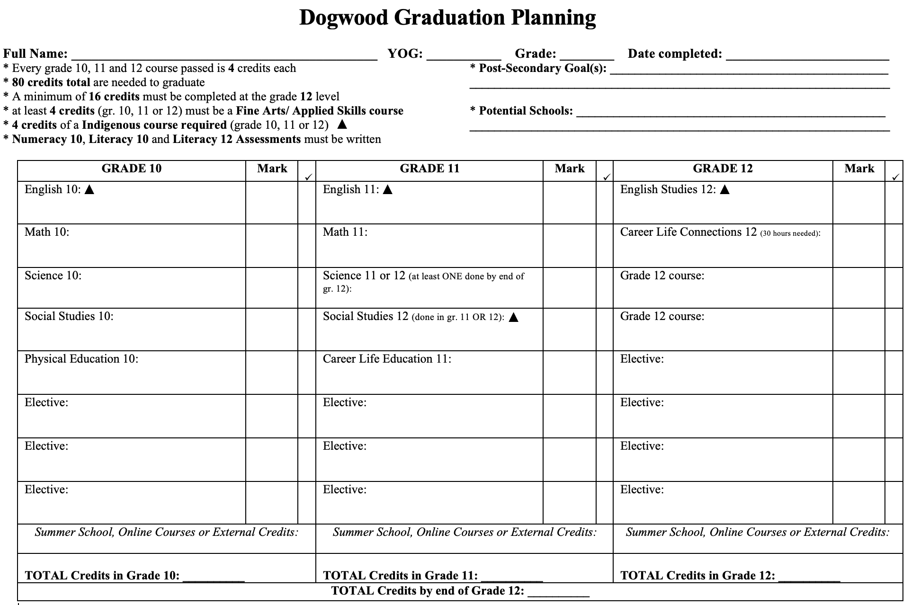 GRADE 10 2026-2027 COURSE REQUESTS Name: ________________________________

All students working toward a B.C. Certificate of Graduation (“Dogwood Diploma”), must successfully complete at least 4 credits in Indigenous-focused coursework offered through select English or Social Studies courses in grades 10-12.

Core Courses:
SCIENCE 10
SOCIAL STUDIES 10 – CANADA AND THE WORLD
PHYSICAL & HEALTH EDUCATION 10

Request ONE Grade 10 English Course:
Literary Studies/Composition 10 English First Peoples Literary Studies/Writing 10

Request ONE Grade 10 MATH Course:
Foundations of Math and Pre-Calculus 10 Workplace Math 10

Request 3 Electives:
LANGUAGES |  | BUSINESS EDUCATION |  | TECHNOLOGY EDUCATION
FRENCH 10 |  | ENTREPRENEURSHIP AND MARKETING 10 |  | DRAFTING 10: 3D PRINTING AND DESIGN
INTRODUCTORY PUNJABI 11 |  | MEDIA DESIGN 10 |  | ROBOTICS AND ELECTRONICS 10
SPANISH 10 |  | WEB DEVELOPMENT 10 |  | METALWORK 10
INTRODUCTORY SPANISH 11 |  | PERFORMING ARTS |  | TRADE SKILLS EXPLORATION 10
HOME ECONOMICS |  | CONCERT BAND 10: INTERMEDIATE |  | WOODWORK 10
FOOD STUDIES 10 |  | JAZZ BAND 10 |  | ENGINEERING & POWER TECHNOLOGY 10
TEXTILES 10 |  | CHOIR 10 |  | LEADERSHIP & PHYSICAL HEALTH EDUCATION
FAMILY AND SOCIETY 10 |  | GUITAR 10: BEGINNER |  | ATHLETIC LEADERSHIP 10
FINE ARTS |  | GUITAR 10: INTERMEDIATE |  | COMMUNITY LEADERSHIP 10
ART STUDIO 10: GENERAL |  | DANCE TECHNIQUE AND PERFORMANCE 10: FOUNDATIONS
3D ART 10: CERAMIC & SCULPTURE - FOUNDATIONS |  | DANCE TECHNIQUE AND PERFORMANCE 10: INTERMEDIATE
3D ART 10: CERAMIC & SCULPTURE - INTERMEDIATE |  | DANCE TECHNIQUE AND PERFORMANCE 10: ADVANCED
PHOTOGRAPHY 10 – FOUNDATIONS |  | DRAMA 10
PHOTOGRAPHY 10 – INTERMEDIATE |  | THEATRE COMPANY 10
MEDIA ARTS 10:YEARBOOK |  | MUSICAL THEATRE 10

Alternates selection, next page
ALTERNATE ELECTIVES
Request 3 Alternate Electives:
LANGUAGES |  | BUSINESS EDUCATION |  | TECHNOLOGY EDUCATION
FRENCH 10 |  | ENTREPRENEURSHIP AND MARKETING 10 |  | DRAFTING 10: 3D PRINTING AND DESIGN
INTRODUCTORY PUNJABI 11 |  | MEDIA DESIGN 10 |  | ROBOTICS AND ELECTRONICS 10
SPANISH 10 |  | WEB DEVELOPMENT 10 |  | METALWORK 10
INTRODUCTORY SPANISH 11 |  | PERFORMING ARTS |  | TRADE SKILLS EXPLORATION 10
HOME ECONOMICS |  | CONCERT BAND 10: INTERMEDIATE |  | WOODWORK 10
FOOD STUDIES 10 |  | JAZZ BAND 10 |  | ENGINEERING & POWER TECHNOLOGY 10
TEXTILES 10 |  | CHOIR 10 |  | LEADERSHIP & PHYSICAL HEALTH EDUCATION
FAMILY AND SOCIETY 10 |  | GUITAR 10: BEGINNER |  | ATHLETIC LEADERSHIP 10
FINE ARTS |  | GUITAR 10: INTERMEDIATE |  | COMMUNITY LEADERSHIP 10
ART STUDIO 10: GENERAL |  | DANCE TECHNIQUE AND PERFORMANCE 10: FOUNDATIONS
3D ART 10: CERAMIC & SCULPTURE - FOUNDATIONS |  | DANCE TECHNIQUE AND PERFORMANCE 10: INTERMEDIATE
3D ART 10: CERAMIC & SCULPTURE - INTERMEDIATE |  | DANCE TECHNIQUE AND PERFORMANCE 10: ADVANCED
PHOTOGRAPHY 10 – FOUNDATIONS |  | DRAMA 10
PHOTOGRAPHY 10 – INTERMEDIATE |  | THEATRE COMPANY 10
MEDIA ARTS 10:YEARBOOK |  | MUSICAL THEATRE 10

*Alternates must be different courses from those three electives requested above.

Core Courses

SOCIAL STUDIES 10 – CANADA AND THE WORLD (MSS 10)
Social Studies 10 concentrates on Canadian history from 1914 to the present. It examines the perspectives of groups of Canadians, including a focus on First Peoples. Topics of geography, economics, basic political theory and current events are covered along with themes of governance, autonomy, Canadian identities, justice for Indigenous peoples of Turtle Island and all Canadians. Through thinking, speaking and writing, students will build skills in identifying and analyzing different perspectives, cause and effect, the reliability of sources and evidence, and critical thinking.

SCIENCE 10 (MSC 10)
Science 10 is a required course and a continuation of the junior science program.
The big ideas to be developed in this course include:
- Genes are the foundation for the diversity of living things (Biology)
- Chemical processes require energy change as atoms are rearranged (Chemistry)
- Energy is conserved and its transformation can affect living things and the environment (Physics)
- The formation of the universe can be explained by the big bang theory (Cosmology)

The big ideas will be taught with an emphasis on developing analytic skills, scientific processes and critical thinking while learning about scientific topics.

PHYSICAL AND HEALTH EDUCATION 10 (MPHED10)
The goal of our physical and health education program is to instill an appreciation for an active, healthy lifestyle.

The program will provide students with the opportunity to fulfill the following objectives:
- to participate and enjoy a variety of performance, fitness, and leisure-oriented activities.
- to develop positive attitudes towards active living
- to acquire the skills and knowledge necessary to develop an active and healthy lifestyle
- to demonstrate appropriate social behaviour, etiquette, fair play and leadership skills related
to physical activity, personal, and social responsibility.

ENGLISH COURSES
During Grade 10 course requests, students are provided a choice.
- They can take Literary Studies & Composition 10 to complete their English 10 credit
OR
- They can take First People’s Literary Studies & Writing 10 to complete their English 10 credit AND their Indigenous Graduation credit.

Those who do not fulfill their Indigenous Graduation Credit through Gr.10 English may do so by taking a variety of other courses in the English or Social Studies Departments in Gr.11 or 12.

BOTH English courses require reading a variety of texts, writing multi-paragraph and essay responses, and communicating verbally with peers and teachers.

LITERARY STUDIES & COMPOSITION 10 (MLTST10)
This course focuses on various themes, authors, and genres through the study of text, stories, and various forms of media, such as poetry, stories, novels, graphic novels, children’s literature, and First Peoples texts. Students create coherent, purposeful compositions while developing and refining their writing abilities.

ENGLISH FIRST PEOPLES LITERARY STUDIES & WRITING 10 (MEFLS10)
This course is designed for students who are interested in exploring First Peoples literature in a variety of contexts, genres, and media. This area of choice provides students with opportunities to explore personal and cultural identities, histories, stories, and connections to land/place. This course is grounded in the understanding of how texts are historically and culturally constructed. Students will work individually and collaboratively to broaden their understanding of themselves and the world.

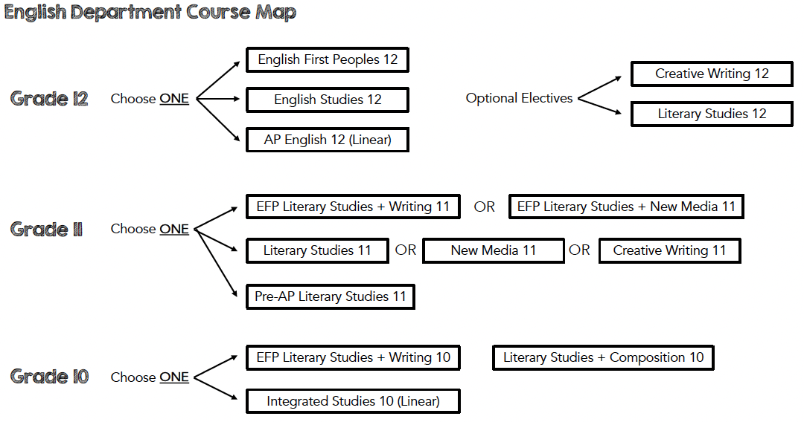

MATH COURSES
During Grade 10 course requests, students are provided a choice.
- They can take Foundations & Pre-Calculus 10
OR
- Workplace Math 10.

Following Math 9, recommendations for each individual student are made by their Gr.9 teacher.

FOUNDATIONS OF MATH AND PRE-CALCULUS 10 (MFMP 10)
This course is designed for students who intend to enroll in Pre-Calculus 11 or Foundations of Mathematics 11 courses. The course will introduce students to the notion of functions, will treat in depth linear functions, and will expose students to more advanced mathematics related to exponents and trigonometry. To be successful in this course, students need a strong background in Algebra and Arithmetic, good mental calculation skills, strong work habits, and good reading skills. Since this course is part of the graduation program, parents’ involvement in their children’s progress through the course is strongly encouraged.

WORKPLACE MATH 10 (MWPM 10)
Workplace Math 10 is designed to provide students with the understanding and skills identified for entry into the majority of trades and for direct entry into the work force. Topics include algebra, geometry, measurement, numbers, and statistics and probability. This course will lead to Workplace Math 11 or Foundations and Pre-Calculus 10.

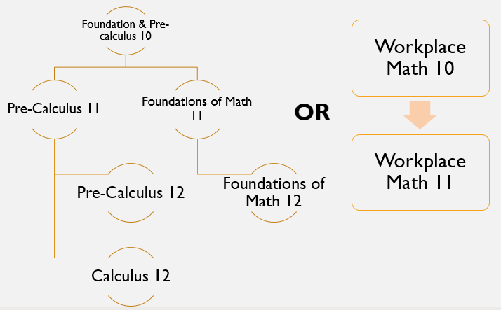

Understanding Electives for Grade 10 students
As the diagram on Page 2 explains, the majority of Grade 10’s are assigned Social Studies 10, Science 10, and Physical and Health Education 9. Students must also either take Literary Studies & Composition 10 or First People’s Literary Studies & Writing 10 as well as either Foundations & Pre-Calculus 10 or Workplace Math 10.

Students are then to request 3 electives (and 3 alternate options) from the following areas:
- Languages
- Home Economics
- Fine Arts
- Business Education
- Performing Arts
- Technology Education
- Leadership & Physical and Health Education

Modern Languages

FRENCH 10 (MFR 10)
Students in French 10 are increasingly able to take risks while engaging in spontaneous interactions using what they have learned in previous years. In this course, students will engage in speaking, listening, reading and writing tasks to develop their ability to:

- communicate and understand simple, sequenced instructions
- demonstrate expression of needs, desires and emotions
- apply language patterns they have previously learned in a variety of real-life situations
- understand the cultural influence of the French language
- understand more complex oral, visual and written Francophone creative works
- take risks with the language to extend language boundaries
- set personal goals in language skills and monitor their progress

INTRODUCTORY PUNJABI 11 (MIPUN11)
This is an introductory level Punjabi course open to senior students who have never taken a Punjabi course before. This beginner’s course will introduce the students to Punjabi alphabets, basic grammar structures, vocabulary, and oral skills. Students will explore Punjabi culture with emphasis on history, festivals, religion, and music.

SPANISH 10 (MSP 10)
Spanish 10 grows on the concepts from Spanish 9 further building skills in the language. Students will be able to speak at a higher level of proficiency while understanding a broader range of topics in depth. Through virtual field trips, we visit places around the world such as Macchu Pichu, the Galapagos Islands, Barcelona and more! Students will also participate in food tastings, art projects, engaging in play-based learning and various cultural events in developing skills and understanding in Spanish.

INTRODUCTORY SPANISH 11 (MBSP 11)
Bienvenidos! This course will cover basic Spanish speaking skills allowing students to have conversations with locals when you travel. You will learn to speak, read, write, and listen in Spanish, while learning about Hispanic culture. This course will allow you to gain basic speaking skills, discuss fiestas and learn about cultural events that happen around the globe.
What you gain:
- basic speaking skills allowing you to speak in both present and past
- Be able to read and write at a beginner level so that when you travel you can understand
tourist information!
- be able to have a basic conversation in over 22 countries around the world
- communicate at the airport, in restaurants, at food and clothing stores
- the ability to say you speak Spanish on your resume

Home Economics

FOOD STUDIES 10 – ADST (MFOOD10)
In this course students will develop practical culinary skills and the ability to create and design their own food products. Students will become familiar with the design process, elements of meal preparation and the relationship between eating practices, and mental and physical well-being. Other topics will include food trends, food contamination, nutrition, marketing, and various factors that impact food choice and availability.

TEXTILES 10 (MTXT 10)
Whether you are new to sewing or have some experience, this class will provide for a more hands-on approach to learning. Projects are selected based on your ability but could include: pajamas, sweatshirts, bags, tops and other accessories. Have fun creating new things and adapting items you already own. In addition to sewing, students will explore issues and careers in the fashion and textile industry.

FAMILY AND SOCIETY 10 (MFAMS10)
This is a sociology course designed for students to unpack the “family” unit. We will explore what defines a family, what is the key role in society and why it is an important facet of human society. This includes studying culture, societal influences, spirituality, and family relationship dynamics. We will explore topics such as healthy/unhealthy communication, interpersonal relationships, the roles and rights of children, living and housing options for individuals and families, and caregiving issues. This is a good introduction to sociology course for any student who wants to pursue post-secondary, learn about human behaviour, go into social work, education or any public service sector.

Fine Arts

ART STUDIO 10: GENERAL (MVAST10)
Visual Arts 10 is an introductory course in the Fine Arts Graduation program. It covers historical and contemporary art, personal imagery development, and traditional media (drawing, painting, printmaking, ceramics, and sculpture). Students learn design principles and elements, create and communicate through imagery, and reflect on personal, social, cultural, and historical contexts. No prerequisite is required, but a prior art course is recommended. This course builds a foundation for future visual arts courses and enhances learning in other subjects through critical and creative thinking, problem-solving, and self-reflection.

STUDIO ARTS 3D 10 - CERAMICS & SCULPTURE: FOUNDATIONS (MVAC10)
New to ceramics? Start here! This introductory course focuses on the essential skills and knowledge you need to begin your ceramic journey. You’ll learn:
- Hand-building techniques such as pinch, coil, and slab construction
- Basic glazing and surface decoration methods
- How to work safely and effectively in a ceramic's studio
- The fundamentals of clay properties and firing processes
By the end of Level 1, you will create a series of functional and decorative pieces that demonstrate your understanding of form, texture, and color.

STUDIO ARTS 3D 10 - CERAMICS & SCULPTURE: INTERMEDIATE (MVAC10)
Already know the basics? Time to level up! This course builds on foundational skills and introduces more advanced techniques, including:
- Wheel throwing for creating symmetrical forms
- Surface design experimentation using slips, underglazes, and carving
- Combining hand-building and wheel-thrown elements for complex projects
- Exploring personal style through themed assignments
Students will complete projects that reflect creativity and technical growth, such as sets of functional ware or sculptural pieces with unique surface treatments.

PHOTOGRAPHY 10: FOUNDATIONS (MVAPH10)
Photography 10 – Foundations introduces students to the core technical and creative skills including control of exposure, focus, and depth of field, and the use of digital tools to edit and enhance images for a specific audience. Emphasis is placed on expressive image-making and creating photographic work that responds to personal, cultural, social, and environmental issues.

PHOTOGRAPHY 10: INTERMEDIATE (MVAPH10)
Photography 10 - Intermediate extends the competencies of Introductory/Foundations Photography by deepening students’ technical control, visual literacy, and personal voice in image making. Learners refine camera, lighting, and editing skills, develop cohesive series or projects, and critically analyze how photographic practice connects to identity, place, and contemporary issues.

MEDIA ARTS 10: YEARBOOK 10 (MVAM-10)
The Yearbook class is a unique course that focuses on producing the annual publication that celebrates each school year’s story. It is an advanced class, requiring students to apply for entrance, with the expectation that applicants have existing photography and graphic design skills. Successful applicants will have the opportunity to further their knowledge and experience in digital photography, graphic design, composition and layout, journalism, and marketing. This is a year-long course that meets on alternating days during the 5th period. However, as many important school events take place outside of regular school hours, students should expect to have occasional photo assignments requiring them to stay late or visit nearby athletic sites.
Application required: Please see Mr. Nilson for an application form.

Business Education

ENTREPRENEURSHIP AND MARKETING 10 (MADEM10)
Entrepreneurship and Marketing 10 is an immersive course that introduces students to the exciting intersection of business innovation and strategic marketing. Designed for aspiring entrepreneurs and marketing enthusiasts, this course covers fundamental concepts such as opportunity recognition, business planning, and marketing strategies. Students will gain practical skills in digital marketing, market analysis, and effective communication. By the end of the course, participants will be well-equipped to navigate the dynamic landscape of entrepreneurship and marketing, whether launching their own venture or contributing to existing businesses.

MEDIA DESIGN 10 (MMEDD10)
Level up your media creation skills as you explore graphic design, video production and animation in Media Arts 10. As a part of the class you will explore Adobe Photoshop, Premiere and Animate as you plan, design and refine a variety of awesome media types. No experience is required, but students who have already completed Digital Media 9 will have the opportunity for more complex design challenges.

WEB DEVELOPMENT 10 (MMEDD10)
Learn to build websites from the ground up! Master HTML, CSS, and JavaScript to create interactive and dynamic web pages. Skills developed in this course are of great importance in today’s increasingly digital/web-based world!

Performing Arts

CONCERT BAND 10: INTERMEDIATE (MMUCB10)
Recommended: Successful completion of previous concert band classes or director’s permission. This course is designed for students who have reached an interim level of proficiency on a band instrument. Students will experience a significant increase in complexity and excitement of repertoire over previous band levels. Students will have the opportunity to perform in festivals and concerts. In addition, students may be performing as a pit band.

JAZZ BAND 10 (MMUJB 10)
This course explores jazz and big band genres in more depth. Students will develop their instrumental and theoretical skills through the lens of standard jazz bands, including swing, funk, Latin, and rock. Soloing and improvisation will be expected. Standard jazz band instrumentation is as follows: alto, tenor, baritone saxophone, trumpet, trombone, guitar, bass guitar, piano or drums. However, all instruments are welcome! Because the jazz band learns and performs more challenging music, jazz students must be registered in concert band or have teacher permission. Jazz students will have the opportunity to play in concerts and festivals and participation in music department events is expected.

CHOIR 10 (MMUCC10)
A fun way to learn more than just vocal technique. This performing group will explore a wide variety of musical styles and repertoire, and will focus on developing sight singing and ear training skills. Discover ways to extend your vocal range, create breath energy, formulate and place vowels correctly, and perform with confidence in a choral setting. No previous singing experience is required. Participation in music department activities is expected.

GUITAR 10: BEGINNER (MMUGT10 BEG)
This is an introductory course. No previous guitar or music experience is necessary! Students in this course will learn basic chords and strumming patterns which will enable them to play several styles of music including popular, rock and blues music. Students will also learn the basics of finger-picking and basic guitar technique, while learning to read music and tab.

GUITAR 10: INTERMEDIATE (MMUGT 10 INT)
Intermediate guitar is designed for students who have guitar experience, and want to learn more challenging styles and techniques. In advanced guitar students will explore a variety of topics such as blues, classical guitar, scales, and advanced chording. Students are encouraged to pursue individual projects in this course.

DANCE TECHNIQUE AND PERFORMANCE 10: FOUNDATIONS (MDNTP 10)
This course is for students who have always wanted to learn to dance but may not yet had the opportunity or who have up to three years of recent experience in any genre or those who dance at the recreational level. Students will learn the basics of multiple genres including Jazz, Hip Hop and Contemporary in a fun and supportive atmosphere. This class is perfect for people of all fitness levels to learn new skills in flexibility, strength, and coordination through the learning of choreography. Students will advance at individual levels and be encouraged to challenge themselves through establishing individual dance goals. Students will have multiple performance opportunities.

DANCE TECHNIQUE AND PERFORMANCE 10: INTERMEDIATE (MDNTP 10 INT)
This course is for students with four or more years of recent dance experience, either in school or at a studio. Students will have opportunities to study many genres including Hip Hop, Contemporary and Jazz. Students will increase their dance technique and vocabularies through the regular viewing and critiquing of live and recorded performances and through the creation of choreography for stage. There will be multiple workshop and performance opportunities. Students must be recommended or receive permission to enroll in this course. Students who have not previously taken a dance course at Sullivan should speak with Ms. Law directly prior to requesting this course.

DANCE TECHNIQUE AND PERFORMANCE 10: ADVANCED (MDNTP10 ADV)
This course is designed to challenge the advanced dancer and facilitate explorations of the world of dance and performance. This course is appropriate for those with five or more years of competitive and/or examinable dance experience in one or more of the following genres: Ballet, Jazz, Lyrical, Contemporary or Hip Hop, either at school or at a studio and who have been recommended to the course. In this performance-based class, students will work to view, critique, and create performances in multiple genres, improve technique and create choreography for stage. There will be multiple workshop and performance opportunities as well as opportunities for students to work within their chosen genre of dance. Students must be recommended or receive permission to enroll in this course. Students who have not previously taken a dance course at Sullivan should speak with Ms. Law directly prior to requesting this course.

DRAMA 10 (MDRM 10)
Drama 10 is a multi-level course, that continues to develop the teamwork, confidence building, and creativity that students have gained in previous Drama classes and for those new to Drama. The course takes a more in depth look at the process of developing character, story, mood, and the ability to thoughtfully write about and reflect on a variety of performances. It will involve theatre units of study such as improvisation, mime, comedic character development, vocal exploration, creative movement exploration, monologue development, and one act plays, all which will vary from year to year. Students will experience growth through assignments and feedback aligned with past experience, or build foundations for those new to Drama, enabling students to increase their skill level year on year. While there is little written homework, students are required to memorize lines and rehearse their assigned scenes outside of class time. Active participation and enthusiastic contributions to the class will help you find success in this course.

THEATRE COMPANY 10 (MDRTC 10)
Theatre Company is a course that prepares students for school wide and community performances during the semester and a full class play in January. Students will develop character, story, mood and the ability to thoughtfully write about and reflect on a variety of performances with the intention of applying these concepts to community performance. In addition to this, students will contribute to the development of Theatre Company, though stagecraft, rehearsal, and performance. A positive attitude and strong commitment are essential for success in the course.

MUSICAL THEATRE 10 (MMUTH10)
Musical Theatre 10 is a course that prepares students for a school wide and community Musical Theatre performance in May. Students will develop their acting, music, and dance skills in an effort to build character, story, mood and the ability to thoughtfully write about and reflect on performances. In addition to this, students will contribute to the development of the Musical Theatre Company through stagecraft, rehearsal, and performance. Past performance experience is useful, but not a prerequisite. A positive attitude and strong commitment are essential for success in the course. This course will be run as a year long course every other day in block E. This course can be selected as a 9th course.

Technology Education

DRAFTING 10: 3D PRINTING AND DESIGN (MTDRF10 3D)
Are you interested in design? Join the class to try out designing and printing your projects on a 3D printer! You will learn a variety of different software to create, animate, and fabricate anything that you can think of. Try out a Laser Printer and a CNC milling machine!

ROBOTICS AND ELECTRONICS 10 (MTEAR10 ROB)
ROBOTS! Need more be said? You will be introduced to the world of robotics along with 3D modeling software. Come build your own robot, compete in challenges, and learn all at the same time.

METALWORK 10 – ADST (MTMET10)
Design and fabricate amazing metal creations! In Metalwork 10, you'll use a wide range of tools and techniques to bring your ideas to life. From welding and cutting to grinding and joining, you'll gain the skills to build almost anything.

TRADE SKILLS EXPLORATION 10 (MSTX-0A TS)
Planning to move out of your parents’ house? You should probably learn how to fix a few things! Try out different trades including Carpentry, Plumbing, and Electrical. After this course, you could pursue a career in Trades or Engineering; or just give you the confidence on how to fix a few things around your future home.

WOODWORK 10 – ADST (MWWK10)
Build your dream projects in Woodwork 10! This hands-on course teaches advanced woodworking skills, from design and joinery to finishing techniques. Discover the craftsmanship that can lead to rewarding careers in cabinetry and design.

ENGINEERING & POWER TECHNOLOGY 10 – ADST (YENG10)
This is a project-based hands-on course. Explore Aerospace, Mechanical, Civil and Electrical Engineering. Projects are first designed in using CAD (Computer-Aided Design), then prototypes are built and tested. Some projects will involve the use of 3D printing.

Leadership & Physical and Health Education

ATHLETIC LEADERSHIP 10 (YIPS 0B ATHL)
Athletic leadership provides an opportunity for students to make a true connection with the school community and athletic culture through various athletic volunteering opportunities. It’s a linear course backed with PE 10. Students will learn how to score keep and run scoring tables for both volleyball and basketball. They will organize and run intramurals for the entire school at lunch. They will have an opportunity to plan a school wide pep rally and year end athletic banquet. Various field trips are included that work on leadership skills and team building. This course has been developed to support and improve leadership skills in students. With a component of personal and social responsibility, students can safely discover organizational structures and concepts of recreational leadership extending themselves to others within school and community programs. Students will be able to explore their levels of understanding specific skill sets including team building, goal setting, problem solving, leadership styles, management strategies, event selection and planning, reflective and evaluative tools. Athletic Leadership allows students to leave a lasting impression on both the school and athletics. What will you and your classmate's legacy be?

COMMUNITY LEADERSHIP 10 (YIPS 0B COM)
By registering in this course, you will identify yourself as an active citizen - someone wanting to take a proactive role in developing our school’s culture and fostering healthy local and global communities. Success in the course depends heavily on your commitment to personal and social responsibility. Leaders at Sullivan Heights are role models respected for their independence, motivation, organization and charity. Volunteering is a requirement. We are team players who are visible by all members of the community. Some of the initiative in which you may participate include: The Terry Fox Run, Grade 8 retreat, The Remembrance Day Assembly, RELeaf Program, Parks Lend-a-Hand, Surrey Food Bank, Surrey Christmas Bureau Adopt-a-Family, Clebr8, The Sullivan Star-Quality program, SD36 ELL Reading Buddy program, Pink Shirt Day, International Surrey Children’s Festival, Elementary School Leadership and many more depending on the class culture and dynamic. All members will become registered City of Surrey volunteers, and get certified in Emergency First Aid and CPR-C through St. John Ambulance.

ELL PROGRAMS

Students are assessed upon entrance into the District and the School and are assigned one or two ELL Support blocks dependent on their individual needs.

ELL Beginner
English Language Learners (ELLs) Beginner/Reception courses are offered for new students who have been assessed at the Beginner level. It is recommended that students enrol in two or three ELL courses initially to build their Basic Interpersonal Communication Skills (BICS). The ELL Beginner/Reception course will help students to develop and practice basic reading and writing skills in a variety of content areas, as well as school, community, and Canadian Culture.

ELL Developing
This course is the second level of English Language Learners (ELLs) courses. Students will continue to build their oral, reading, and writing skills. Integration into non-academic courses is supported. Content areas cover general knowledge in academic areas, as well as school, community, and Canadian culture to build on foundational concepts needed for other content areas.

ELL Expanding
English Language Learners (ELLs) Expanding courses prepare students with language skills to consider elective courses with some language demands but not entirely print-based. These students augment their English acquisition through a variety of strategies to enhance their cognitive, oral, writing, and reading skills. ELL Expanding students are ready for the beginning stages of explicitly developing academic English (Cognitive Academic Language Proficiency, or CALPS). Furthermore, the course will continue to cover general knowledge, but will focus mainly on English Language Arts specific content. Most students will have at least one ELL Expanding course per year; sometimes one per semester to best support the student’s need.

Academic Language for ELL 10, 11 & 12 (4 credits)
Through Academic Language ELL10, students will develop their academic English within a sheltered environment which meets the specific cultural adjustment needs of English Language Learners (ELLs). This course continues to expand upon the skills acquired in Introduction to Academic Language ELL10, which are needed to be successful in writing, speaking, listening, and reading competencies through a variety of text genres, registers, structures, forms, and styles. To build their competencies, students will experience language (listen, read, and study texts) from a variety of genres by studying the forms, styles and models required to create original work, while also building their awareness of the socially constructed nature of language. This course includes elements of Canadian culture (cultural identity and First Peoples culture). Academic language ELL10 is designed for ELLs at Developing level and Expanding Level on the current 5 level Standards/Surrey District Continuum.

