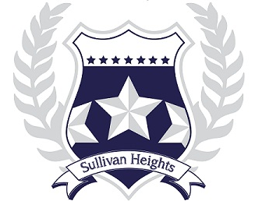

Sullivan Heights is a caring, inclusive community where everyone is a lifelong learner.

Entering Grade 11-12

COURSE REQUEST HANDBOOK

2026 – 2027

TABLE OF CONTENTS

Graduation Requirements 2
Grade 11 Course Request Sheet 3
Grade 12 Course Request Sheet 4
Grade 11/12 Course Offerings Sheet 5
Course Descriptions 6
- English Course Map 6
- Gr. 11 English 6
- Gr. 12 English 7
- English Electives 7
- Mathematics Course Map 8
- Gr.11 Math 8
- Gr. 12 Math 9
- Gr. 11 Science 10
- Gr. 12 Science 11
- Senior Social Studies 12
- Gr. 11 Modern Languages 13
- Gr. 12 Modern Languages 14
- Senior Physical Education & Leadership 14
- Business Education 15
- Business Co-Op Program 16
- Fine Arts 17
- Home Economics 18
- Information Technology 19
- Performing Arts - Music 20
- Performing Arts - Dance 21
- Performing Arts Drama 21
- Technology Education 22
- Work Experience 22
- Career Education 23
- District Programs 23
- Peer Tutoring 27
- Study 27
English Language Learners Programs 27

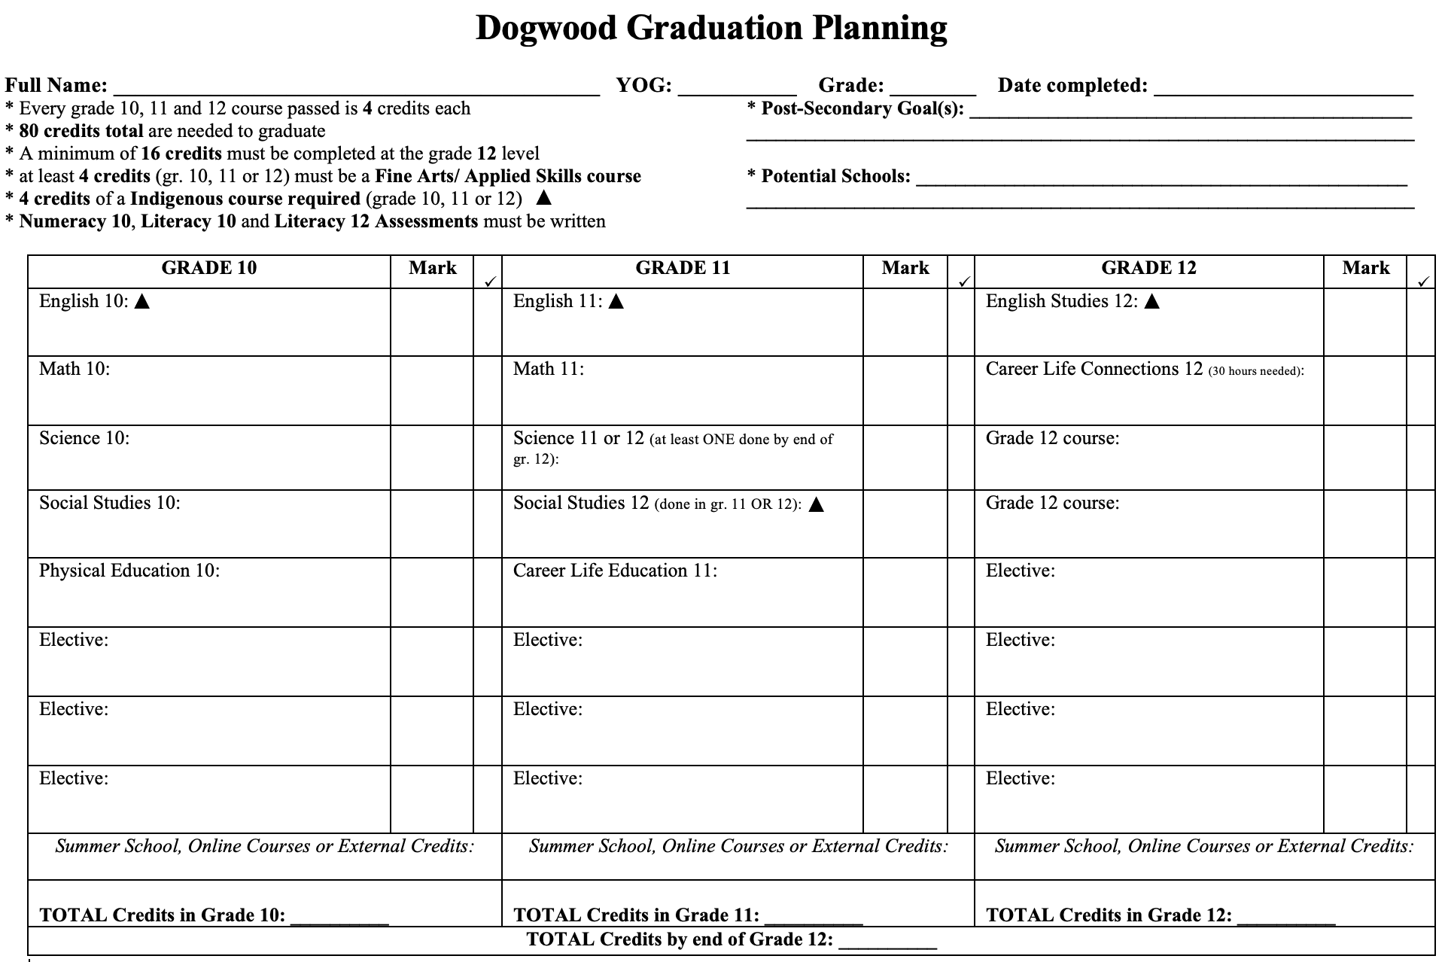
GRADE 11 2026-2027 COURSE REQUESTS Name: ___________________

All students working toward a B.C. Certificate of Graduation (“Dogwood Diploma”), must successfully complete at least 4 credits in Indigenous-focused coursework offered through select English or Social Studies courses in grades 10-12.

Request ONE English course:  - CREATIVE WRITING 11  - LITERARY STUDIES 11  - EFP LITERARY STUDIES/WRITING 11 *  - NEW MEDIA 11  - EFP LITERARY STUDIES/NEW MEDIA 11 *  - PRE-AP LITERARY STUDIES 11  Request CLE 11 (Mandatory for graduation):  - CAREER LIFE EDUCATION 11  Request ONE Science course:  - LIFE SCIENCES 11  - CHEMISTRY 11  - PHYSICS 11  - EARTH SCIENCE 11  - ENVIRONMENTAL SCIENCE 11  - SCIENCE FOR CITIZENS 11 | Request ONE Math course:  - PRE-CALCULUS 11  - FOUNDATIONS OF MATHEMATICS 11  - WORKPLACE MATH 11  Request ONE Social Studies course:  - 20TH CENTURY WORLD HISTORY 12  - COMPARATIVE CULTURES 12  - HUMAN GEOGRAPHY 12  - PHYSICAL GEOGRAPHY 12  - LAW STUDIES 12  - GENOCIDE STUDIES 12  - POLITICAL STUDIES 12  - URBAN STUDIES 12  - SOCIAL JUSTICE 12  - PHILOSOPHY 12  - CONTEMPORARY INDIGENOUS STUDIES 12 *  - BC FIRST PEOPLES 12 *  * Fulfills the Indigenous Grad Requirement

Request 3 Elective Courses:
Request 3 Alternates (alternates must be different from the three electives requested above):

GRADE 12 2026-2027 COURSE REQUESTS Name: ___________________

All students working toward a B.C. Certificate of Graduation (“Dogwood Diploma”), must successfully complete at least 4 credits in Indigenous-focused coursework offered through select English or Social Studies courses in grades 10-12.

Students must take Career Life Connections 12 to Graduate. If you did not take Career Life Education in Grade 11, you must select it for Grade 12.

Request an English 12 If you have not completed CLC 12 request it here
ENGLISH STUDIES 12 CAREER LIFE CONNECTIONS 12
EFP ENGLISH STUDIES 12

Request 7 Elective Courses Request 6 Elective Courses
*Alternates must be different courses from those three electives requested above.

Request 3 Alternate Courses:
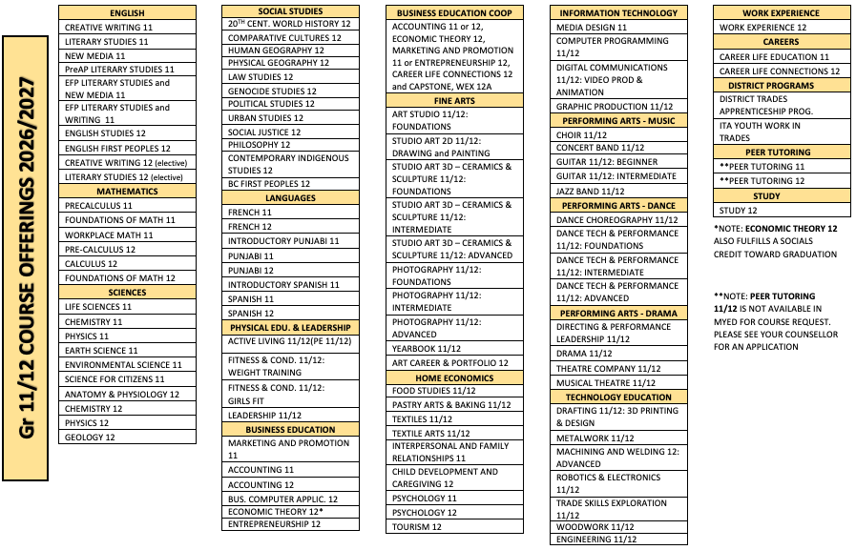
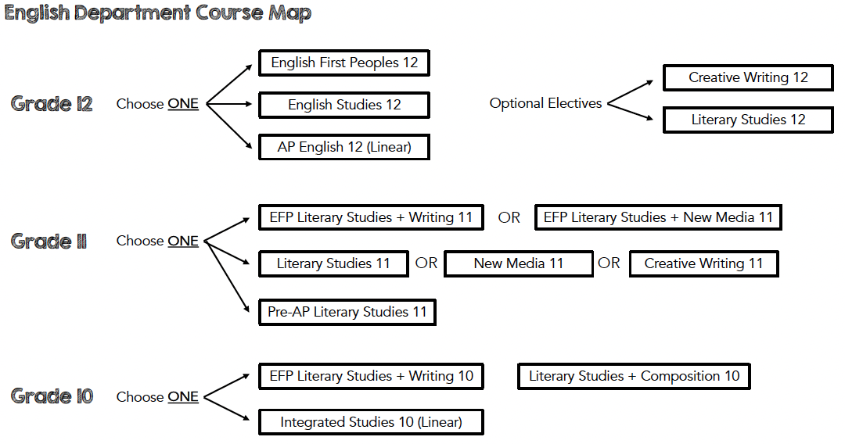

Grade 11 English

ALL English courses require reading a variety of texts, writing multi-paragraph and essay responses, and communicating verbally with peers and teachers.
CREATIVE WRITING FOCUS
CREATIVE WRITING 11 (MCTRW11)
The course provides students with in-depth opportunities to become better writers through the exploration of personal and cultural identities, memories, and stories in a wide range of genres. Within a supportive community, students will collaborate and develop their skills through writing and design processes. Creative Writing 11 is grounded in the exploration and application of writing processes, inviting students to express themselves creatively as they experiment with, reflect on, extend, and refine their writing.

LITERATURE FOCUS
LITERARY STUDIES 11 (MLTST11)
This course allows students to delve more deeply into literature. Students can explore specific themes, periods, authors, or areas of the world through literary works (fiction and non-fiction) in a variety of media.
Students will:
- increase their literacy skills through close reading of appropriately challenging texts.
- expand their development as educated global citizens.
- broaden their understanding of themselves and the world.

NEW MEDIA FOCUS
NEW MEDIA 11 (MNMD11)
Coursework is aimed at providing students with a set of skills vital for success in an increasingly complex digital world by affording numerous opportunities to demonstrate understanding and communicate increasingly sophisticated ideas through a wide variety of digital and print media.

The following are possible focus areas in New Media 11:
- media and film studies
- journalism and publishing
- poetry, song lyrics
- digital communication

PRE-AP LITERARY STUDIES 11 (MLST11 PRE AP)
This course is intended for students who wish to pursue AP English studies in their grade 12 year and is designed to begin preparing students for academic studies at the College/University level. Students will examine a variety of texts, while developing an appreciation for the role that literature plays in understanding our communities and ourselves. Through analysis of language features, conventions, and strategies, students will develop their writing skills. There will be an emphasis placed on the academic essay.
Students will:
- Begin to analyze University/College level literature
- Increase their literacy skills through close reading of appropriately challenging texts
- Further develop higher-level thinking

INDIGENOUS NEW MEDIA FOCUS
ENGLISH FIRST PEOPLES NEW MEDIA 11/ LITERARY STUDIES/ (MELNM11)
EFP Literary Studies + New Media 11 is designed for students who are interested in studying First Peoples literature and examining the evolving role of technology in today’s society, especially the increasing importance of digital media in communicating and exchanging ideas and engaging in social advocacy. Students delve deeply into First Peoples oral and written literature in a range of media to explore various themes, authors, and topics. This provides a foundation for students to think critically and creatively as they continue to explore, extend, and strengthen their own writing and communication. Students examine the increasingly complex digital world and have opportunities to demonstrate understanding and communicate sophisticated ideas through a wide variety of digital and print media.

INDIGENOUS LITERATURE FOCUS
ENGLISH FIRST PEOPLES LITERARY STUDIES & WRITING 11 (MELFS11)
EFP Literary Studies + Writing 11 is designed for students who are interested in studying First Peoples literature and using writing for self-expression and communication in a variety of contexts. Students delve deeply into First Peoples oral and written literature in a range of media to explore various themes, authors, and topics. This provides a foundation for them to think critically and creatively as they continue to explore, extend, and strengthen their own writing. Within a supportive community, students work individually and collaboratively to explore oral and written literature and create powerful, purposeful compositions.

Grade 12 English

ALL English courses require reading a variety of texts, writing multi-paragraph and essay responses, and communicating verbally with peers and teachers.
ENGLISH STUDIES 12 (MENST12)
Similar to English First Peoples 12, this course continues to develop and enhance students’ appreciation of literature and language. It includes the core skills from Composition, Creative Writing, Focused Literary Studies, New Media, and Spoken Language. Students must write the provincial English assessment.
Skills include:
- reading strategies, comprehension, and analysis
- composing narrative, expository, descriptive, persuasive, and opinion texts
- oral language

ENGLISH FIRST PEOPLES 12 (MENFP12)
Similar to English 12, this course continues to develop and enhance students’ appreciation of literature and language. It includes the core skills from Composition, Creative Writing, Focused Literary Studies, New Media, and Spoken Language. In EFP, students specifically focus on the texts, oral traditions, and protocols of First Peoples. Students must write the provincial English assessment.
Skills include:
- reading strategies, comprehension, and analysis
- composing narrative, expository, descriptive, persuasive, and opinion texts
- oral language

English Electives
Note: These do NOT count as credit for the English Language 12 requisite for graduation.

CREATIVE WRITING 12 (MCTWR12)
This course is designed for students who are seriously interested in creating a sophisticated writing portfolio reflective of depth of skill. Within a supportive writing community students will collaborate, and develop and refine their writing skills and style through various stages of the writing process. They will explore personal and cultural identities, memories, stories in a wide variety of genres. And they will be given the opportunity to specialize and publish in a real-world context. Students will be expected to write daily and actively participate.
LITERARY STUDIES 12 (MENST12-LIT)
This course will explore specific themes, time periods, authors and/or areas of the world through literature and a variety of media texts. Literature such as world, feminist, Canadian or First People’s may be explored through poetry, short stories, novels, drama, graphic novels and children’s
literature. Possible areas of focus in Literary Studies include genre-specific studies, Canadian literature, Shakespeare, Mythology, First Peoples texts, thematic studies, and specific
author studies.

Math Department Course Map

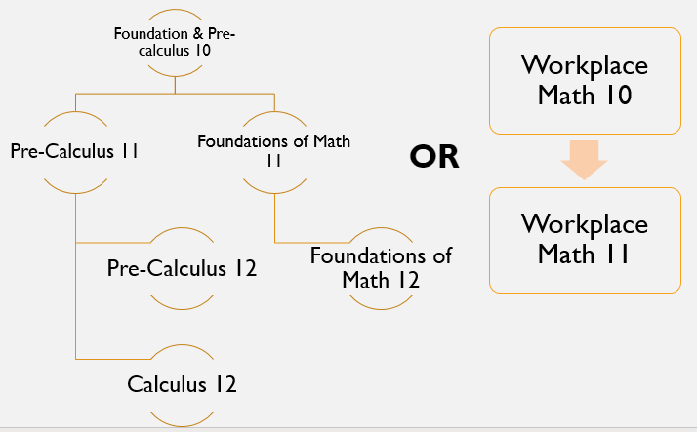

Grade 11 Math Courses

PRE-CALCULUS 11 (MPREC 11)
This course is for students who intend to attend post-secondary education institutions in fields such as Engineering, Sciences, Computer Sciences, and others, where the study of Calculus is a requisite. During the course, students will experience intense problem-solving processes as well as extensive algebraic manipulation of mathematical expressions. To be successful in this course, students need a strong background in Algebra and Trigonometry, good reading skills, as well as the will to spend 45 minutes to an hour a day on individual study at home.

FOUNDATIONS OF MATHEMATICS 11 (MFOM 11)
Foundations of Math 11 is intended for students who wish to pursue post-secondary study in fields which may require some mathematics, but do not require knowledge of Calculus. There is emphasis on logical reasoning and use of problem-solving strategies throughout the course. In order to be successful, students should allocate an average of 30 to 45 minutes of individual work a day.

WORKPLACE MATH 11 (MAWM 11)
Workplace Math 11 is a continuation of Workplace Math 10. It is designed to provide students with the mathematical understandings and critical-thinking skills identified for entry into many post-secondary trades programs, and for direct entry into the work force.

Grade 12 Math Courses

PRE-CALCULUS 12 (MPREC12)
Note: Pre-Caluclus 12 is a prerequisite for Calculus 12.
This course is for students who intend to attend post-secondary education institutions in fields such as Engineering, Sciences, Computer Sciences, and others, where the study of Calculus is a requisite. The course is an in-depth study of functions and of some particular classes of functions such as Trigonometric functions or Exponential and Logarithmic functions.

During the course, students will experience intense problem solving processes as well as extensive algebraic manipulation of mathematical expressions. Students will also need to be able to use technology for solving problems.

To be successful in this course, students need a strong background in Algebra and Trigonometry, good reading skills, as well as the will to spend at least an hour a day on individual study at home.

CALCULUS 12 (MCALC12)
This course is for students who intend to attend post-secondary education institutions in fields such as Engineering, Sciences and Computer Sciences. The course is an introductory course in Calculus and covers mostly Differential Calculus with a short reference to Antidifferentiation/Integration. It is meant to be taken after Pre-Calculus 12.
During the course, students will experience working with the tools of Differential Calculus. They will also learn about views on the historical developments of mathematics.
To be successful in this course, students need a strong background in Algebra, Trigonometry and Geometry, as well as the will to spend at least an hour a day on individual study at home.

FOUNDATIONS OF MATHEMATICS 12 (MFOM 12)
Foundations of Mathematics 12 is a continuation of Foundations of Mathematics 11 course.
As such, the course for students who plan to enter post-secondary education in a field of study which may require some mathematical thinking, but which does not require knowledge of Calculus. Emphasis continues to be on logical thinking and problem-solving skills through analysis of puzzles and strategy games.

Science 11 Courses
Life Sciences 11  This course explores Earth's incredible biodiversity and examines how living organisms are connected through evolution and shared biological processes. Students investigate life at the molecular and cellular levels, study representative groups of organisms, and develop strong laboratory, analytical, and application skills through hands-on inquiry. A solid understanding of scientific vocabulary, observational skills, and problem-solving is essential for success. Dissections are an integral part of the course with a strong emphasis on microscope work.  It is strongly recommended that students take Life Science 11 before Anatomy & Physiology 12, as this course provides the foundational knowledge and skills needed for advanced study in the life sciences. | Chemistry 11  Chemistry 11 is an introductory high-school chemistry course that explores the structure of matter, chemical reactions, and the quantitative relationships that govern them.  Students utilize math skills in dimensional analysis, significant figures, mole calculations, stoichiometry, solution concentrations, and gas laws. Emphasis is placed on applying algebra, ratios, and problem-solving techniques to interpret data, perform calculations, and understand the mathematical foundations of chemical principles.  Strong math skills are recommended for success in this Chemistry 11 course. Foundations and Pre-Calculus 10 is strongly recommended.  Chemistry 11 is strongly recommended if you plan to take Anatomy & Physiology 12.
Physics 11  Physics 11 introduces students to the fundamental principles that explain how the physical world works, with a strong emphasis on analytical thinking and mathematical problem-solving. Students explore core topics such as motion and forces, energy and momentum, waves and sound, electricity, and basic optics. Through hands-on experiments and quantitative investigations, students learn to apply algebra and graphical analysis to real-world physical situations.  Strong math skills are essential for success in this Physics 11 course. Foundations and Pre-Calculus 10 is strongly recommended. | Earth Science 11  An exploration of rocks, minerals, resources, and processes that shape the Earth. Exploring relationships and cycles from Oceans, Atmospheres, Plate Tectonics, and space science.  This course involves strong math skills to analyze and organize data into graphs and charts. General science knowledge and skills will also be beneficial. Making detailed observations, conducting hands-on labs, and supporting explanations and responses are necessary skills. Daily practice and review are essential to success. There is a large vocabulary component to this course as much of the terminology is unique to Earth Science.
Environmental Science 11  Our Earth - The physical and biological processes that shape our world.  Ecology - The ways in which living things interact with the environment and each other.  Human Impact - How human behaviour has an outsized influence on the planet.  This course has a significant hands-on component. Students learn to collect samples from the local environment and process them in the lab. Weekly discussions guide the development of environmental philosophy. Personal philosophies will be put in action in student’s CAP (Community Action Plan)  Strong scientific communication skills are advised. The CAP project will be a long-term project with a large time investment. | Science for Citizens 11  Explore a variety of topics and skills of science in this hands-on, project-based course. Investigations dealing with inventions and discoveries and how science and technology affect individuals and global society.  This course offers an opportunity for students to develop their foundational Science skills. While this course fulfills the graduation requirement for Science 11, it is not intended for students who plan to pursue post-secondary studies in science related fields. Students should confirm that this course meets their post-secondary program requirements.
Science 12 Courses
**These are challenging courses meant for students interested in pursuing science studies in post-secondary**
IF you are intending to take Chemistry 12, Physics 12, or Anatomy & Physiology 12, it is STRONGLY recommended to have taken the science 11 prior to the science 12
Chemistry 12  Chemistry 12 builds on the foundations of Chemistry 11, offering a deeper exploration of chemical systems and the principles that govern their behavior. Students investigate advanced topics such as reaction kinetics, dynamic equilibrium, solubility equilibrium, acids and bases, oxidation–reduction reactions, and electrochemistry. Emphasis is placed on quantitative problem-solving, laboratory analysis, and the application of chemical theory to real-world processes.  This course is designed for students pursuing science-related post-secondary pathways and requires strong math skills and a solid understanding of foundational chemistry concepts.  This course incorporates many concepts and skills from Chemistry 11 as well as math concepts from Pre-calculus 11. | Anatomy & Physiology 12  This course explores the human body from the cellular level to organ systems, focusing on gene expression, metabolism, and the interrelationships that maintain homeostasis. It covers biological molecules and major body systems, integrating chemistry concepts to deepen understanding of body functions.  Anatomy and Physiology 12 builds upon skills and concepts of Life Science 11, critically analyzing life functions in greater detail.  Students are expected to have a strong work ethic and advanced lab skills, including dissections, with the ability to manage extensive scientific vocabulary and self-investigate topics. Proficiency in microscope techniques and analytical thinking is essential, and students are challenged to apply their knowledge to real-world examples.  Success in this course strongly depends on solid foundations from Life Science 11 and Chemistry 11, as many concepts and lab skills directly carry over to support learning in Anatomy and Physiology 12.
Physics 12  Physics 12 builds on the concepts learned in Physics 11 and provides a more advanced study of the principles governing the physical universe. Students explore topics such as vector kinematics, dynamics, circular motion, universal gravitation, momentum, energy, electricity, magnetism, and electromagnetic induction. Emphasis is placed on mathematical modeling, multi-step problem-solving, and applying physical theories to analyze complex systems. Hands-on labs and inquiry activities deepen understanding of how scientific principles operate in real-world contexts.  Strong math skills in Pre-Calculus 11 and a solid foundation in Physics 11 are essential for success in this course. | Geology 12  An exploration of rocks, minerals, resources, and processes that shape the Earth. Explore the relationships between Earth’s materials and resources, Plate Tectonics, and surface processes that shape the planet. This course utilize concept from Chemistry and Physics as well as Math to analyze and organize data into graphs and charts. Detailed observations through hands-on lab and ability to recognize patterns in data and communicate understanding essential.  Although Earth Science 11 is not needed prior to this course, it is recommended to have taken at least one other science 11. This course does involve a lot of data analysis, graphing and math skills found in Pre-Calculus 10. Having a solid science and math foundation is beneficial for those considering Geology 12.
Senior Social Studies Courses
***All courses are at a Gr.12 level but can be taken in Gr.11 or 12 and fulfill the
Sr. Social Studies Graduation Requirement***

20th CENTURY HISTORY  Go more in depth with the major events of the 20th Century (1901-2000), learning about the complex forces that shaped the world throughout the century. The First and Second World Wars and the Cold War are featured.  *** This course is challenging! *** | COMPARATIVE CULTURES  Explore how culture is created, and experience the different cultures of the world in all of their diversity! You will experience over 30 different world cultures in this course.
HUMAN GEOGRAPHY  Why do people live where they do, how do they affect the environment around them, and why does it all matter? These are some of the big questions you’ll explore in Human Geo! | PHYSICAL GEOGRAPHY  What forces created the world we see around us? Whether it’s landforms, water resources or climate, there are vast, complex and powerful forces that shape our world. In Physical Geo, you get to explore them.
LAW STUDIES  Ever wondered how the legal system really works? In Law Studies, you can explore what your rights are as a citizen, how the criminal process works, and pull back the curtain on the system that has inspired countless hit TV shows. | GENOCIDE STUDIES  One of the more unfortunate themes in human history is the systematic destruction of certain cultures. Take a look at the psychology behind these actions, how the perpetrators are able to pull them off, and how the victims resist and protect their culture in Genocide Studies.
POLITICAL STUDIES  Explore various worldwide political trends and issues, and look at how various systems of government work throughout the world. Look at the different viewpoints on major issues, and examine the logic behind them in Political Studies. | URBAN STUDIES  Explore the visible and invisible patterns behind modern cities and how they have developed. Examine the various ways we choose to use space in urban areas, and the ways we are striving to make city living better for everyone.
SOCIAL JUSTICE  In Social Justice, we take a close look at some of the major issues of equity and justice in the spotlight around the world. In this highly self-directed course, students are able to focus on the issues that matter to them, and explore them in depth. | PHILOSOPHY  Why do we exist? Why do we have certain beliefs? What is the purpose of our imperfections? Are human beings innately good or evil? All these questions and more are examined in Philosophy!
CONTEMPORARY INDIGENOUS STUDIES*  Explore the positions of Indigenous peoples throughout the world in this course. What level of rights are these people given? How are they being marginalized? How can we act to respect the rights of those peoples within societies that have developed on top of them and largely without their participation? | BC FIRST PEOPLES*  Take a look at the rich variety of cultures, worldviews and languages of the Indigenous people of BC in this course. You will explore how these people interact with colonial society and the Crown. You will also explore how they draw and reinforce their identities from their connection to the land.

** Completion of the starred courses will satisfy your Indigenous graduation requirement!**
Grade 11 Languages Courses

FRENCH 11 (MFR 11)
Students are able to interact with greater confidence in familiar situations and apply their growing range of strategies more consistently. French 11 students will use a range of speaking, listening, reading and writing skills to:

- Exchange information
- Express opinions and emotional reactions
- Narrate more complex stories or events
- Recognize and use time indicators and language patterns in a variety of situations
- Understand complex authentic oral, visual and written Francophone creative works
- Understand cultural differences and use cultural cues
- Rephrase in French to compensate for expressions they may not know
- Self-monitor and correct recurring or significant errors in communication

INTRODUCTORY PUNJABI 11 (MIPUN11)
This is an introductory level Punjabi course open to senior students who have never taken a Punjabi course before. This beginner’s course will introduce the students to Punjabi alphabets, basic grammar structures, vocabulary, and oral skills. Students will explore Punjabi culture with emphasis on history, festivals, religion, and music.

PUNJABI 11 (MPUN 11)
This is an intermediate level Punjabi course. Students who have successfully completed Intro Punjabi 11 or have a formal language background in Punjabi are eligible to take this course. Through a variety of communicative activities and projects, students will continue to expand their vocabulary and refine their ability to talk and write about past events as well as express their opinions about more abstract and hypothetical ideas. It refines skills already acquired in the language. Students will develop communication skills through listening, speaking, reading, and writing. Students will explore Punjabi culture with emphasis on history, festivals, religion, and music.

INTRODUCTORY SPANISH 11 (MBSP 11)
Bienvenidos! This course will cover basic Spanish speaking skills allowing students to have conversations with locals when you travel. You will learn to speak, read, write, and listen in Spanish, while learning about Hispanic culture. This course will allow you to gain basic speaking skills, discuss fiestas and learn about cultural events that happen around the globe.
What you gain:
- basic speaking skills allowing you to speak in both present and past
- Be able to read and write at a beginner level so that when you travel you can understand
tourist information!
- be able to have a basic conversation in over 22 countries around the world
- communicate at the airport, in restaurants, at food and clothing stores
- the ability to say you speak Spanish on your resume

SPANISH 11 (MSP 11)
Spanish 11 continues to build on the concepts and ideas that students have previously learned in Spanish 9 & 10. Students will be able to have Spanish conversations that are more extensive and participate in activities that are more complex. It centers on a variety of themes such as childhood, advertising, and literature. Due to the communicative nature of this course, active participation is an essential part of this class. Spanish 11 also acts as a preparatory course for Spanish 12; therefore, there is a great deal of emphasis on oral and written expression. By the end of Spanish 11, students should be able to express themselves in the past and present, using structures that are more complex and a wide variety of vocabulary. Evaluation is on communicative proficiency in all of the four language skills: speaking, listening, reading, and writing. Students who successfully complete Spanish 11 will have the minimum required language credit for admission to colleges and universities.

Grade 12 Languages Courses

FRENCH 12 (MFR 12)
Students will engage in increasingly complex and spontaneous oral interactions in which they demonstrate their ability to communicate in French, as well as the strategies they have
developed to sustain and extend communication. Students will use a range of speaking,
listening, reading and writing skills to develop their ability to:

- Research, prepare and discuss plans and other information
- exchange ideas and debate or discuss
- Retell and analyze events with a more complex timeline
- Use complex time indicators, language patterns and vocabulary
- Participate in spontaneous situations
- Understand complex and sophisticated authentic Francophone oral, visual and written
creative works
- Understand cultural perspectives and use cultural cues in spontaneous situations
- Negotiate meaning by using questions in French and other techniques for clarification
- Summarize information in oral, graphic and written forms
- Seek out and create practice opportunities in and out of the classroom

PUNJABI 12 (MPUN 12)
Welcome to Punjabi 12! In this class, we will learn about Punjabi language, Culture, History, Literature through different interactive and fun-filled activities. Students will also enhance their reading and writing skills. With dedication and hard work students will be successful in this course, and we hope that students will receive a great deal of enjoyment and satisfaction from their work.

- Students can be expected to engage with the following:
- Comprehend & connect: Retrieve, research and analyze information for authentic resources.
- Analyze and compare elements of creative works and adjust speech & writing to reflect different
purposes and degree of formality.
- Community Connection: Recognize & appreciate the role of story, narrative, and oral tradition in
- expressing First people perspectives, beliefs, points of view and worldviews through place.
- Engage and interact in a variety of meaningful real-life situations.
- Language, Culture and Connection: Recognize connections between language and culture and how it affects behaviour,
attitudes, bias and cultural perspectives.

SPANISH 12 (MSP 12)
Spanish 12 is a course designed for students with a genuine interest in the language and culture of Spanish-speaking countries. It is a continuation of Spanish 11, and continues to build vocabulary, language structures, and language learning skills. Students will be able to have more extensive conversations and discussions about issues that are relevant to them. Themes include fiestas, shopping, film, travel, and the outdoors. Due to the communicative nature of this course, active participation is essential. By the end of Spanish 12, students should be able to express themselves comfortably in the past, present and future time frames using more complex structures and a wide variety of vocabulary. Evaluation is on communicative proficiency in all of the four language skills: speaking, listening, reading, and writing. There is a great deal of emphasis on oral and written expression.

Physical Education Electives

ACTIVE LIVING 11/12 (MACLV11) (MACLV12)
This course is a continuation of PHE 10. Through participation in a variety of games, sports and fitness activities, students are encouraged to develop a positive attitude towards movement. Course focus and activity choice can be student driven, so that students are able to develop a functional level of activity-specific motor skills. This course provides opportunities for students to enhance their teamwork skills, leadership and quality of life through active living, ideally as a life-long pursuit.

FITNESS AND CONDITIONING 11/12: WEIGHT TRAINING (MFTCD11 WT) (MFTCD12 SF)
This course is designed to support and encourage students’ safe and effective participation in weight training. Students will gain hands-on weight training techniques, knowledge of principles of training, safety procedures, adaptations to training, nutrition and supplement use. Students will be expected to plan and carry out specific weight training and/or cardio programs that will help them reach their specific individual goals. Students will record and reflect upon their program throughout the course. Through participation in a variety of activities, this course is designed to enable students to improve their personal level of fitness and develop lifelong fitness goals and knowledge.

FITNESS AND CONDITIONING 11/12: GIRLS FIT (MFTCD12 SF)
This course is designed to support and encourage students’ safe and effective participation in weight training. Students will gain hands-on weight training techniques, knowledge of principles of training, safety procedures, adaptations to training, nutrition and supplement use. Students will be expected to plan and carry out specific weight training and/or cardio programs that will help them reach their specific individual goals. Students will record and reflect upon their program throughout the course.
This class is for females students, students who identify as she/her and those who identify as non‐binary.

LEADERSHIP 11/12: (YIPS-1B 11) (YIPS-2B 12)
This course will be offered in a hybrid model with a mix of in-class and experiential learning that occcurs outside the timetable. It provides students the opportunity to further develop leadership skill through a variety of in and out of school experiences. Collaborating with the existing leadership groups in the school, students will continue to learn the skills of effective leaders. This course is intended to be student driven. The success of the course and our year's leaders at Sullivan Heights will be dependent on what students as individuals and as a group are willing to invest. The direction of the course and the productivity of the group will be dependent on each member's participation and input.

Business Education

MARKETING & PROMOTION 11 (MMAP 11)
Welcome to the world of Marketing! This course is crafted for students eager to explore the exciting realm of marketing and promotion. Dive into the fundamentals of consumer behavior, market research, the 4 P’s of marketing, and the development of impactful promotional campaigns. Discover how to navigate various marketing channels, including digital platforms and traditional media, and gain hands-on experience in creating compelling marketing materials. Join us as we embark on a journey to understand and master the art of promoting products and ideas in today's dynamic marketplace!

ACCOUNTING 11 (MAC 11)
Explore the fundamentals of Accounting with Accounting 11! This course provides a comprehensive introduction to key accounting principles, financial statements, and the tools needed to analyze and interpret financial data. You will develop a solid foundation in accounting practices and enhance your financial literacy. Whether you're preparing for further studies or seeking practical skills for the professional world, Accounting 11 is your gateway to financial understanding and success.

ACCOUNTING 12 (MACC 12)
It is recommended to have previously taken Accounting 11.
Accounting 12 is an advanced course designed to deepen your understanding of accounting principles and financial management. Building on the foundation laid in Accounting 11, this course delves into more complex topics, including advanced financial statement analysis, inventory systems, cash control systems and specialized accounting journals. Ideal for students aspiring to pursue careers in accounting, finance, or business management, Accounting 12 equips you with the skills needed to navigate the intricate world of financial decision-making.

BUSINESS COMPUTER APPLICATION 12 (MBCA12)
Prepare yourself for entering the world of business or post-secondary. This course is designed to empower students with practical skills and knowledge in leveraging computer applications for business success. In an increasingly digital world, proficiency in software tools is essential for effective communication, data analysis, and project management. Throughout this course, students will explore applications such as Microsoft Office Suite (Word, Excel, PowerPoint), Desktop Publishing Programs, and other relevant tools. Emphasis will be placed on developing proficiency in document creation, spreadsheet analysis, presentation design, and collaborative online workspaces. Whether you're gearing up for a business career or seeking to enhance your technological toolkit, Business Computer Applications will equip you with the digital skills crucial for success in today's professional landscape.

ECONOMIC THEORY 12 (MECT 12)
Introducing Economic Theory 12, where the intricate world of economic theory meets real-world applications! This advanced course Learn about the complexities of macroeconomics and microeconomics, providing students with a comprehensive understanding of economic principles and their impact on society. Explore topics such as market structures, fiscal and monetary policies, global trade, and economic development. Engage in critical analysis of economic issues, enhance your problem-solving skills, and develop a deeper appreciation for the forces that shape our economic landscape. Economics 12 is designed to challenge and stimulate your intellectual curiosity, preparing you for higher education and providing valuable insights for informed decision-making in both personal and professional spheres. Join us on this exploration of economic theories and their dynamic role in shaping the world around us!

ENTREPRENEURSHIP 12 (MENT 12)
Do you want to be your own boss? Do you have innovative ideas? Learn to identify and explore opportunities to turn your ideas into a reality. This course is designed for students with a passion for creativity, problem-solving, and a drive to explore the world of entrepreneurship. Throughout this dynamic journey, students will learn the fundamentals of starting and managing a business, from ideation to execution. Topics include business planning, market research, financial management, and the development of a business model. Engage in hands-on activities, case studies, and collaborative projects to hone your entrepreneurial skills. Whether you aspire to launch your own venture or seek to understand the dynamics of the business world, Entrepreneurship 12 equips you with the knowledge and tools to thrive in today's dynamic marketplace. Join us as we foster innovation, cultivate an entrepreneurial mindset, and prepare for the exciting challenges of the business landscape!

Business Education Co-Op
WHAT IS A CO-OP?
The name “Co-operative Education” reflects the cooperative relationship between the educational institution, the employer, the parents and the student in realizing the program's objective. A Co-op program also will allow for a more authentic work placement where students will attend a job placement for three consecutive weeks for a total of 100 hours of work. This allows us to take advantage of placements during the workday in a variety of different settings such as business’s, accounting firms health care, law offices, banks, museums, sporting organizations, grocery stores, drug stores, engineering and architectural firms. Further, a Co-op will allow the Co-op teacher to plan for comprehensive trips and events that will not negatively impact upon the curriculum, as students will be in one cohort for an entire semester.

BUSINESS CO-OP
Within the Business Co-op, students will examine accounting principles and financial management, understanding the interconnectedness of macroeconomics and microeconomics and their societal impact which creates a domino effect on businesses. Students will engage in a hands-on experience by developing a product for a mock business and apply the knowledge and theories learned.

COURSES
• Accounting 11 or 12 (4 credits)
• Economic Theory 12 (4 credits)
• Marketing and Promotions 11 or Entrepreneurship 12 (4 credits)
• Career Life Connections and Capstone (CLC 11/12) (4 credits)
• WEX 12A (4 credits)

WHO IS IT FOR
The Business Co-op is designed for students interested in enhancing their resume and career path contacts with on-the-job training in varied fields, while at the same time, fulfilling their graduation requirements. Whether or not a student intends to go to college or university or directly into the work force, this program is for them.
The Business Co-op is a good fit for the following type of students:
• Students who are business minded.
• Students who plan on being self-employed.
• Students who would like to contribute their learned knowledge to their family business.
• Students intending to pursue a future in the business program at university or college.
• Students wanting to enter the workforce after high school.

BENEFITS
• Allows the student to obtain work placements in business-related career areas.
• Allows for a more authentic work placement where students will attend a job placement for three consecutive weeks.
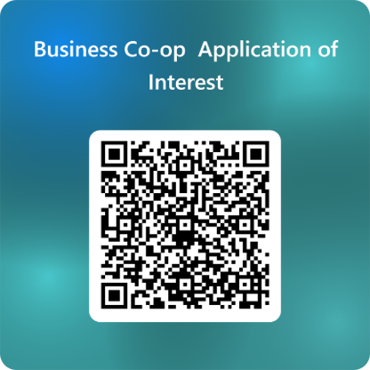
• 20-credit program (5 courses) - typically in 2nd semester
• Cohort of approximately 30 students with just 2 teachers for the entire semester.
• Gain connections in the work force for after graduation and gain valuable experience for your resume.

Students interested in applying for the Business Co-op can apply using this QR code. Filling out the form does not guarantee acceptance into the co-op - The application will be open between January 5th and February 27th for interested students.

Fine Arts

ART STUDIO 11/12: FOUNDATIONS (MVAST11) (MVAST12)
Art Foundations 11/12 is a general level course in the Fine Arts program that focuses on experimentation with traditional medias (drawing, painting, printmaking, ceramics and sculpture) and personal imagery development. Students are required to demonstrate their knowledge of the elements and principles of design; communicating through imagery and reflecting on personal, social, cultural, and historical contexts. No prerequisite is required, but completion of a prior art course is recommended.

STUDIO ARTS 2D 11/12: DRAWING AND PAINTING (MVAD 11 DRW) (MVAD 12 DRW)
Drawing and Painting 11/12 is a specialized course in the Fine Arts Graduation program designed for students who enjoy 2D art form. The course includes a variety of projects that cover different subject matters and emphasize the knowledge, and application of the elements and principles of design. Students will work in depth with a range of 2D art mediums. Additionally, the course encourages students to deepen their understanding of the creative process through class discussions about art issues. While no prerequisite is required, completing a prior art course is recommended.

STUDIO ARTS 3D 11/12 - CERAMICS AND SCULPTURE: FOUNDATIONS
(MVAC 11 CER) (MVAC 12 CER)
New to ceramics? Start here! This introductory course focuses on the essential skills and knowledge you need to begin your ceramic journey. You’ll learn:
- Hand-building techniques such as pinch, coil, and slab construction
- Basic glazing and surface decoration methods
- How to work safely and effectively in a ceramic's studio
- The fundamentals of clay properties and firing processes
By the end of Level 1, you will create a series of functional and decorative pieces that demonstrate your understanding of form, texture, and color.

STUDIO ARTS 3D 11/12 - CERAMICS AND SCULPTURE: INTERMEDIATE
(MVAC 11 CER) (MVAC 12 CER)
Already know the basics? Time to level up! This course builds on foundational skills and introduces more advanced techniques, including:
- Wheel throwing for creating symmetrical forms
- Surface design experimentation using slips, underglazes, and carving
- Combining hand-building and wheel-thrown elements for complex projects
- Exploring personal style through themed assignments
Students will complete projects that reflect creativity and technical growth, such as sets of functional ware or sculptural pieces with unique surface treatments.

STUDIO ARTS 3D 11/12 - CERAMICS AND SCULPTURE: ADVANCED
(MVAC 11 CER) (MVAC 12 CER)
Ready for a challenge? This advanced course is all about pushing boundaries and refining your craft. You’ll focus on:
- Complex construction techniques and large-scale projects
- Advanced wheel throwing and altering forms
- Problem-solving for structural integrity and design innovation
- Developing a personal artistic voice through original works
Students will design and execute a cohesive body of work that demonstrates mastery of technique, creativity, and conceptual depth—perfect for portfolio development or exhibition.

PHOTOGRAPHY 11/12: FOUNDATIONS (MVAPH11) (MVAPH12)
Photography 11/12 – Foundations introduces students to the core technical and creative skills including control of exposure, focus, and depth of field, and the use of digital tools to edit and enhance images for a specific audience. Emphasis is placed on expressive image-making and creating photographic work that responds to personal, cultural, social, and environmental issues.

PHOTOGRAPHY 11/12: INTERMEDIATE (MVAPH11) (MVAPH12)
Photography 11/12 - Intermediate extends the competencies of Introductory/Foundations Photography by deepening students’ technical control, visual literacy, and personal voice in image making. Learners refine camera, lighting, and editing skills, develop cohesive series or projects, and critically analyze how photographic practice connects to identity, place, and contemporary issues.

PHOTOGRAPHY 11/12: ADVANCED (MVAPH11) (MVAPH12)
Photography Level 3 is an advanced course further extends on competencies of Photo Intermediate and isdesigned for students ready to pursue independent, inquiry-based photographic projects and portfolio development. Students deepen their understanding of light, composition, and digital workflow, take creative risks through experimental or mixed-media approaches, and consider ethical, cultural, and environmental dimensions of photographic practice in preparation for post-secondary pathways in the visual arts.

YEARBOOK 11/12: GENERAL (MMEDD12 YBK) (MVAMT11) (MVAMT12)
The Yearbook class is a unique course that focuses on producing the annual publication that celebrates each school year’s story. It is an advanced class, requiring students to apply for entrance, with the expectation that applicants have existing photography and graphic design skills. Successful applicants will have the opportunity to further their knowledge and experience in digital photography, graphic design, composition and layout, journalism, and marketing. This is a year-long course that meets on alternating days during the 5th period. However, as many important school events take place outside of regular school hours, students should expect to have occasional photo assignments requiring them to stay late or visit nearby athletic sites. This course will be run as a year long course every other day in block E. Application required: Please see Mr. Nilson for an application form.
ARTS CAREERS AND PORTFOLIO DEVELOPMENT 12 (YVAPD12)
This course is designed for students who are interested in and considering careers in the visual arts and want to develop a professional portfolio for post-secondary applications. Students will create a cohesive body of work that reflects their personal style and artistic voice while exploring a variety of artistic disciplines and techniques.
In addition to portfolio development, students will gain insight into career pathways in the visual arts, including fine arts, design, illustration, animation, photography, and related fields. Instruction will include guidance on presenting work effectively, writing artist statements, and preparing both digital and physical portfolios.
This linear course runs every second day. On instructional days, students will engage in lessons, critiques, and portfolio-building activities. On alternate days, students will have a study block combined with open studio time, providing flexibility to work independently on projects, refine techniques, and receive individualized feedback.
Key Features:
- Portfolio preparation for art school applications
- Exploration of visual arts careers and industry expectations
- Development of technical and conceptual skills
- Dedicated open studio time for independent work
- Guidance on digital portfolio presentation.

Home Economics

FOOD STUDIES 11/12 (MFOOD11) (MFOOD12)
This course is for students with some food and cooking skills who want to develop beyond the basics. Students will take part in challenging labs and various meal and recipe design opportunities. They will learn about ingredients proportions, temperatures, and preparation methods and understand how to develop and modify recipies. Other fascinating topics such as food security, food recalls, cultural appropriation, food labelling, and food marketing will be covered. Emphasis is on the ability to use advance knowledge and skills in food preparaton to design original recipes and menus. Social, cultural, health, economic, and aesthetic aspects of food will be discussed in depth. This course also provides an opportunity to explore future career options in the food industry and to develop an individual food philosophy.

PASTRY ARTS & BAKING 11/12 (MBP11) (MBP12)
This is a course which focuses on developing and advancing skills in baking. Students will broaden and challenge their skill set with exciting recipes and interesting ingredients. The emphasis will be on baking theory, practical knowledge, skill building, time management and production. Students in grade 11 will learn basics and experiment with design to create innovative products. Students in grade 12 will focus on creativity and artistic expression as they design and present baking masterpieces. This course will be valuable for any student who wants to learn more about baking and pastry or who is interested in a career in the industry.

TEXTILES 11/12 (MTXT11) (MTXT12)
Whether you are new to sewing or have some experience, take this class for a more hands-on approach to learning. Projects are selected based on your ability but could include: pajamas, sweatshirts, pants, tops, dresses, quilts, and other accessories. More advanced students will have the opportunity to work with more complicated fabrics and patterns and will learn a variety
of new sewing techniques. Have fun designing your own project or giving a new look to something you already own. In addition to sewing, we will explore issues and careers in the fashion and textile industry.

TEXTILE ARTS 11/12 (YHEC-1D 11) (YHEC-2D 12)
If you are someone that sits on Pinterest and say, “I want to make that!” but never get to it, this course is for you. Instead of just pinning great projects, make them come to life. The teacher will help you with the skills and learn how to use tools and materials that are specially designed for crafting. We will learn the history of certain art and art practices. There will be a foundational understanding of element and design in art created. Textiles Arts & Design is your opportunity to design and create your own unique and individual projects and gifts for you or your home. Main projects will be decided with the interest of the students, with some basic projects to teach skills initially."

INTERPERSONAL AND FAMILY RELATIONSHIPS 11 (MIAFR11)
This is a sociology course designed for students in grades 10 to 12 who wish to study human behaviour, development, and relationships. It explores human societies and how over time change is always occurring. What drives social change? Who advocates it? Why is it important to study change? Why do people behave the way they do? Does society create criminals?
These are some of the questions explored. Some topics such as love and relationships, the interactive nature of self and family, personality theories, communication styles, types of interpersonal and family relationships, components of healthy/unsafe relationships, and factors involved in ending relationships will be studied. Student interest will be asked to create the content for the course. This is a good course for those who have an interest in counselling, social work, or education.

CHILD DEVELOPMENT AND CAREGIVING 12 (MCDAC12)
This is a sociology course designed for students in grade 11 and 12 who are interested in studying infant and child development. The main theme is parenting. Understanding how to parent, how parenting shapes society and individuals. Topics will include pregnancy and childbirth, the needs of infants and children, theories and stages of child development, and the rights and responsibilities of caregivers. Simulated parenthood with electronic computer babies is available. This is an excellent course for those considering a career in human services (e.g. health care, counselling, social work, education, business, etc.)

PSYCHOLOGY 11 (YPSYC1A1)
How do drugs affect a person’s brain? What is it like to have schizophrenia? How controlled are you by forces you are not aware of? How can you reduce anxiety? How much does your childhood affect you now? These are some of the questions that are explored in Psychology 11. This course is designed to give students an introduction to psychology, while focusing on applicable skills and will change the way you see the world.

PSYCHOLOGY 12 (YPSYC2A)
What causes people to join cults? How do advertisers target you? How can you build better communication skills? How can you best help people who are in psychological distress? How does attraction work? What are the “love languages”? These are some of the questions that are explored in Psychology 12. This course is designed to build on students’ knowledge and further their ability to understand the world using a psychological mindset.

TOURISM 12 (MTRM 12)
Tourism is a course that focuses on the development and ever changing face of the tourism industry in Canada. Tourism focuses on applied design, which conducts user-centered research to understand design opportunities and barriers. Applied skills and technologies prepare students to work in the new environments of the modern age. There is a heavy focus on local, Canadian, and Aboriginal tourism. Students will engage in critical thinking skills in relation to issues in the tourism industry. The aim is to get students to understand the current situation of tourism and be able to predict future trends and find success in vocations related to the tourism industry.

Information Technology

MEDIA DESIGN 11 (MMEDD11)
Level up your media creation skills as you explore graphic design, video production and animation in Media Design 11. As a part of the class you will explore Adobe Photoshop, Premiere and Animate as you plan, design and refine a variety of awesome media types. No experience is required, but returning students will have the opportunity for more complex design challenges.

COMPUTER PROGRAMMING 11/12: COMPUTER PROGRAMMING (MCMPR11) (MCMPR12)
Learn to code and create! This course is for students with interest in gaining experience in computer programming. Students will be investigating several computer programming languages (Python, HTML, CSS) and how they can be used in many ways. Students can explore programming by developing Web Apps, Data Analytics and/or Games Development. All skill levels are welcome.

VIDEO PRODUCTION AND ANIMATION 11: DIGITAL COMMUNICATIONS / DIGITAL MEDIA DEVELOPMENT (MDCOM11) (MDMD-12 VID)
Want to create your own high-end videos and animations? How about exploring different types of special and audio effects that take your media to the next level? Students will have the opportunity to use a variety of cameras and other studio equipment while exploring industry standard applications like Adobe Premiere, After Effects and Animate. Returning students will have the opportunity to expand their skills and problem-solving abilities with advanced design challenges.

GRAPHIC PRODUCTION 11/12 (MGRPR11) (MGRPR12)
Do you have a passion for digital design and graphics creation? Graphic Production focuses on the advanced planning, design and refining of digital images, both photographic and original creations, and applying them to a variety of media types. As a part of this, students will explore various Adobe Suite applications such as Adobe Photoshop, Illustrator and InDesign. Returning students will have the opportunity to expand their skills and problem-solving abilities with advanced design challenges.

Performing Arts - Music

CHOIR 11/12 (MCMCC11) (MCMCC12)
A fun way to learn more than just vocal technique. This performing group will explore a wide variety of musical styles and repertoire, and will focus on developing sight singing and ear training skills. Discover ways to extend your vocal range, create breath energy, formulate and place vowels correctly, and perform with confidence in a choral setting. No previous singing experience is required. Participation in music department activities is expected. This course will be run as a year long course every other day in block E.

CONCERT BAND 11/12 (MIMCB11) (MIMCB12)
Recommended: Successful completion of previous concert band classes or director’s permission. This course is designed for students who have reached an interim level of proficiency on a band instrument. Students will experience a significant increase in complexity and excitement of repertoire over previous band levels. Students will have the opportunity to perform in festivals and concerts. In addition, students may be performing as a pit band.

GUITAR 11/12: BEGINNER (MIMG 11 BEG) (MIMG 12 BEG)
This is an introductory course. No previous guitar or music experience is necessary! Students in this course will learn basic chords and strumming patterns which will enable them to play several styles of music including popular, rock and blues music. Students will also learn the basics of finger-picking and basic guitar technique, while learning to read music and tab.

GUITAR 11/12: INTERMEDIATE (MIMG 11 INT) (MIMG 12 INT)
Intermediate guitar is designed for students who have guitar experience, and want to learn more challenging styles and techniques. In advanced guitar students will explore a variety of topics such as blues, classical guitar, scales, and advanced chording. Students are encouraged to pursue individual projects in this course

JAZZ BAND 11/12 (MIMJB11) (MIMJB12)
This course explores jazz and big band genres in more depth. Students will develop their instrumental and theoretical skills through the lens of standard jazz bands, including swing, funk, Latin, and rock. Soloing and improvisation will be expected. Standard jazz band instrumentation is as follows: alto, tenor, baritone saxophone, trumpet, trombone, guitar, bass guitar, piano or drums. However, all instruments are welcome! Because the jazz band learns and performs more challenging music, jazz students must be registered in concert band or have teacher permission. Jazz students will have the opportunity to play in concerts and festivals and participation in music department events is expected.
Please note that this course may be requested as a ninth course and is offered before school. It runs simultaneously with Jazz 8 – 12.

Performing Arts - Dance

DANCE PERFORMANCE 11/12: CHOREOGRAPHY (MDNC 11 CHO) (MDNC 12 CHO)
This course is for student choreographers and those advanced level dancers, wishing to work towards mentoring students and creating group choreography for stage. Students will be placed with a class and will work under the direction of Ms. Law to act as peer tutors and learn to create dynamic pieces for stage, using the choreography, cleaning, and planning for stage processes. Students, who register for choreography should be either enrolled in an advanced/elite class, be members of a senior team or speak with Ms. Law about qualifying studio experience. Students must speak with Ms. Law before registering.

DANCE TECHNIQUE AND PERFORMANCE 11/12: FOUNDATIONS (MDNTP 11) (MDNTP 12)
This course is for students who have always wanted to learn to dance but may not yet had the opportunity or who have up to three years of recent experience in any genre or those who dance at the recreational level. Students will learn the basics of multiple genres including Jazz, Hip Hop and Contemporary in a fun and supportive atmosphere. This class is perfect for people of all fitness levels to learn new skills in flexibility, strength, and coordination through the learning of choreography. Students will advance at individual levels and establish individual dance goals. Students will have multiple performance opportunities.

DANCE TECHNIQUE AND PERFORMANCE 11/12: INTERMEDIATE
(MDNTP 11 INT) (MDNTP 12 INT)
This course is for students with four or more years of recent dance experience, either in school or at a studio. Students will have opportunities to study many genres including Hip Hop, Contemporary and Jazz. Students will increase their dance technique and vocabularies through the regular viewing and critiquing of live and recorded performances and through the creation of choreography for stage. There will be multiple workshop and performance opportunities. Students must be recommended or receive permission to enroll in this course. Students who have not previously taken a dance course at Sullivan should speak with Ms. Law directly prior to requesting this course.

DANCE TECHNIQUE AND PERFORMANCE 11/12: ADVANCED (MDNTP11 ADV) (MDNTP12 ADV)
This course is designed to challenge the advanced dancer and facilitate explorations of the world of dance and performance. This course is appropriate for those with five or more years of competitive and/or examinable dance experience in one or more of the following genres: Ballet, Jazz, Lyrical, Contemporary or Hip Hop, either at school or at a studio and who have been recommended to the course. In this performance-based class, students will work to view, critique, and create performances in multiple genres, improve technique and create choreography for stage. There will be multiple workshop and performance opportunities as well as opportunities for students to work within their chosen genre of dance. Students must be recommended or receive permission to enroll in this course. Students who have not previously taken a dance course at Sullivan should speak with Ms. Law directly prior to requesting this course.

Performing Arts - Drama

DIRECTING AND PERFORMANCE LEADERSHIP 11/12 (MDRDS11-PL) (MDRDS12-PL)
This course is for student directors and those experienced actors wishing to work towards mentoring younger students in addition to assisting in the creation of performances. Students will be placed with a class and will be under the direction of Ms. Young acting as peer tutors. Course goals include assisting in the direction of performance, leading in classroom activities, and modeling excellent community behavior. Students who register for Directing & Performance Leadership, should be enrolled in a senior performance class and should speak with Ms. Young about qualifying acting experience.

DRAMA 11/12 (MDRM 11) (MDRM 12)
Drama 11/12 is a multi-level course, that continues to develop the teamwork, confidence building, and creativity that students have gained in previous Drama classes and for those new to Drama. The course takes a more in depth look at the process of developing character, story, mood, and the ability to thoughtfully write about and reflect on a variety of performances. It will involve theatre units of study such as improvisation, mime, comedic character development, vocal exploration, creative movement exploration, monologue development, and one act plays, all which will vary from year to year. Students will experience growth through assignments and feedback aligned with past experience, or build foundations for those new to Drama, enabling students to increase their skill level year on year. While there is little written homework, students are required to memorize lines and rehearse their assigned scenes outside of class time. Active participation and enthusiastic contributions to the class will help you find success in this course.

THEATRE COMPANY 11/12 (MDRTC11) (MDRTC12)
Theatre Company 10, 11, 12 is a course that prepares students for school wide and community performances during the semester and a full class play in January. Students will develop character, story, mood and the ability to thoughtfully write about and reflect on a variety of performances with the intention of applying these concepts to community performance. In addition to this, students will contribute to the development of Theatre Company, though stagecraft, rehearsal, and performance. A positive attitude and strong commitment are essential for success in the course.

MUSICAL THEATRE 11/12 (MMUTH11) (MMUTH12)
Musical Theatre 10, 11, 12 is a course that prepares students for a school wide and community Musical Theatre performance in May. Students will develop their acting, music, and dance skills in an effort to build character, story, mood and the ability to thoughtfully write about and reflect on performances. In addition to this, students will contribute to the development of the Musical Theatre Company through stagecraft, rehearsal, and performance. Past performance experience is useful, but not a prerequisite. A positive attitude and strong commitment are essential for success in the course.
This course will be run as a year long course every other day in block E.

Technology Education

DRAFTING 11/12: 3D PRINTING AND DESIGN (MTDRF11) (MTDRF12)
Are you interested in design? Join the class to try out designing, and printing your projects on a 3D printer! You will learn a variety of different software to create, animate, and fabricate anything that you can think of. Try out a Laser Printer and a CNC milling machine!

METALWORK 11/12 (MTMET 11) (MTMET 12)
Design and fabricate amazing metal creations! In Metalwork 11-12, you'll use a wide range of tools and techniques to bring your ideasto life. From welding and cutting to grinding and joining, you'll gain the skills to build almost anything. Students with previous metalwork experience will build upon their skills, applying them to more advanced projects.

MACHINING & WELDING 12: ADVANCED (MTMET 12 ADV)
**Requirement: Proficient skills in Metalwork 10-12 or teacher support from Woodwork or Trade Skills **
Advanced Metal Work will be focused on more complex processes and advanced machinery. Students will be using precision measuring tools to create parts with accuracy. Express your imagination using metal!

ROBOTICS AND ELECTRONICS 11/12 (MTELE11 ROB) (MTELE12 ROB)
ROBOTS! Need more be said? You will be introduced to the world of robotics along with 3D modeling software. Come build your own robot, compete in challenges, and learn all at the same time. No previous experience is needed; repeating the course will have you building upon and stretching your skills.

TRADE SKILLS EXPLORATION 11/12 (MSTX-1A TS)
Planning to move out of your parents’ house? You should probably learn how to fix a few things! Try out different trades including Carpentry, Plumbing, and Electrical. After this course, you could pursue a career in Trades or Engineering; or just give you the confidence on how to fix a few things around your future home.

WOODWORK 11/12 – ADST (MWWK11) (MWWK12)
Build your dream projects in Woodwork 10-12! This hands-on course teaches advanced woodworking skills, from design and joinery to finishing techniques. Discover the craftsmanship that can lead to rewarding careers in cabinetry and design.

ENGINEERING 11/12 – ADST (MENR11) (MENR12)
Build your dream projects in Woodwork 10-12! This hands-on course teaches advanced woodworking skills, from design and joinery to finishing techniques. Discover the craftsmanship that can lead to rewarding careers in cabinetry and design.

Work Experience

WORK EXPERIENCE 12A
Work Experience 12A (WEX12A) equips students with the essential knowledge and skills needed for success in the world of professional work. This course establishes a direct link between classroom learning and practical skills, aligning with the attitudes and competencies demanded in the workplace. This course involves approximately 1 month of classroom instruction covering WorkSafe knowledge and appropriate work etiquette, followed by a substantial 100 hours of work experience during after school hours, evenings, and weekends. Benefits: Gain valuable hands-on experience in real world work scenarios and with various equipment; Secure references and build contacts that can support future job pursuits and scholarship applications. Additionally, for those already employed, there may be an opportunity to incorporate their current job as a part of the work experience component.

Career Education

Career Life Education 11:
Career Life Education (CLE) is a 4-credit course required to graduate. This course will be offered in a hybrid model with a mix of in-class and online learning opportunities. Students explore the elements of post secondary education, career paths, financial literacy, self-discovery, and the graduation program. The aim of Career Life Education is to empower students to develop the skills, knowledge, and attitudes necessary for self-directed growth, fostering a lifelong commitment to learning and innovative thinking. This prepares the students to adeptly navigate challenges, solve problems, and pursue their goals effectively throughout their lives. The emphasis is on understanding the significance of a balanced life and recognizing that successful education and career paths demand planning, evaluation, and adaptability.

Career Life Connections 12
Career Life Connections (CLC) is a comprehensive 4-credit course designed specifically to give Grade 12 students time for critical reflection and planning for their future after high school. This course will be offered in a hybrid model with a mix of in-class and online learning opportunities. The primary objective is to assist students in becoming successful, informed citizens by enabling them to explore diverse careers and future pathways. Students will discover the connection between classroom education, the workplace, and post-secondary realities. This course captures and honors each student through numerous learning experiences that collectively contribute to a meaningful showcase of learning in the Capstone Project.

District Trades/Apprenticeship Programs (YOUTH TRAIN IN TRADES)

These programs help students learn specific skills for employment in certain careers.

District programs are being offered at other schools or post-secondary institutions so students can acquire certification for employment. Students enrolled in these programs will acquire dual credit (high school course credit as well as post-secondary diploma program credit). Work experience leading to possible employment will be organized during the summer. Interested students must acquire and complete a District Program application form from the Career Centre. Students have an opportunity to enrol in the following programs:

DISTRICT PARTNERSHIP PROGRAMS
The school district offers programs to students in trade and skills training. These programs are excellent opportunities for students to get a head start in their formal trades training. Seats are limited and students must undergo a successful application and interview process to secure a seat. District programs are in partnership with post-secondary institutions such as Kwantlen Polytechnic University (KPU), British Columbia Institute of Technology (BCIT) or Vancouver Community College (VCC). Students will complete their graduation requirement at their home school and will receive both high school and post-secondary credit while completing a district program. For many programs, the Surrey School District pays for the first-year tuition; this can mean a cost savings of hundreds of dollars! Please visit the Career Centre and speak with a Career Development Facilitator to complete the application.
Deadline is March 6, 2026.
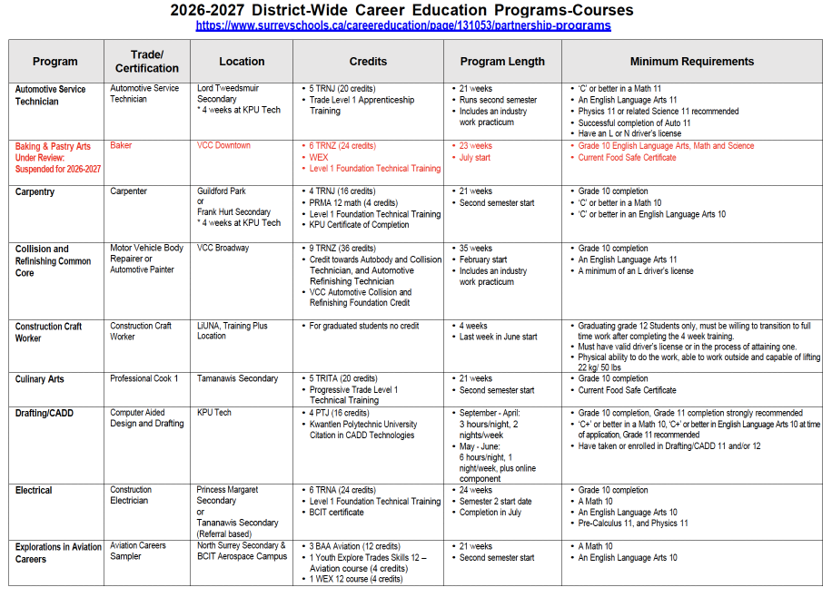
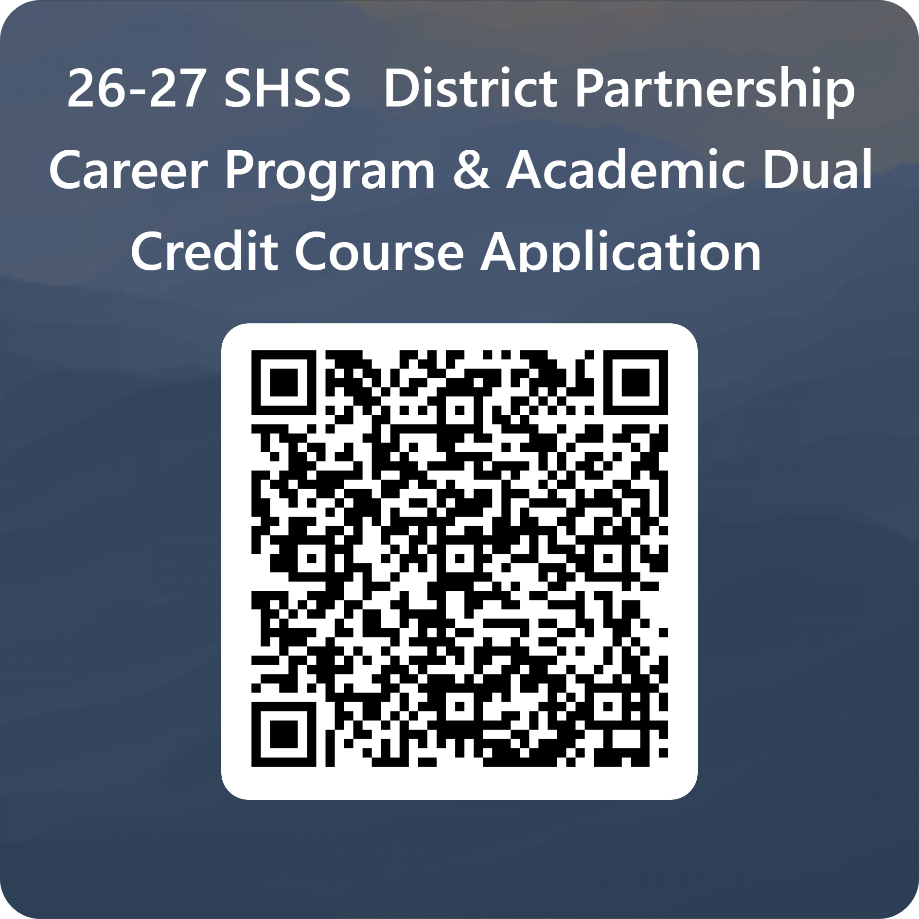
Use this QR code to access the application for any of the programs on this, or the following 2 pages.
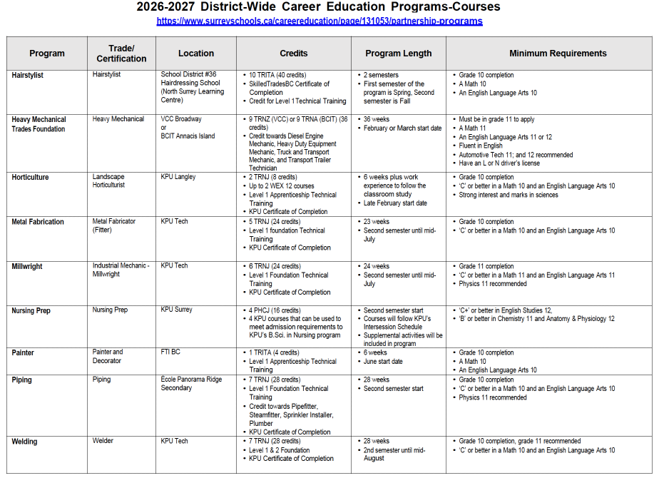

YOUTH WORK IN TRADES

Students over the age of 15 who have an opportunity to acquire part-time employment in a trade can begin an apprenticeship while completing secondary school. Students will attend regular classes towards graduation and also participate in paid employment as a registered apprentice. Work hours completed will be credited towards the first year of apprenticeship training as well as work experience courses, i.e. WRK 11A, 11B, 12A and 12B. Students complete the required 480 hours during the summer months or during regular school hours if their timetable is adjusted. Students working in an applicable trade may be identified as a hidden apprentice and registered Industry Authority.

A list of apprenticeship trades and additional information can be acquired by the Career Resource Centre.
Deadline for applications is March 6, 2026.

ACADEMIC DUAL CREDIT
Surrey School District #36 has Academic Dual Credit partnership programs where students can earn post-secondary credits with KPU, Douglas College, NVIT, Emily Carr University of Art and Design in the following areas:
*Community and Public Safety
*Headstart in Art
*High School on Campus
*Introduction to Health Science
*Introduction to Legal Office Procedures
*Introduction to Practice for Child and Youth Care Counsellors
*Introduction to Practice for Child and Youth Care Counsellors

Applications for these programs are available in the Career Centre. Please speak to Ms. Rogerson about application deadlines. Most programs have deadlines of March 6, 2026.
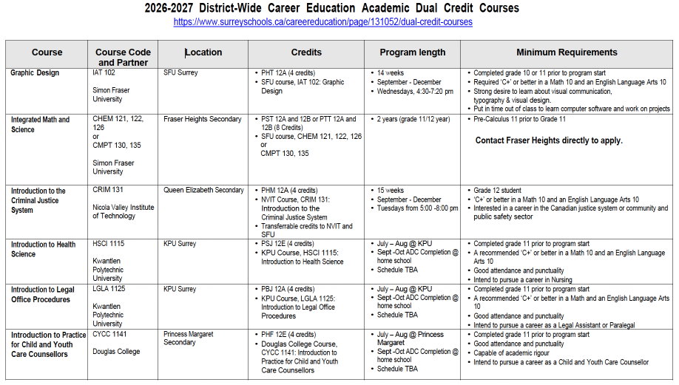

Peer Tutoring

PEER TUTORING 11/12 (YIPS 1A) (YIPS 2A)
This course is designed for peer tutors to gain a deeper understanding of the dynamic nature of the teaching process through the exploration of learning theories and processes. This includes course assignments and written reflections. There is a practical component to this course in which students are placed in the classroom to tutor younger students. Successful candidates demonstrate strong attendance, responsibility and an aptitude in their requested subject area.

NOTE: THIS COURSE IS NOT AVAILABLE FOR SELECTION IN MYED DURING THE COURSE REQUEST PROCESS
If you are interested in being a Peer Tutor, please pick up an application form in the Counselling Office. On the form, please indicate which subject (and back up subject) would like to tutor. If it is a specialized elective (such as PE, Dance, Textiles, Carpentry, Drama, Music or Art), please speak the appropriate teacher about your interest to see if you are an appropriate candidate. Please also understand that placements with a specific teacher are not guaranteed. All applications will be reviewed by the Counselling and LST departments in conjunction with administration.

Study Blocks

STUDY
NOTE: THIS COURSE IS NOT AVAILABLE FOR SELECTION IN MYED DURING THE COURSE REQUEST PROCESS
Students in Gr.11 or 12 have the opportunity to apply for a Study Block (a block with no course formally scheduled). At the Grade 12 level each student is provided a 1st Study Block upon request assuming students have enough credits for graduation. For Gr.11 students or Gr.12 students requesting a second Study Block, an application process is in place. Please see your Counsellor to fill out an application and review your Graduation Program!

ELL PROGRAMS

Students are assessed upon entrance into the District and the School and are assigned one or two ELL Support blocks dependent on their individual needs.

ELL Beginner
English Language Learners (ELLs) Beginner/Reception courses are offered for new students who have been assessed at the Beginner level. It is recommended that students enrol in two or three ELL courses initially to build their Basic Interpersonal Communication Skills (BICS). The ELL Beginner/Reception course will help students to develop and practice basic reading and writing skills in a variety of content areas, as well as school, community, and Canadian Culture.

ELL Developing
This course is the second level of English Language Learners (ELLs) courses. Students will continue to build their oral, reading, and writing skills. Integration into non-academic courses is supported. Content areas cover general knowledge in academic areas, as well as school, community, and Canadian culture to build on foundational concepts needed for other content areas.

ELL Expanding
English Language Learners (ELLs) Expanding courses prepare students with language skills to consider elective courses with some language demands but not entirely print-based. These students augment their English acquisition through a variety of strategies to enhance their cognitive, oral, writing, and reading skills. ELL Expanding students are ready for the beginning stages of explicitly developing academic English (Cognitive Academic Language Proficiency, or CALPS). Furthermore, the course will continue to cover general knowledge, but will focus mainly on English Language Arts specific content. Most students will have at least one ELL Expanding course per year; sometimes one per semester to best support the student’s need.

Academic Language for ELL 10, 11 & 12 (4 credits)
Through Academic Language ELL10, students will develop their academic English within a sheltered environment which meets the specific cultural adjustment needs of English Language Learners (ELLs). This course continues to expand upon the skills acquired in Introduction to Academic Language ELL10, which are needed to be successful in writing, speaking, listening, and reading competencies through a variety of text genres, registers, structures, forms, and styles. To build their competencies, students will experience language (listen, read, and study texts) from a variety of genres by studying the forms, styles and models required to create original work, while also building their awareness of the socially constructed nature of language. This course includes elements of Canadian culture (cultural identity and First Peoples culture). Academic language ELL10 is designed for ELLs at Developing level and Expanding Level on the current 5 level Standards/Surrey District Continuum.

