Things to Remember
For safety reasons, and in accordance with the fire regulations, if attendance reaches the maximum number (25), a FULL SIGN will be posted. Please respect these guidelines and arrange to visit StrongStart on another day.

Have a “safe” and happy holiday everyone!!!
Safety Tip

Please remember … in hopes that we have snow this winter, children are not allowed to throw snowballs on the school ground. Snowballing, although lots of fun can lead to serious injuries, especially to the eyes. Snow balls are especially dangerous if the snow is hard-packed or contains a rock or other hard object.
Happy Holidays!
What a busy November! We welcomed Nancy from Options, Yanina from United Way Avenues of Change (Session 1), and Maureen from Fraser Health. They all provided important information, and we thank them for their commitment to early learning!
“Time to Rest”
One of the blessings of this year is having the opportunity to connect with you and your children. We have had fun laughing, learning and playing together; I am so grateful to be able to share this time with you.

As we draw near the holiday season, please be aware of the importance of young children getting sufficient hours of sleep. Here is the recommended number of hours sleep per night for children ages 0-5:

o Infants: 12- 15 hrs + naps
o Toddlers (1 – 3 yrs): 12 hrs +naps
o Preschoolers (3 – 5 yrs): 11 hrs
Helpful tips to get your little one tucked in at night:
- Turn off electronics at least one hour prior to bedtime.
- Have no electronics in the bedroom.
- Keep before bedtime activities calm, the lights dim, and the environment quiet.

Upcoming Events

Dec. 1 Dental Presentation (9-9:40am)

Dec. 12 Yanina Savenko - Session 2: “Stress and Coping Strategies Over the Holidays” (10:30am)

Dec. 13 and 14 *Holiday Party

*(Please sign up as space is limited)

Dec. 16 Professional Development Day – StrongStart Closed.

December 19, 2016 to January 2, 2017
Winter Break - StrongStart Closed.

DECEMBER 2016 Volume 4, Issue 4

Holly Elementary
10719 - 150 Street
Surrey, BC V3R 4C8
Phone: 604-585-2566
Fax: 604-581-1783

StrongStart Hours:
(M-F) 8:30 - 11:30 am

Principal: Andrew Shook
Vice-Principal: Gallit Zvi
StrongStart Facilitator: Michelle McKenzie (Mrs. Mac)

Surrey Schools on the Web!
www.surreyschools.ca

Holly Elementary on the web!
www.surreyschools.ca/schools/holly

Holly Elementary
StrongStart Newsletter

“Let It Snow…”
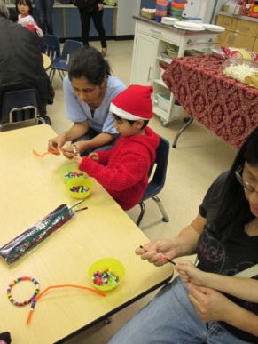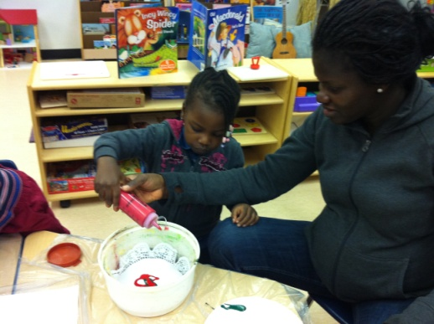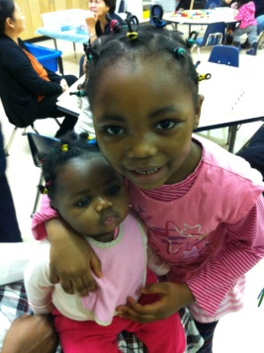

DECEMBER
Sunday | Monday | Tuesday | Wednesday | Thursday | Friday | Saturday
 |  |  |  | 1 Gym 10-10:15  Chris from Fraser Health:  Dental Presentation  9-9:40am | 2  Gym  10-10:15am | 3
4 | 5  Gym 10-10:15am | 6  Gym  10-10:15am | 7  Gym  10-10:15am | 8  Gym  10-10:15am | 9  Gym  10-10:15am | 10
11 | 12  Yanina from Avenues of Change:  “Stress and Coping Strategies”  10:30am | 13  PARTY  (Sign up as space is limited to 25) | 14  PARTY  (Please sign up- limited to 25) | 15  No Gym | 16  Professional Development Day  StrongStart Closed | 17
18 | 19  Winter Break  StrongStart Closed | 20  Winter Break  StrongStart Closed | 21  Winter Break  StrongStart Closed | 22  Winter Break  StrongStart Closed | 23  Winter Break  StrongStart Closed | 24
25 | 26  Winter Break  StrongStart Closed | 27  Winter Break  StrongStart Closed | 28  Winter Break  StrongStart Closed | 29  Winter Break  StrongStart Closed | 30  Winter Break  StrongStart Closed | 31

