Ocean Cliff Elementary PAC Presents:
Thursday December 19th

PJ’s and Pancakes

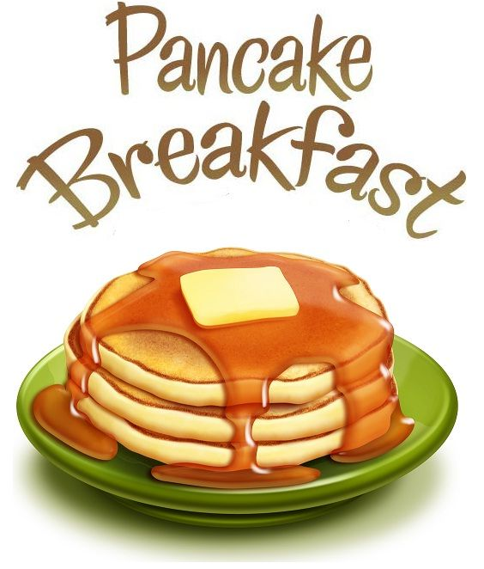
O C PAC invites students to join us for a special pancake breakfast with holiday activities on December 19th! The PAC Elves will be preparing delicious pancakes, hot chocolate, cookie decorating, card making, music and a very special visit from Santa!
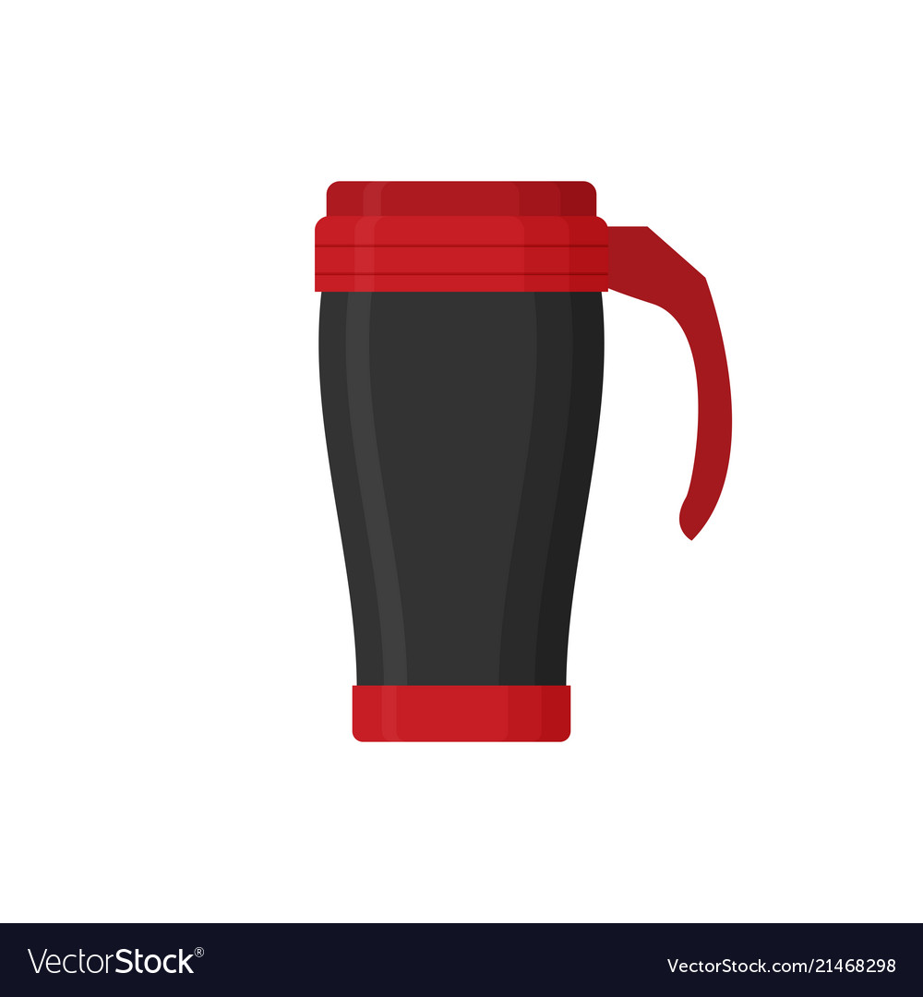
Wear your PJs and remember to bring your travel mug to fill with hot chocolate!
PAC will provide the compostable plates and cutlery for your meal!

We will have lots of pancakes and hot chocolate to treat our students! Teachers will bring their students to the gym by grade, so the PAC Elves suggest students have a small snack at home in the morning to keep everyone in good cheer waiting for their turn!

OC PAC would like to give a special thank you to our event sponsor:

