2021/2022 Kindergarten Registration
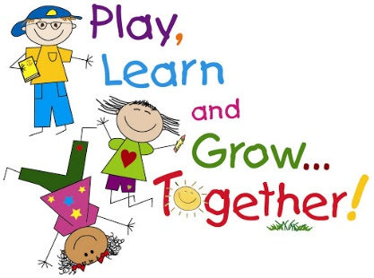
Kindergarten Students (Year of birth = 2016)
The first steps into Kindergarten represent an important milestone in a student's school journey. We look forward to welcoming your child into our school next year September and sharing in this milestone with you.
As we look ahead to the 2021-2022 school year, responding to COVID-19 will be central to the planning. While schools typically start Kindergarten registration the second week in January, the rapidly changing landscape in relation to COVID precludes us from providing families with information on how this will look at this time. We anticipate that it will be an on-line process. Once we have received direction from the Ministry regarding registration we will share it with you.
What can you do to get ready?
Start by organizing your student's needed paperwork:
1. Child's Birth Certificate if born in Canada. If not Citizenship paper/PR card/ or landing papers
2. Medical Services Card
3. Proof of Address (School District requires 3) Rental or Purchase agreement/BC Drivers License/Medical Services Card/Utility Bill. All address must be the same
4. Parent Proof of Citizenship (Birth Certificate/PR Card/Citizenship papers
5. Proof of Parent/Guardianship
6. Immunization Records
We appreciate your patience and look forward to celebrating your child's entry into kindergarten in Sept 2021.

