Accounting 11
Ms. Kruger
kruger_c@surreyschools.ca
http://accounting11kruger.blogspot.com
Website Password:

Course Materials:
- Pens/Pencils
- Paper/binder
- Calculator
- Sticky notes/highlighters
- Chapter Handouts

Welcome to Accounting 11!

Accounting 11 builds an understanding of business skills and concepts in the context of current technology, ethical standards, and an increasingly global economy, empowering students with economic, financial, consumer, and communication skills for lifelong participation in local and global contexts. The focus is on hands-on designing and making, acquisition and honing of skills, and choosing and applying technologies.

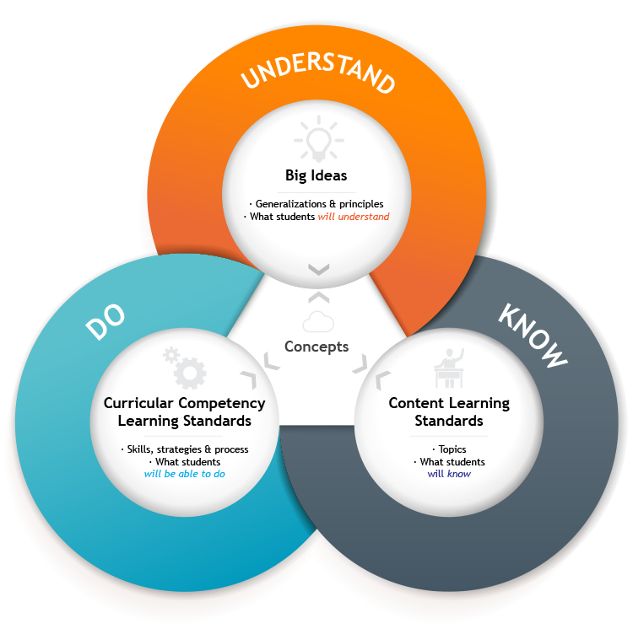

L. A. Matheson Secondary School
Accounting 11 – Assessment

Exceeding Expectations | Fully Meets Expectations | Minimally Meets Expectations | Not Yet Within Expectations
The student consistently demonstrates exceptional skills and knowledge and achievement is often above expectations. | The student proficiently demonstrates grade level skills and knowledge. | The student is making progress toward meeting the grade level expectations, sometimes showing evidence of meeting the outcome, at other times showing a lack of understanding to apply the concept and/or skill. | The student is making minimal or no progress toward meeting grade level expectations.

Applied Design
EE | FM | MM | NY | Curricular Competencies
 |  |  |  | Understanding context
 |  |  |  | Conduct user-centred research to understand design opportunities and barriers
 |  |  |  | Defining
 |  |  |  | Choose a design opportunity and point of view
 |  |  |  | Identify potential users, intended impact, and possible unintended negative consequences
 |  |  |  | Make inferences about premises and boundaries that define the design space
 |  |  |  | Ideating
 |  |  |  | Take creative risks to identify gaps to explore as design space
 |  |  |  | Generate ideas to create a range of possibilities and add to others’ ideas in ways that create additional possibilities
 |  |  |  | Critically analyze how competing social, ethical, and sustainability considerations impact designed solutions to meet global needs for preferred futures
 |  |  |  | Prioritize ideas for prototyping and designing with users
 |  |  |  | Prototyping
 |  |  |  | Identify and use a variety of sources of inspiration and information
 |  |  |  | Choose an appropriate form, scale, and level of detail for prototyping, and plan procedures for prototyping multiple ideas
 |  |  |  | Analyze the design for life cycle
 |  |  |  | Construct prototypes, making changes to tools, materials, and procedures as needed
 |  |  |  | Record iterations of prototyping
 |  |  |  | Testing
 |  |  |  | Identify feedback most needed and possible sources of that feedback
 |  |  |  | Develop an appropriate test of the prototype
 |  |  |  | Iterate the prototype or abandon the design idea
 |  |  |  | Making
 |  |  |  | Identify appropriate tools, technologies, materials, processes, potential funding sources, and time needed for production, and where/how these could be available
 |  |  |  | Use project management processes when working individually or collaboratively to coordinate production
 |  |  |  | Sharing
 |  |  |  | Share their progress while making to increase feedback, collaboration, and, if applicable, marketing
 |  |  |  | Decide on how and with whom to share or promote their product, creativity, and, if applicable, intellectual property
 |  |  |  | Critically evaluate their design thinking and processes, and their ability to work effectively both as individuals and collaboratively in a group, including the ability to implement project management processes
 |  |  |  | Identify new design issues, including how they or others might build on their concept
Applied Skills
EE | FM | MM | NY | Curricular Competencies
 |  |  |  | Demonstrate an awareness of safety issues for themselves, co-workers, and users in both physical and digital environments
 |  |  |  | Identify and evaluate their skills and skill levels, in relation to their project or design interests, and develop specific plans to learn or refine their skills over time
Applied Technologies
EE | FM | MM | NY | Curricular Competencies
 |  |  |  | Explore existing, new, and emerging tools, technologies, and systems and evaluate their suitability for their design interests
 |  |  |  | Analyze the role and impact of technologies in societal change, and the personal, social, and environmental impacts, including unintended negative consequences, of their choices of technology use
 |  |  |  | Analyze how cultural beliefs, values, and ethical positions affect the development and use of technologies
Summative Assessment

Designed to measure student achievement at the end of instruction.

Formative Assessment

Monitors student progress during learning.
Evaluation

A large portion of assessment will be dedicated to descriptive feedback in order to improve skills. Success in this course is dependent on the application
of this feedback.

Content
Students are expected to know the following:
• role of accounting in business
• career opportunities
• accounting principles and practice
• accounting equation
• relationship between debit and credit entries
• the accounting cycle
• source documents, general journal, ledgers, and trial balance, and the relationships between them
• chart of accounts
• preparation process of financial documents
• financial decision making based on financial documents

