Dear Administrators,

Summer break is fast approaching and we’re all looking forward to unplugging and unwinding – including our school electronics and appliances!

As part of our ***Go Green for Summer 2025*** summer shutdown event, please help us encourage teachers and staff to turn off and unplug electronics that will not be in use over the summer. This includes large appliances in classrooms and staff rooms like fridges and freezers.

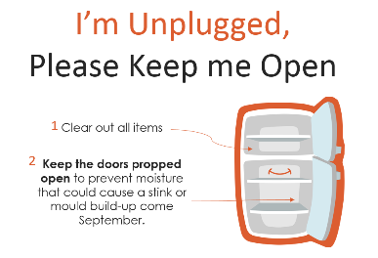Fridges should be cleaned out and if necessary consolidated into one fridge that will be left running. For those fridges not in use, please:

1. Clean out, unplug, and **prop the doors open** to prevent mildew build up over the summer.
2. Place a notice (see right) on fridges to signal which fridges should be unplugged and which (if any) will be in use.

You’ll find the following resources attached to help you promote the campaign at your school:

* **Summer Shutdown Poster** (place in staff room, classrooms, and other high profile locations)
* **Sample PA announcements**
* **Fridge notices** to be posted on fridges
* **Staff Checklist** to keep track of what to unplug or turn off
* **PAC letter**

Introducing the event early to staff will help them plan ahead. Ask your PAC to participate by cleaning out, unplugging, and unlocking any fridges they may use. Don’t forget to send a reminder email the last week of school!

By working together, we can achieve our energy and sustainability goals.

Thank you in advance for your support and have a great vacation!

Sincerely,

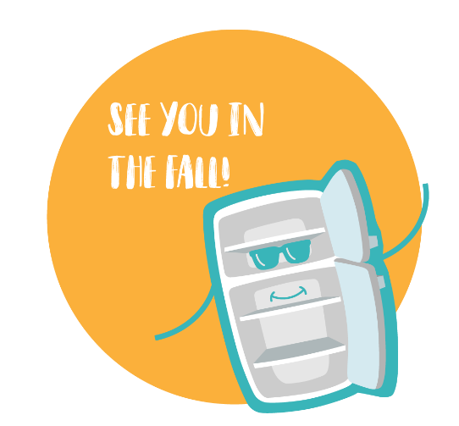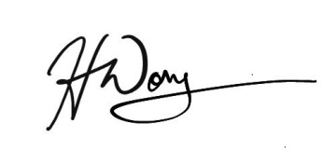

Energy Management & Sustainability

[sustainability@surreyschools.ca](mailto:sustainability@surreyschools.ca)