BISCUIT METHOD
Biscuits and Scones are quick breads that have a bread or cake like texture and are fast to make because they do not contain yeast. Simply put, scones are the Scottish cousins of the American rolled and cut biscuit. The technique for making them is identical. The differences are that scones are usually sweeter, enriched with eggs or cream and larger than the American biscuit.

Biscuit / Scones vary in shape, size and filling but all fall into one of two categories:

- Rolled - made from a soft dough that is firm enough to knead with hands and roll or cut into shapes

- Dropped - too soft to be rolled and cut. Instead the dough is pushed off a spoon onto a baking sheet, producing a free-form biscuit that is tender, flavorful and quicker to make

The biscuit mixing method is the technique used to make quick breads that are tender and flaky by reducing gluten development. This technique also works to form layers in the dough that result in flakiness. The method involves 4 key steps:

- Mixing all the dry ingredients together in a bowl

- Cut solid cold fat into the dry ingredients so that it resembles cornmeal.

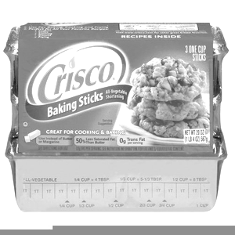
- The unique step to “cut in” solid fat serves two purposes. The first is to coat the flour in fat helping to reduce gluten development. The second is to distribute little pieces of solid fat throughout the dough which will melt and quickly turn into steam to help push the dough up while leaving little pockets that help form the flaky layers. While the pastry blender is the most efficient tool for this job, two knives or even your fingertips can be used if one is not available.

Have you ever wondered how shortening got its name? Well believe it or not, shortening got its name precisely because of what it does to flour. The process of cutting fat into the flour helps with shortening the protein strands in the flour and reduces the gluten development once the liquid is added.

I wonder why?
- Slowly add liquid ingredients while tossing with a fork until dry
ingredients are moistened and the mixture clings together.

- Shape the dough which is determined by whether it is a rolled
dough or drop recipe.

        - Rolled dough - dough mixture is kneaded lightly with fingertips on floured countertop until it forms a soft dough then gently rolled or pat into desired thickness and cut into shapes

        - Drop dough – batter is gently moved out of the bowl using spoons and dropped onto the pan. No shaping is required but care is taken to equally divide the batter.

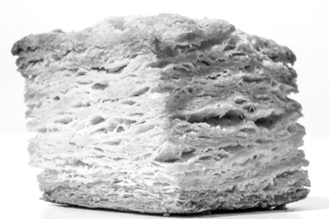
What makes a great biscuit? Standards of a quality biscuit:

Shape: If rolled and cut, same size with flat tops and straight sides
Colour: Light golden brown
What is gluten?
A pair of proteins called gliaden and glutenin found in flour join together to form a new molecule we call gluten when we add water to flour and mix. Gluten molecules arrange themselves into elastic chains. This elasticity is what allows the dough to stretch and grow as it traps C02 bubbles. When making quick breads, shorter gluten chains are desirable to create a more tender crumb.
Taste: Pleasing delicate flavour
Inside: Light, tender, and flaky crumb
Tips and tricks for making a perfect batch every time
- Select all-purpose flour or a blend of all-purpose and cake flour for their lower protein content when making biscuits and scones. Choosing a flour with less proteins helps prevent overdeveloping of gluten strands as there are less proteins available. The higher the protein content, the denser and tougher the dough will be.
- Make sure your oven is set to the proper temperature so that the small pieces of fat melt quickly and turn to steam in the high oven temperature. Steam pushes the gluten strands up to create small pockets layered throughout the product. These pockets create the iconic texture of a good quality biscuit.
- Use very cold solid fat (butter, shortening, or lard) and cold liquid. When cold ingredients hit the oven they will start to evaporate quickly creating steam which will help your biscuits get very tall.
- Be careful to mix as little as possible once the liquid hits the flour. The trick is to be gentle - this will reduce gluten formation keeping your baked goods tender. Overworked dough makes for a tough biscuit and there is no way to fix this.
- Use a thin sharp cutter and press straight down. No twisting. Instead of cutting, it crimps the dough together, which inhibits lift.

- To prevent the dough from sticking to the cookie cutter, dip cutter in flour.

- For glossy golden biscuits, brush the tops with milk, cream or beaten egg. This is also a great time to sprinkle sugar, a herb or even a seed on top of the scone to enhance its’ appearance.

- Leavening agents such as baking powder and baking soda are used to support the rising action made by the steam. They begin to create Co2 gas the instant the dry and wet ingredients come together which means biscuits must be baked as soon as the dough is mixed.

- Trust your recipe. Make sure to follow the recommended baking time along with the recommended shape or yield so that you do not overcook these tender treats. They will also appear a light golden brown color when done.

- Why is solid fat used in the biscuit method rather than a liquid option such as with the muffins?
a. The unique step to “cut in” solid fat serves two purposes. The first is to coat the flour in fat helping to reduce gluten development. The second is to distribute little pieces of solid fat throughout the dough which will melt and quickly turn into steam to help push the dough up while leaving little pockets that help form the flaky layers.

