Recipe: Black Bean and Quinoa Salad Name: ___________________
Servings: 2 people

Ingredients:
Cook as a unit:
250mL uncooked quinoa + 500mL of water

250mL cooked quinoa
30mL oil
2.5mL ground cumin
1/2 clove garlic, minced
15mL Lime Juice (1/2 lime)
2.5mL salt
1.25mL cayenne pepper

185mL canned black beans
1/3 colored bell pepper, diced
3 green onions, chopped
30mL cilantro, chopped

½ Avocado (Day 2)

Instructions:
Day One
- Prepare the quinoa as a unit: Combine 250mL uncooked quinoa and 500mL water in a small saucepan.
- Bring the saucepan to a boil, then cover and reduce heat to low for 15 minutes. When timer goes remove from stovetop, fluff quinoa with a fork then set aside until ready to use.
- While the quinoa is cooking wash and dice bell pepper, green onions and cilantro
- Prepare dressing by mixing oil, cumin, garlic, lime, salt, and cayenne together.
- Rinse and drain the black beans
- Divide cooked quinoa into two portions
- Combine 250mL cooked quinoa with chopped vegetables, black beans and dressing.
- Refrigerate for next day.
Day 2
- Dice ½ an avocado then mix into salad. Serve and enjoy

Tray Equipment
Dishwasher: ________________________________________
Housekeeper: ______________________________________
Dish dryer: _________________________________________
Special Duties: _____________________________________

Cooking Time:
Baking Time:

Person A: (day 1) __________________________________ Person B: (day1)_______________________________
(day2) ____________________________________________ (day2) _________________________________________
Questions:

- Match the description with the ingredients used in this recipe:
Great source of complex carbohydrates, fiber, protein as well as calcium, iron, manganese, magnesium, and folate etc.

Provided by : ___________________

Fiber, protein, iron, potassium, magnesium, and folate. They’re also low on the glycemic index

Provided by : ___________________

Vitamin C, A, E, and K as well as antioxidants that help reduce harmful free radicals in your body.

Provided by : ___________________

How to. Easily Cut an Avocado – 2 different ways. (Evolving Table - Youtube)
https://www.youtube.com/watch?v=Qov1KLcxlkg – 5:23

2. Name 3 ways to tell if an avocado is ripe?

3. Describe how to remove the pit.

4. What is oxidation?

5. Describe how to store half an avocado.

After the Lab Reflection
Rate the recipe. What did you like or not like about it?

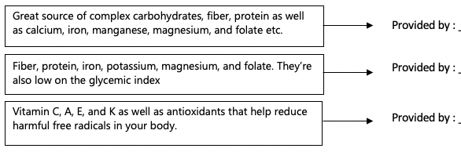
Quinoa
Black Beans
Bell Pepper

- Name 3 ways to tell if an avocado is ripe? A) Should give a little when you apply pressure. (Best to eat when they are softened but not mushy.) B) Look for dark colored skin. Light skin usually means it needs more time. C) If stem pulls back easy and green appears underneath

- Describe how to remove the pit. Carefully hit the pit with knife then twist the pit until it loosens

- What is oxidation? When flesh is exposed to air it turns brown.

- Describe how to store half an avocado. Wrap in plastic wrap and press down so it has complete contact with its surface then place in fridge for up to 2 days.

