What will make a delicious breakfast hash?

Use your creativity! List all the ingredients you can think of that would work in a breakfast hash.
Who are you cooking with?
___________________________________ &
___________________________________

MAJOR INGREDIENTS:
- Design your breakfast hash recipe.
- Maximum of 6 major ingredients (potato, egg, vegetables, cheese etc.)
- You may use 1 meat (slice of ham or bacon per person)
- Up to 60mL of cheese (cheddar, mozzarella, feta..)
- Decide the amount of each ingredient- total of all major ingredients (not including seasonings) should not be more than 600mL for 2 people and 725mL for 3 people

SEASONINGS BEING USED:
AMOUNT: | INGREDIENT:
250 mL | Diced Potato
 | Eggs
mL
mL

mL

mL

Think about the flavour palette you want to create. You may use up to 5 seasonings/herbs/spices:

AMOUNT: | INGREDIENT:
mL
mL
mL
mL
mL
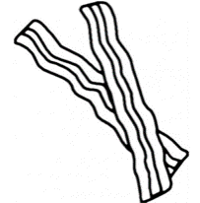
What is your garnish?
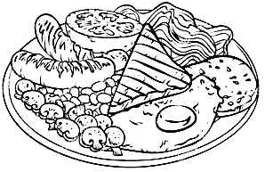
Who is responsible for what? Think of the different tasks, duties and responsibilities you and your partner(s) will need to complete:
List all the equipment you are going to need on your tray:

PERSON A:

PERSON B:

Think: what equipment will you need to pick up from the side table?

Cooking Instructions:

1. | If using bacon / sausage- Cook meat first in a frying pan on medium heat, then remove from pan and let rest on a plate lined with paper towel. Save the grease in the pan to use instead of oil to cook hash browns.  If not using meat- heat 10mL of oil in a large frying pan over medium heat.  Cook hash browns tossing often until they are warmed and beginning to brown.
2. | Add spices and herbs that you have chosen to use. (Try starting with half what you have chosen)
3. | Set table and begin to dice vegetables.
4. | When potatoes are almost done, add diced vegetables and or cubed ham.
5. | Cook vegetables, ham and hash browns until softened and warm.
6. | In a medium mixing bowl, beat eggs with 15mL of water.
7. | Reduce heat to LOW and push the cooked potato mixture to the side of the pan.
8. | Pour scrambled eggs into the space available in the pan.
9. | Continue to stir the egg mixture around the frying pan using a silicon spatula until the eggs are no longer liquid.
10. | Pull the cooked eggs into the potato mixture. Stir in cooked bacon/sausage pieces
11. | Top with the ingredients that do not require cooking such as cheese as well as your garnish, serve and enjoy!

