What will make a delicious breakfast hash?

Use your creativity! List all the ingredients you can think of that would work in a breakfast hash.
Who are you cooking with?
___________________________________ &
___________________________________

MAJOR INGREDIENTS:
- Pick your protein: 125mL beans or 1 portion of meat (ham, turkey, sausage or bacon per person)
- Select your choice of cheese (cheddar or mozzarella)
- Decide on the vegetables you want to include. They should add up to twice the amount of potatoes so approximately 500mL. Be specific with how much of each ingredient you want.

SEASONINGS BEING USED:
AMOUNT: | INGREDIENT:
250 mL | Diced Potato
2 | Eggs
 | Protein choice
60mL | Cheese choice =
Think about the flavour palette you want to create. What seasonings do you want?
**remember that our hasbrowns only used 0.5mL of each spice so don’t use too much!

AMOUNT: | INGREDIENT:
mL
mL
mL
mL
mL

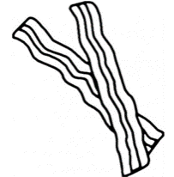
What is your garnish?
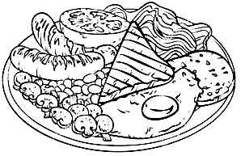
Who is responsible for what? Think of the different tasks, duties and responsibilities you and your partner(s) will need to complete:
List all the equipment you are going to need on your tray:

PERSON A:

PERSON B:

Think: what equipment will you need to pick up from the side table?

Cooking Instructions:
1. | If using bacon / sausage- Cook meat first in a frying pan on medium heat, then remove from pan and let rest on a plate lined with paper towel. Save the grease in the pan to use instead of oil to cook hash browns.  If not using meat- heat 10mL of oil in a large frying pan over medium heat.  Cook hash browns and other dense vegetables tossing often until they are warmed and beginning to brown.
2. | Add spices and herbs that you have chosen to use. (Try starting with half what you have chosen)
3. | Set table and begin to dice vegetables.
4. | When potatoes are almost done, add diced vegetables and cubed ham/ beans is using
5. | Cook vegetables, meat and hash browns until softened and warm.
6. | In a medium mixing bowl, beat eggs with 15mL of water.
7. | Reduce heat to LOW and push the cooked potato mixture to the side of the pan.
8. | Pour scrambled eggs into the space available in the pan.
9. | Continue to stir the egg mixture around the frying pan using a silicon spatula until the eggs are no longer liquid.
10. | Pull the cooked eggs into the potato mixture. Stir in cooked bacon/sausage pieces
11. | Top with the ingredients that do not require cooking such as cheese as well as your garnish, serve and enjoy!

