Chemistry 11 – Course Outline
Mr. Marques
Room: C231
E-Mail: marques_j@surreyschools.ca
This is an introductory course for Chemistry students looking to enter the physical or medical sciences. Students looking to apply to university, college, or other specialty post secondary programs will find this course will count towards your overall GPA when applying to those institutions…..in other words, what you do here matters!!!!
General Classroom Expectations
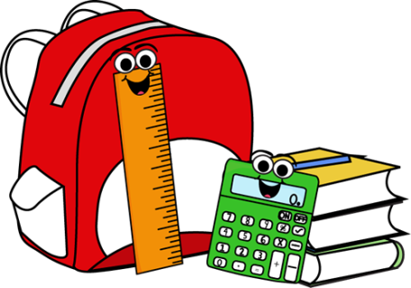
Materials – What should you be bringing with you to every class?
Pencil, Pen, Scientific Calculator(EXP,√,x²), Ruler, Binder, Highlighters, Data Booklet, Paper
Cell Phones are NOT required!!!! Students unable to control their cellphone use will have their phones confiscated and a conversation between myself and parents will occur.

Absences and Lates – What happens if you are late or absent?

If you are late, simply walk in and get busy. If we are going through notes or working on an activity simply find out what you’ve missed and get caught up. Frequent lates means we have to have a discussion possibly including parents and a plan to get you here on time. If you miss one or more classes, it is your job to get caught up and get any materials you have missed.

Missing tests or quizzes are an automatic zero, the zero will be changed when I get a note from a parent and/or guardian excusing you for the missed quiz, test, or assignment.

Marks – How are marks spread through the course and where can you see them?

All marks are entered into Freshgrade, we will go over how to check your account so you can view your marks anytime.
Assessments
Quizzes - 10%
Labs - 10%
Tests - 60%
Cumulative Final - 20%
Final can replace lowest test or overall class mark
Letter Grades
A - 86% to 100%
B - 73% to 85%
C+ - 67% to 72%
C - 60% to 66%
C- - 50% to 65%
F - 0% to 49%

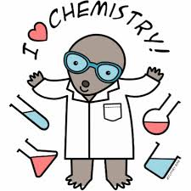
Unit 1 - Numbers, Measurements, and Conversions
Time: 2 Weeks
- Introduction to Significant Figures and Scientific Notation
- Learning to Convert Between Units
- Learning to Read Scales on Measuring Devices

Unit 2 – Introduction to the Mole
Time: 3 Weeks
- Learning to Work With the Mole
- 1-Step and 2-Step Mole Conversions(Number, Volume, Mass)
- Interpreting Molar Ratio and Molar Mass
- Determining Unknown Hydrate, Empirical, and Molecular Formulas

Unit 3 – Stoichiometry
Time: 4 Weeks
- Writing Full Chemical Reactions(Balancing and Predicting Products)
- Connect Any Two Chemicals in a Chemical Reaction via Molar Ratios
- Convert Between Mass, Volume, Moles, Number, and Heat in a Reaction
- Determining Limiting and Excess Reactants

Unit 4 – Atomic Theory
Time: 3 Weeks
- Periodic Table Basics, Patterns, and Isotopes
- Updated Atomic Theory, Electron Configurations, and VSEPR
- Drawing Covalent Molecules

Unit 5 – Solution Chemistry
Time: 3 Weeks
- Solution Basics and Molarity Calculations
- Dilution and Ion Calculations
- Predicting Precipitate Formation

Unit 6 – Atomic Theory
Time: 2 Weeks
- Periodic Table Basics and Patterns
- Updated Atomic Theory, Electron Configurations, and VSEPR
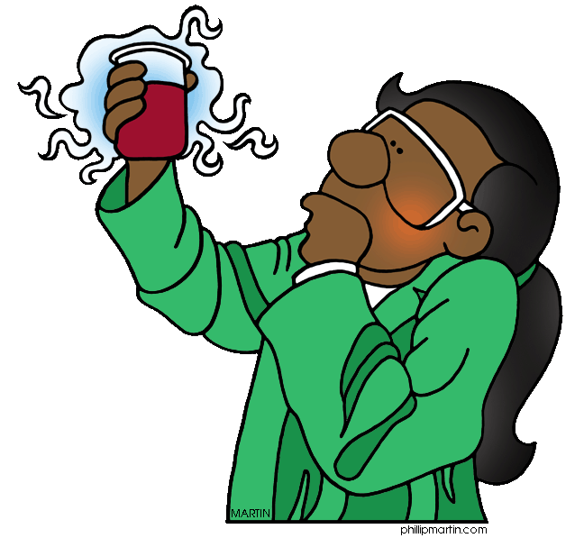
- Drawing Covalent Molecules

Unit 7 – Organic Chemistry
Time: 2 Weeks
- Organic Chemistry Nomenclature
- Basic Organic Reactions
Core Competencies

How we approach learning has changed over the years. Instead of simply memorizing information and regurgitating it back to me as many of you have done in science, you will now be assessed on specific core competencies. These competencies assess your abilities as a whole taking into account both what you do in the class academically, but additionally how you interact with others, how you communicate your ideas, and how you personally develop over time.

It is expected from now on that you maintain a record of what you have accomplished by citing specific pieces of evidence that demonstrate growth and improvement.

Areas that will be covered by the Core Competencies:
- Communication -The communication competency encompasses the set of abilities that students use to impart and exchange information, experiences and ideas, to explore the world around them, and to understand and effectively engage in the use of digital media.

- Thinking - The thinking competency encompasses the knowledge, skills and processes we associate with intellectual development. It is through their competency as thinkers that students take subject-specific concepts and content and transform them into a new understanding. Thinking competence includes specific thinking skills as well as habits of mind, and metacognitive awareness.

- Personal and Social - Personal and social competency is the set of abilities that relate to students' identity in the world, both as individuals and as members of their community and society. Personal and social competency encompasses the abilities students need to thrive as individuals, to understand and care about themselves and others, and to find and achieve their purposes in the world.

From now on, whenever we do any activity or classwork, you should be thinking, “How am I meeting these three competencies and what proof do I have of it? You don’t have to hit all three areas at once but you should have evidence of meeting parts of them every day.

