Cross Country Running

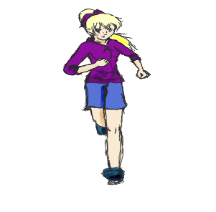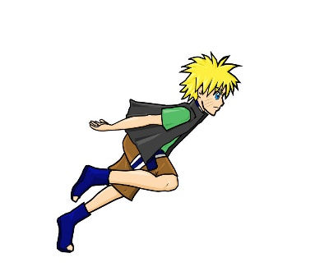

Hello Latimer Road Families!

Latimer Road is looking for students to participate in Cross Country, a long distance running competition held within the school district every September and October. All grades 3-7 are invited to practice running with us. The goal is for students to run 1.2km for grades 3 and 4 or 2km for students in grades 5, 6, and 7. Competition meets are held at Fleetwood Park on September 18 and 25 and October 2, 9, and 16. On competition dates, students are expected to arrive at Fleetwood Park by 3:00 PM and must have their own transportation to and from the event to compete. Practices will begin September 12. Another notice will be coming home next week to outline the practice schedule.

Any questions, please contact Mrs. Hillen at Latimer Road.

