Applicant’s Name:

Name of Reference: _________________________________________________________________ U

Position / Employer:

Thank you for providing your observations of this applicant’s leadership work and your assessment of their potential in the above position. The Surrey School District will ensure that the information you provide is kept confidential, in accordance with the Freedom of Information and Protection of Privacy Act.

Please forward directly to the Superintendent’s Department, Surrey School District
by e-mail: 1USUPR-Office@surreyschools.caU1T or by fax: 604 595 6309
In what capacity have you known the applicant?

How long have you known the applicant?

- Using the Leadership Competencies below, please select 3 phrases that you feel best describe the candidate.

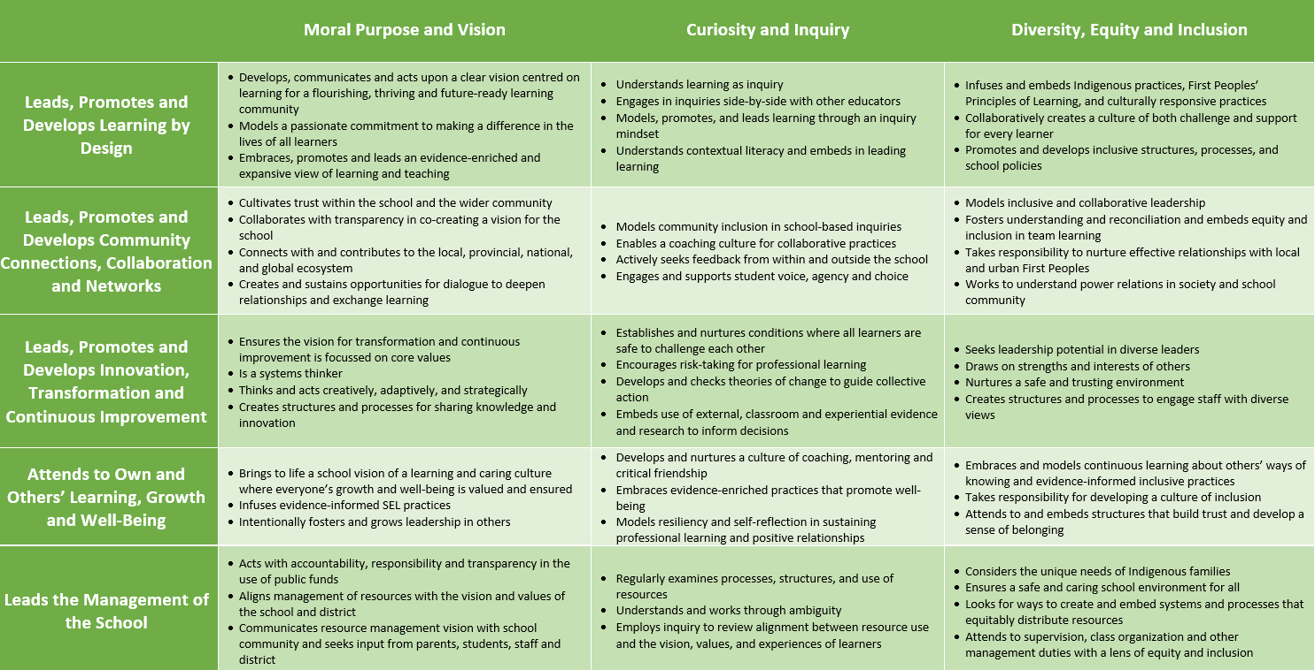

 | Competency | Why selected? | Provide your best example from their work that shows how they demonstrated this competency.
a.
b.
c.

- From the above competency chart please name two areas for professional growth for the candidate. Please explain why you chose those areas. If you are unable to choose two areas for growth, please identify why.

- Provide an example in which the candidate built a trusting relationship in the face of adversity.

- Describe an example of when the candidate has demonstrated learning leadership in relation to Surrey's priority practices.

- Provide an example in which the candidate modelled self-reflection.

escribe an example of when the candidate has demonstrated instructional leadership.

6. Would you like to be led by this person? | Yes | No
7. Would you recommend this individual for the position sought? | Yes | No
8. Would you hire or rehire this individual for this position in your district? | Yes | No

9. Optional: please provide any other information you believe we should know about the candidate.

Signature of Reference: Date:
Email Address: Telephone:
please indicate home, office, cell

Please send your completed document to supr-office@surreyschools.ca

