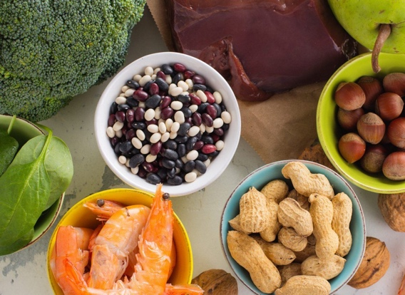
Folate – Vitamin B9

This handout was adapted from an articles posted March 2019 from unlockfood.ca

Folate is a B-vitamin that is naturally present in many foods.
Folate (vitamin B-9) is important in red blood cell formation and for healthy cell growth and function. The nutrient is also crucial during early pregnancy. During the first four weeks of pregnancy when most women do not even realize they are pregnant, folic acid is needed for the proper development of the baby’s brain, skull and spinal cord. Serious birth defects called neural tube defects are less likely to happen when women take 0.4 milligrams of folic acid daily.

What is the difference between folate and folic acid?

Folate and folic acid are different terms for the same B vitamin. Folic acid is the form found in vitamin supplements while folate is the form found in food.
What is the neural tube?
The neural tube is the part of the developing baby that becomes the brain and spinal cord. Birth defects occur when the neural tube does not fully close during the early weeks of pregnancy. This results in spine, brain and skull defects that can lead to stillbirth or lifelong disability

Why do I need folate?

- To help prevent anemia. Without enough folate to make healthy red blood cells you may feel weak or tired and find it hard to concentrate.
- For a healthy heart. Folate keeps both the blood vessels and heart healthy.
- To reduce the risks of some birth defects. When women of child-bearing age take folic acid before and during pregnancy, the risks of birth defects are reduced.

How can I get enough folate?

To get enough folate eat a variety of healthy foods by following Canada’s Food Guide. Individuals 14-50 years of age should aim to have 400mcg of Folic Acid daily. Use the nutrition facts table to compare and choose foods that have a good source of folate. While it is recommended that people get most of their nutrients naturally from food, health experts do recommend that all women over the age of 14 take a folic acid supplement of 0.4mg a day.

What foods are good sources of folate?

- Vegetables (especially asparagus, brussels sprouts, broccoli, and dark green leafy vegetables such as spinach and romaine lettuce
- Orange juice, canned pineapple juice, cantaloupe, honeydew, grapefruit juice, banana, raspberries, grapefruit, strawberries
- Nuts, beans, and peas (such as peanuts, black-eyed peas, and kidney beans)
- Enriched bread, flour, cornmeal, pasta, and rice
- Fortified breakfast cereals

