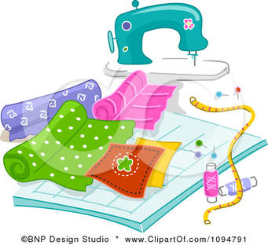

Fashion & Design 8
Course Outline

Objectives:

To develop your basic understanding of clothing & textiles.
To develop applied skills in clothing preparation and care.
To develop a basic understanding of the use and application of sewing equipment.

Contents:
1. Teamwork

2. Safety in the Textiles program and with the use of sewing equipment.

3. Fabric Construction and Care.

4. Body measurements & pattern selection.

5. Terminology, use, and interpretation of pattern
symbols.

6. Introduction to Sewing Equipment
– setting up and operation of the basic machine
- the use of an iron
- basic garment contruction equipmen.

7. Basic garment constructions – plain seam
- seam finish
- plain hem
- waistband technique.
Evaluation:

1. Written work- worksheets and quiz. 30 %

2. Practical work- machine work, samples and boxers. 70 %

3. Work Habits – based on use and care of equipment.
- cleaning and organizing of work stations.
- behavior and attitude within class.
- completing assigned work on time.
- working in a safe and responsible manner.
Materials:

3 ring binder or folder
pen ( blue or black) or pencil
Fabric- 100 % woven cotton
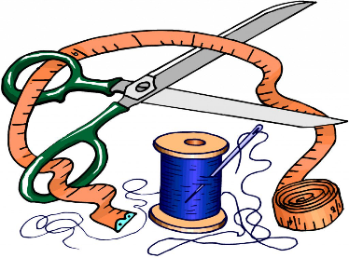
Matching thread
Elastic – 2.5 cm wide and length of your waist.

"What you wear is how you present yourself to the world, especially today, when human contacts are so quick. Fashion is instant language." —Miuccia Prada

