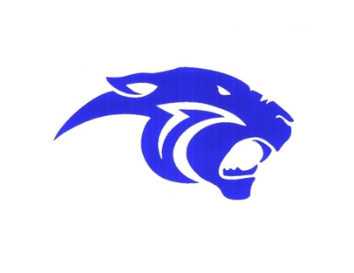

James Ardiel Elementary School
13751 – 112th Avenue, Surrey, B.C. V3R 2G4 Phone: 604-588-3021

August 27, 2021

Hello James Ardiel Families,

We hope you had time to rejuvenate and reconnect with family and friends over the summer. Tuesday, September 7th is our first day back for the start of next year and we are looking forward to welcoming all of the students back.

The first day, September 7th, will be from 10:00Am to 11:00AM. In additional to meeting all of the students, it is a day for us to confirm student numbers, ensure staffing is in place, and outline to students any new procedures for the year.

We are expecting to hear more information from the government and the school district about any new specific Covid guidelines. Early next week we will share these updates with everyone. At the same time, please look for more traditional startup information, such as first day procedures.

Enjoy the remainder of the summer,

James Ardiel Admin team

