École Woodward Hill Elementary
6082 – 142nd St., Surrey, B.C. V3X 1C1
PH: 604-594-2408  Fax: 604-594-2336  www.surreyschools.ca/schools/woodwardhill

Dear Woodward Hill families,

The purpose of this communication is to share specific information on our planning for September 10 and 11 and to remind our families about Surrey Blended. Please read the information carefully and contact the office if you have specific questions.

All parents interested in registering for the Surrey Blended Transition program will need to complete this form by 4:00 p.m. September 8, 2020.

For students attending full time face-to-face – READ THE INFORMATION BELOW CAREFULLY

Thursday and Friday September 10 and 11

Grades 1, 2, 3, 4
9am Students report to their assigned locations (see map below and attached student list) on the grass field where they will be met by a teacher. Please contact the office if your child is not on the list or there is an error. Teachers will take their groups to their classrooms for attendance and school orientation. Social distancing will be mandatory this week as students are not yet in their cohorts. 10am dismissal on the grass field.

Grades 5, 6, 7
11am Students report to their assigned locations (see map below and attached student list) on the grass field where they will be met by a teacher. Please contact the office if your child is not on the list or there is an error. Teachers will take their groups to their classrooms for attendance and school orientation. Social distancing will be mandatory this week as students are not yet in their cohorts. 12pm dismissal on the grass field.

Kindergarten*
12:30 Thursday September 10 Group A only
Students report to their assigned locations on the grass field where they will be met by a teacher. Please help your child maintain social distancing. Teachers will take their groups back to their classrooms for attendance and school orientation. Social distancing will be mandatory this week as students are not yet in their cohorts. 1:30 dismissal on the grass field.

12:30 Friday September 11 Group B only
Students report to their assigned locations on the grass field where they will be met by a teacher. Please help your child maintain social distancing. Teachers will take their groups back to their classrooms for attendance and school orientation. Social distancing will be mandatory this week as students are not yet in their cohorts. 1:30 dismissal on the grass field.

*Kindergarten families are asked to carefully review the information that will be forwarded in a separate email.

MAPS

This is the map for GRADE 1 – 4
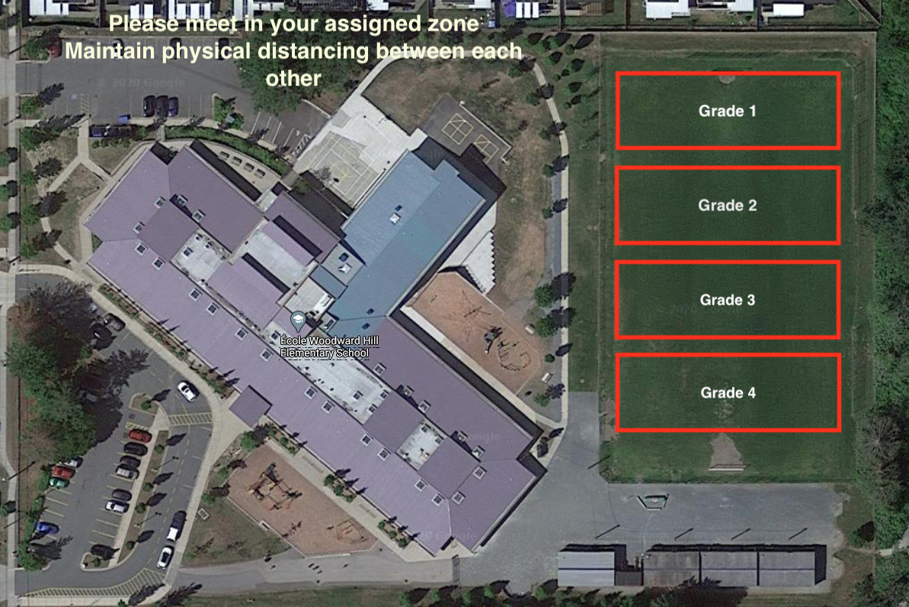

This is the map for Grade 5 - 7
