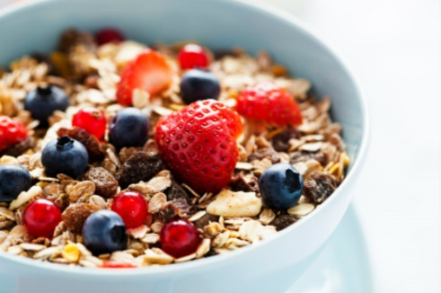
Focus on Fibre
This handout was adapted from articles written and reviewed by Dietitians of Canada and the Association of UK Dieticians.
What do chickpeas, apples and almonds have in common? They all contain fibre.
Dietary fibre is the part of plants that you eat but which doesn’t get digested in your small intestines. Instead it is completely or partially broken down by bacteria in your large intestine. Once broken down in your large intestine the dietary fibre helps to increase good bacteria in your gut. This improves your immune system.
Eating a diet rich in fibre can also help to:
- Keep you regular by improving constipation
- Reduce inflammation in your gut
- Lower your total cholesterol and blood pressure
- Control your blood glucose (blood sugar)
Research shows that fibre may also help you maintain a healthy body weight and lower your risk of heart disease, type 2 diabetes and colon cancer.

How can I eat with this in mind?

Choose fibre rich foods from a variety of sources including wholegrains, fruit and vegetables, nuts and seeds, beans and pulses. When you read food labels, check for the grams of fibre per serving or per 100g.

What are you looking for on a nutrition label?
High fibre | Source of fibre
6g per 100g | 3g or more per 100g

What are the 2 different kinds of fibre?
Insoluble fibre helps to keep you regular. Insoluble fibre is found in some vegetables and fruit, whole grains and wheat bran.
Soluble fibre helps to lower cholesterol and control blood glucose. Soluble fibre is found in some fruits like apples and oranges, vegetables like carrots, okra and eggplant, oats, barley, psyllium, and legumes like beans and lentils.
It is important to eat a variety of fibre-rich foods to get the health benefits of both types of fibre.

How much fibre do I need?
Many people only get half the amount of fibre they need. The amount you need depends on how old you are and whether you are male or female.
Age group | Recommended amount per day
Boys 9-13 years old | 31 grams
Boys 14-18 years old | 38 grams
Girls 9-13 years old | 26 grams
Girls 14-18 years old | 26 grams

How can I get more fibre in my diet?
- Read food labels and choose products with more fibre in them
- Start your day with a high fibre cereal and also add nuts and seeds
- Keep a supply of frozen vegetables so you are never without
- Choose whole wheat pasta or brown rice
- Eat chunky peanut butter with apple slices or celery sticks
Remember to drink plenty of water to allow the fiber to do its job properly. Fibre draws water into the bowels so you need to drink plenty of water!
- Substitute whole grain wheat, teff or sorghum flour in place of white flour when baking
- Choose whole vegetables and fruits instead of juice. Even 100% juice does not have as much fibre as whole vegetables and fruit.
- Leave the skin on vegetables and fruit when possible
- Add fresh berries or dried fruit to your favourite yogurt or cereal.
- Spread hummus on whole grain flat bread, naan or roti.
- Add soybeans to soups, stir-fry dishes and casseroles.
- Add ground flaxseeds to cereal, porridge, roti or tortilla dough or dahl.
- Mix almonds, sunflower seeds and pine nuts and have a small handful as a snack.
- Add hazelnuts or dried coconut to baked muffins.
The bottom line
Getting more fibre can be easy by making small changes that will add up throughout the day. Foods like vegetables and fruit, whole grains, legumes, nuts and seeds have the fibre you need. When grocery shopping, compare food labels and choose foods with 3 grams of fibre or more per serving.

Some of the best fibre rich food choices are:
 | Total fibre per 100g*
Shredded whole wheat or bran cereals | 13-24.5g
Wholemeal bread (two slices) | 7.0g
Wholemeal spaghetti (boiled) | 4.2g
Figs | 6.9g
Strawberries | 3.8g
Parsnip (boiled) | 4.7g
Broccoli (boiled) | 2.8g
Almonds | 7.4g
Peanuts | 7.6g
Sesame | 7.9g
Sunflower seeds | 6.0g
Peas (boiled) | 5.6g
Baked beans (in tomato sauce) | 4.9g
Green beans (boiled) | 4.1g

