HUNGRY MONSTER PILLOW
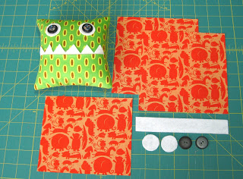
1. Pin square pattern pieces to fabric and cut out 3 squares.
Pin teeth and circle pattern to felt and cut out two eyes and one set of teeth.

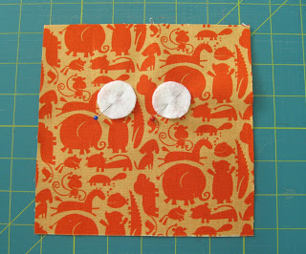
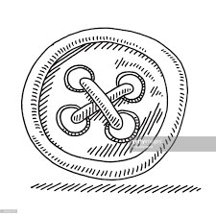
2. Position the felt circles for the eyes on the right side of the fabric (see sample for proper placement) and pin in place.
3. Attach a button in the center of each felt circle through all layers starting from underneath. Secure the button by stitching through each hole 2-3X.

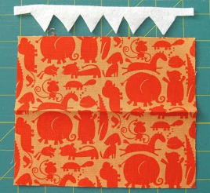
4. Take the smaller square (5 1/2" x 6 1/2") and fold it in half along the longer side, pressing to create a strong crease.

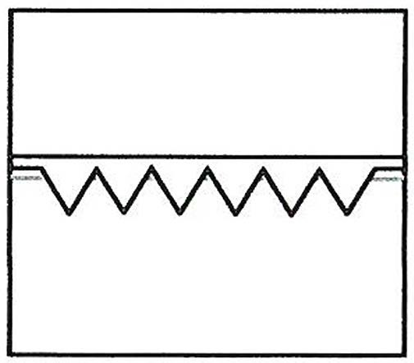

5. Open fabric so that the right side is facing up. Pin the felt teeth on the right side of the fabric pointing down just above the crease as shown in the sample. *Have teacher check!

6. Stitch teeth in place by placing the pressure foot along the straight edge. Remember to backstitch. (See sample for proper placement of teeth and stitching line)

7. To finish the mouth refold square in half along the crease line so that the teeth stick up and the stitching line is hidden underneath.

8. Pin the finished mouth to the lower portion of the square with the attached eyes. Line up your pressure foot with the fabric edge and stitch a line along the three outside edges. (See sample)

9. Place the square with the face right sides up on the table. Cover the face with the last square of fabric so that the wrong side is facing up and the right side is down. Pin together. *Have Teacher Check!

10. Use the 5/8 guideline to line up the outside edge of the fabric then sew the edges together. Leave a 3" opening on the bottom. Remember to backstitch at beginning and end of stitching line. (See sample)

10. Clip excess fabric away at all four corners to reduce the bulk (see last sample for how to trim)

11. Turn the fabric right side out by gently pulling it through the opening.
12. Carefully push the corners out with the back of a pencil then stuff with cotton balls or fiberfill.

13. Hand stitch the opening closed with thread.
14. Find something fun to hide in your monster's mouth!

