IB Mathematics: Analysis and Approaches SL 11
Mr. Kim – Fall 2021 (Room 110)

Contact
- Mr. H. Kim
- Use Microsoft Teams messages (faster)
kim_hunnee@surreyschools.ca (slower)
- Room 110

Course Overview
This course is based on the IB Mathematics: Analysis and Approaches guide. From the guide: “This course recognizes the need for analytical expertise in a world where innovation is increasingly dependent on a deep understanding of mathematics. This course includes topics that are both traditionally part of a pre-university mathematics course (for example, functions, trigonometry, calculus) as well as topics that are amenable to investigation, conjecture and proof, for instance the study of sequences and series at both SL and HL, and proof by induction at HL. The course allows the use of technology, as fluency in relevant mathematical software and hand-held technology is important regardless of choice of course. However, Mathematics: analysis and approaches has a strong emphasis on the ability to construct, communicate and justify correct mathematical arguments.
Read the guide and be aware of:
- The IB mission statement
- The IB learner profile
- The aims of DP mathematics courses (page 22)
In this course students are responsible for studying five mathematical topics:
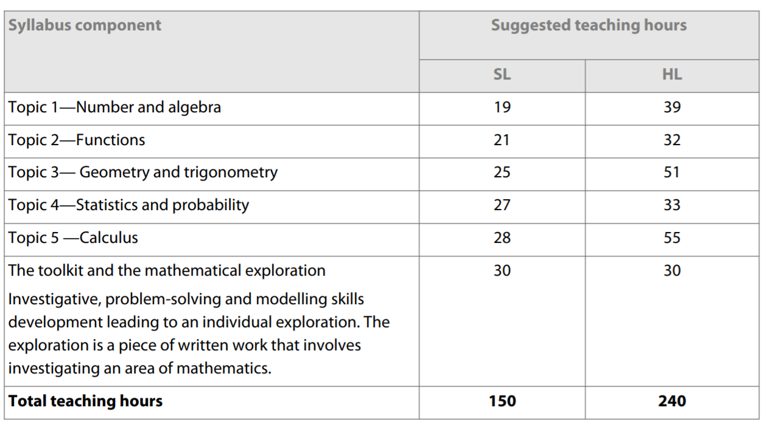
In addition to these five compulsory topics, students are also required to be familiar with the topics listed as prior learning (page 26).

Assessment
Students will write an externally graded IB exam at the end of their two-year programme in May 2021:
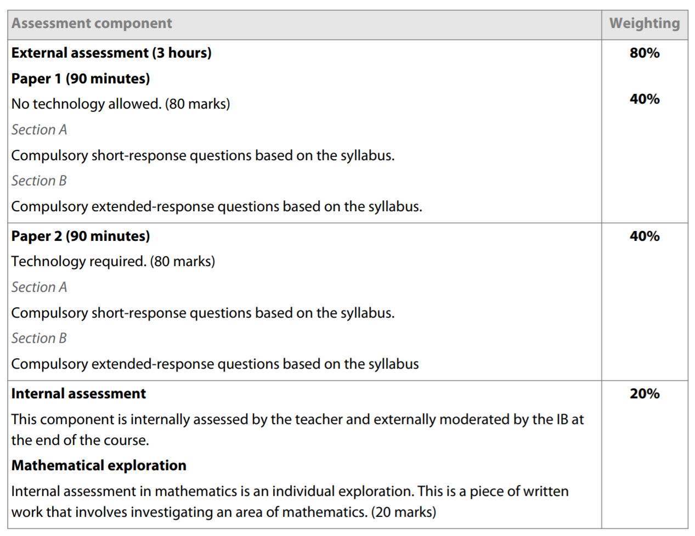
The IB exam, written in May when a student is Grade 12, is worth 80% of a student’s IB grade and students will work on a mathematical exploration paper graded by the teacher worth 20%. See page 74 in the guide for more details about the external IB exam assessment.
Students will begin their mathematical exploration (the internal assessment) during their Grade 12 year. Some details about this paper is found in the guide on page 83.
Students will receive a predicted IB Grade between 1 to 7 based on the following grade descriptors:
Grade 7 - Demonstrates a thorough knowledge and comprehensive understanding of the syllabus; successfully constructs and applies mathematical arguments at a sophisticated level in a wide variety of contexts; successfully uses problem-solving techniques in challenging situations; recognizes patterns and structures, makes generalizations and justifies conclusions; understands and explains the significance and validity of results, and draws full and relevant conclusions; communicates mathematics in a clear, effective and concise manner, using correct techniques, notation and terminology; demonstrates the ability to integrate knowledge, understanding and skills from different areas of the course; uses technology correctly in challenging situations—makes efficient use of calculator’s functionality when required.
Grade 6 - Demonstrates a broad knowledge and comprehensive understanding of the syllabus; successfully constructs and applies mathematical arguments in a variety of contexts; uses problem-solving techniques in challenging situations; recognizes patterns and structures, and makes some generalizations; understands and explains the significance and validity of results, and draws relevant conclusions; communicates mathematics in a clear and effective manner, using correct techniques, notation and terminology; demonstrates some ability to integrate knowledge, understanding and skills from different areas of the course; uses technology correctly in routine situations—makes efficient use of calculator’s functionality when required.
Grade 5 - Demonstrates a broad knowledge and good understanding of the syllabus; applies mathematical arguments in performing routine tasks; successfully uses problem solving techniques in routine situations; successfully carries out mathematical processes in a variety of contexts, and recognizes patterns and structures; understands the significance of results and draws some conclusions; communicates mathematics effectively, using appropriate techniques, notation and terminology; demonstrates an awareness of the links between different areas of the course; makes use of calculator’s functionality when required—may occasionally be inefficient.
Grade 4 - Demonstrates a satisfactory knowledge of the syllabus; applies mathematical arguments in performing some routine tasks; uses problem-solving techniques in routine situations; successfully carries out mathematical processes in straightforward contexts; shows some ability to recognize patterns and structures; has limited understanding of the significance of results and attempts to draw some conclusions; communicates mathematics adequately, using some appropriate techniques, notation and terminology; makes some use of calculator’s functionality, but perhaps not always when required—may be inefficient at times.
Grade 3 - Demonstrates partial knowledge of the syllabus and limited understanding of mathematical arguments in performing some routine tasks; attempts to carry out mathematical processes in straightforward contexts; makes an attempt to use problem-solving techniques in routine situations; communicates some mathematics, using some appropriate techniques, notation or terminology; occasionally uses calculator’s functionality, but often inefficiently; does not always use it when required and may use an inefficient analytic approach.
Grade 2 - Demonstrates limited knowledge of the syllabus; attempts to carry out mathematical processes at a basic level; communicates some mathematics, but often uses inappropriate techniques, notation or terminology; unable to use calculator correctly when required—questions exclusively requiring the use of the GDC are generally not attempted.
Grade 1 - Demonstrates minimal knowledge of the syllabus; demonstrates little or no ability to use mathematical processes, even when attempting routine tasks; communicates only minimal mathematics and consistently uses inappropriate techniques, notation or terminology; is unable to make effective use of technology.

report card marks
As required by the Ministry of Education, students will also be given a percentage converted from the IB level that reflects their achievement in relation to the corresponding BC Curriculum course. Also, for partial IB students, IB course may be combined with an approved high school credential for the purpose of admission to many universities. For instance, UBC uses the following conversions.
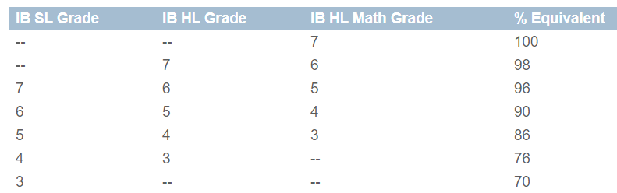

pedagogical approach
This course will integrate the following teaching concepts:
- Approaches to Teaching and Learning
  - Deliberate strategies, skills and attitudes will permeate the teaching and learning environment in order to empower students to achieve their academic goals
  - Students will be challenged to develop their: thinking skills, social skills, communication skills, self-management skills and research skills.
  - Teaching will include elements of inquiry, be concept-focused, contextualized, collaborative, differentiated, and informed by assessment.
- Mathematics and Theory of Knowledge
  - The relationship between each subject and theory of knowledge (TOK) is important and fundamental to the DP. Students will be encouraged to explore tensions relating to knowledge in mathematics.
  - Links to TOK from the guide will be integrated throughout this course.
- The Mathematics Toolkit
  - Students will be encouraged to think like a mathematician; they will develop a mathematical toolkit which will allow them to approach a greater variety of mathematical problems.
  - Students will develop the following five parts of this toolkit:
    - Cognitive activators – students will be motivated to explore new concepts at the beginning of a new topic.
    - Conceptual understanding – core mathematical ideas that connect topics throughout the syllabus will be emphasized.
    - Using technology – students will learn how to use technology with fluency and efficiency.
    - Mathematical modelling – students will learn how to create and test a model. They will be encouraged to reflect and make improvements.
    - Proof – rather than simply memorizing formulas, students will be encouraged to understand how theorems and formula are discovered.

Resources
- This year we will be using the Cambridge IB Mathematics textbook and focus primarily on the first 10 chapters. Students will also be exposed to problems inspired from other IB resources including exam-style questions.
- Online resource: canvas.instructure.com

Expectations
- Have a positive mindset and learn how to manage stress well. Get enough sleep, eat well, exercise, and adhere to a realistic study schedule.
- Attend classes and be on-time. Every day of learning helps you unlock your future potential.
- Be on-task. Work on school material during class time. If a student is confident with the course material, he or she should help other students or work on more challenging material.
- Be assertive and ask for help when needed.
The best time to clarify a concept is during class time with the support of your teacher and your peers.
- Do not request higher grades. Students are challenged to raise their skill to match the expectations of the course. If a student performs poorly on one assessment, they should learn from their mistakes and focus on doing well on future assessments.
- Write tests on time. If there is a family or health emergency, you must email Mr. Kim before the test date. It is an unfair advantage to delay writing a test.
- Parents / guardians should be aware of their child’s academic progress. Contact Mr. Kim anytime on Teams or by email.
- Be concise with your communication on Teams – students are encouraged to talk with Mr. Kim in person.
- Keep the class clean. Respect social distancing, wear a mask, wash your hands well, and keep the class clean.
- Be kind to other students. Be appropriate with your actions and sense of humor towards others.
My hope is that you will improve your math skills in this course and be well prepared to achieve your academic goals in your next math course. Be proud of your effort and be patient in improving your math skills.
I hope that you will contribute to Semiahmoo’s reputation of academic excellence and work hard towards a brighter future.

Mr. Kim
kim_hunnee@surreyschools.ca

hunkim.com/guide.pdf

