Placing an order with Munch a lunch:
- Click on Order:
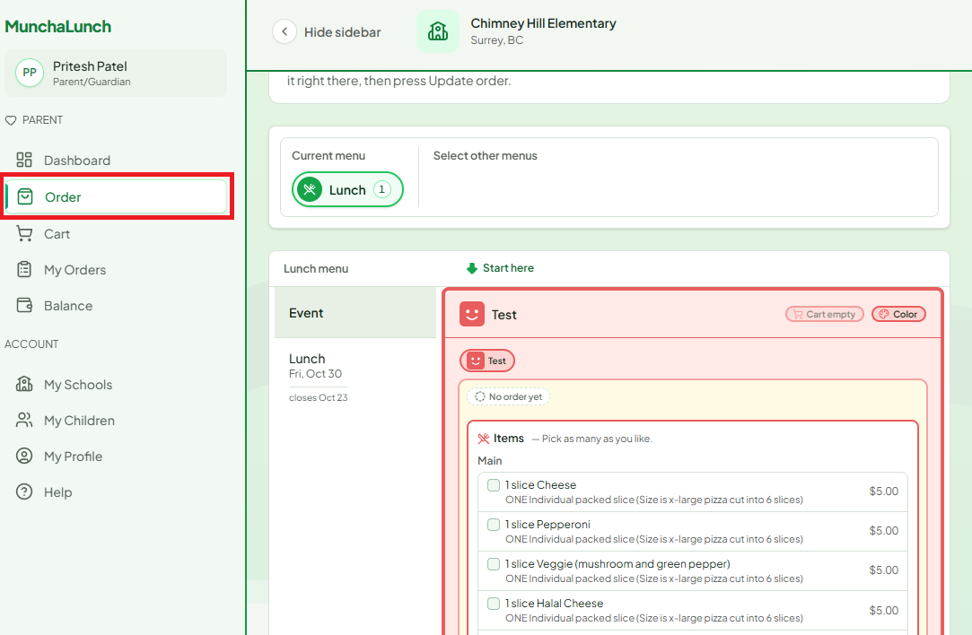
- Select an item to order from the list:
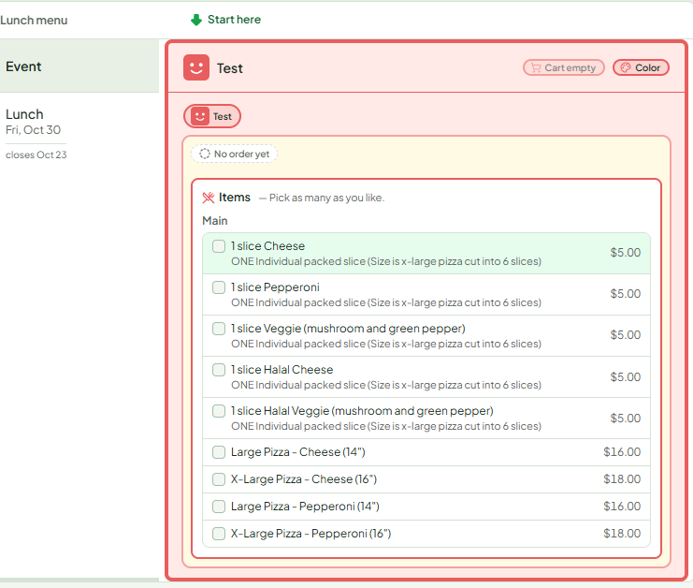
- Adjust the number of items you would like to order if needed
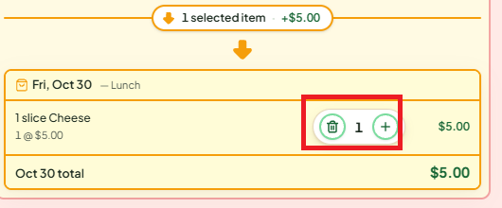
- Click Checkout
- Click Continue to Payment
- Enter your payment details and click Pay
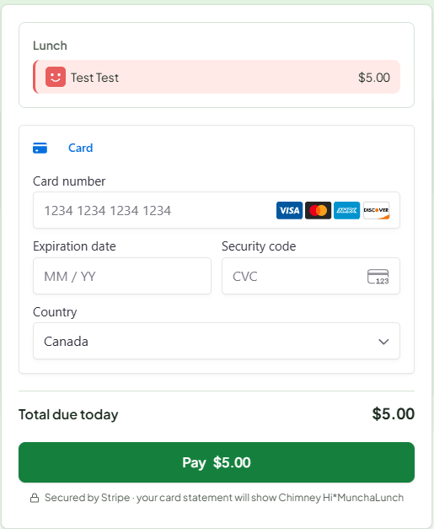
- You will receive an email notification confirming your order

