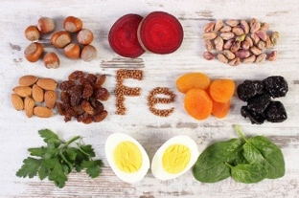
How To Get More Iron

This article was written and reviewed by dietitians from Dietitians of Canada. Last Update - March 2019

Iron is a mineral naturally found in many foods. It is also added to some foods through fortification. Iron is important for good health. Your body needs it to make blood cells that carry oxygen to your lungs, muscles and all the parts of your body. Iron is also needed for growth, development and to make specific hormones.
How much iron do I need?
Did you know that now that you are a teenager you need more iron?
Girls need 15mg /day
Boys need 11mg/day
The amount of iron you need depends on your age and gender. Vegetarians need to eat twice as much iron as non-vegetarians because the iron in plant foods it not absorbed as well by your body.
If you don’t get enough iron from foods or you don’t absorb enough, you may be at risk of iron deficiency. Iron deficiency may be treated with iron supplements as well as eating more iron-rich foods.
What is iron deficiency?
Iron deficiency (known as iron-deficiency anemia) means that you have low amounts of iron in your body. Your red blood cells become small and pale in colour. This makes it hard for your red blood cells to carry oxygen throughout your body. Individuals with iron deficiency experience symptoms such as:

- Weakness and fatigue,
- Fast or irregular heartbeat
- Dizziness, headache, fainting or vertigo
- Feeling cold
- Pale-looking skin
- Trouble focusing or concentrating
What foods have iron?
Iron is found in a variety of animal foods, plant foods and iron fortified products. There are two types of iron – heme and non-heme. Heme iron is found in animal foods. Non-heme iron is found in plant foods. Heme iron is better absorbed in the body than non-heme iron. Combine foods that contain non-heme iron with foods that have Vitamin C to increases the absorption of iron from plant sources.
Sources of heme iron (animal foods) |  | Some Sources of non-heme iron (plant foods)
Meat | Beef, pork, poultry, lamb, duck, venison | Tofu | Extra firm has more iron than soft, medium or firm
Organ meat | Liver, kidney | Legumes | Red, green, brown lentils, black-eyed peas, split peas, chickpeas, soybeans, black beans, white beans, pinto beans, kidney beans
Seafood | Oysters, shrimp, octopus, clams, scallops, crab | Nuts and seeds | Almonds, cashews, hazelnuts, pistachios, soy nuts, Pumpkin seeds, sunflower seeds, sesame seeds
Fish | Mackerel, trout, bass, tuna, sardines | Vegetables | Cooked spinach, asparagus, beets, beet greens, turnip greens
Eggs | Chicken, duck, quail | Grain products | Enriched cold cereals, pasta, instant oatmeal, oat bran cereal, cream of wheat
What you need to know about Vitamin C

This handout was adapted from an articles posted March 2019 from unlockfood.ca

Vitamin C is a water soluble vitamins that is not stored in the body and must be consumed each day because whatever we don’t need or use, will be removed in our urine. It is also sensitive to light, air and heat so you will get the most Vitamin C from eating fresh fruits and vegetables that are eaten raw or lightly cooked. Vitamin C is best known for causing a disease called scurvy that led to the death of millions of sailors who did not have access to fresh fruits and vegetable during their long voyages. Scurvy is rare now adays and individuals can easily meet their nutritional needs for Vitamin C by following Canada’s Food Guide and eating a variety of vegetables and fruit daily.

Vitamin C has many important functions in the body.

- It helps the body absorb the iron from plant foods
How much vitamin C do I need per day?

Age group | Recommended per day
Boys 9-13 years old | 45 mg
Boys 14-18 years old | 75 mg
Girls 9-13 years old | 45 mg
Girls 14-18 years old | 65mg
Because smoking depletes Vitamin C, people that smoke needs an additional 35mg per day
- Keep your gums healthy.
- Protect you from bruising and helps to heal cuts and wounds.
- Produces the tissue that holds muscles and bones together.
- Form and repair blood, bones and other tissues.
- Reduces the risk of some cancers
- May prevent the signs of aging because it is an antioxidant.
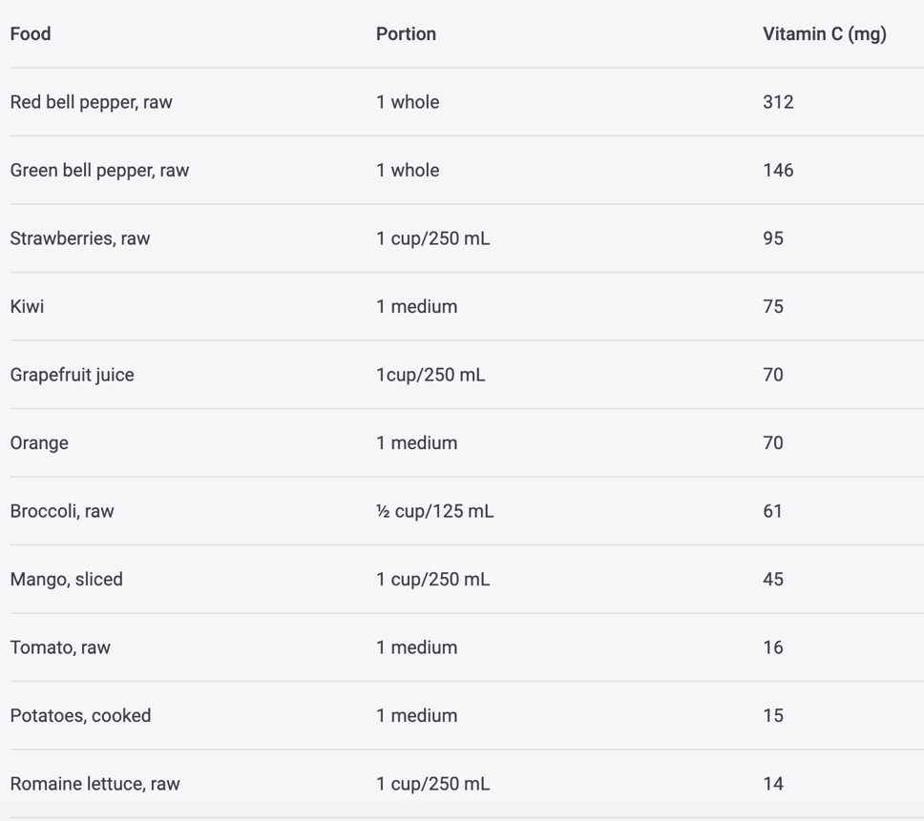
Food Sources of Vitamin C

The best sources of vitamin C are veggies and fruit. Other food groups do not contain much vitamin C. When reading a food label for vitamin C, an excellent source (or very high in) will have more than 30 mg of the vitamin per serving. Because vitamin C is affected by the way it is cooked, you can preserve vitamin C by cooking the food in very little water (like steaming or microwaving) and by eating fresh vegetables and fruit as soon as possible.

Fact or Myth?

Despite the belief that Vitamin C can cure a cold, the scientific evidence doesn’t support the notion. In fact, taking too much vitamin C can actually make you feel worse. The best that can be said is that vitamin C (like other nutrients) is part of the package that can help keep you feeling good.

