**New Media & Composition 10**

**Content & Objectives**

In this class we will study different types of literature, develop our reading skills, work on our paragraph and essay skills, practice our creative writing, improve our presentations, do both individual and group work, and hone our critical thinking. Our goals: think carefully about what we see in the world and communicate our ideas with purpose.

|  |
| --- |
| ***Big Ideas for English 10-12***   * The exploration of text and story deepens our understanding of diverse, complex ideas about identity, others, and the world. * People understand text differently depending on their worldviews and perspectives. * Texts are socially, culturally, geographically, and historically constructed. * Language shapes ideas and influences others. * Questioning what we hear, read, and view contributes to our ability to be educated and engaged citizens. * Digital citizenship requires both knowledge of digital technology and awareness of its impact on individuals and society. |

|  |  |
| --- | --- |
| **Possible Elements:**  Inquiry  Composition: Narrative & Expository  Poetry  Short Fiction  Lit Circles  Film/Media Studies  Podcasts | **Supplies Required:**    1 three ring binder  Looseleaf paper  Blue or black pens |

**Attendance**

Attendance is success: the classroom is meant to be a place where students take great strides forward. Students absent without reason will be referred to their counsellor or administrator. Note that you must pass English 10 in order to move into grade 11 English classes.

**Plagiarism**

Plagiarism means copying without giving credit: copying an assignment from a student, a sentence from a website, or even an *idea* from a book. How to fix this: “Most cases of plagiarism can be avoided…by citing sources” (Plagiarism.com). Use quotation marks and give credit if your idea comes from somewhere else. Plagiarized work may result in sanctions including failure, office referral, and meetings with parents. Please see me or the librarian for help if you are unsure.

**Late Assignments**

Deadlines are motivating. They help learners progress. Work should be completed by the due date. Please see me if you think an assignment might be late.

**Assessment and Evaluation**

This class emphasizes self-understanding and inquiry-based learning. Using the core competencies and the curricular competencies, students engage in regular goal setting and self-assessment and the teacher provides constructive feedback to guide growth.

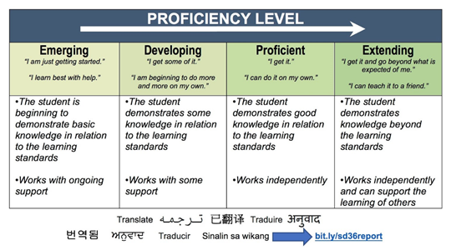This class will be gradeless until your final report card. You have all semester to work on and improve your skills. In the end, your classroom mark comes from your teacher’s observations as well as your portfolio, which gathers evidence of your abilities in the curricular competencies. Your final mark is based on the best work you produce; you must pass in each aspect of your portfolio in order to pass this course.

Please note that the mark given in your final conference is your final mark and will not be changed later, for any reason. Be wise and be focused.

Good luck this semester!

**Kessey Jemmott jemmott_k@surreyschools.ca**

_________________________ _________________________

Student name Parent/Guardian name

_________________________ _________________________

Student signature Parent/Guardian signature