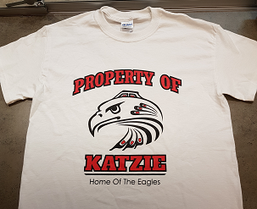
KATZIE ELEMENTARY
SPIRIT WEAR

Order Deadline
Friday, February 9, 2018
Item | Circle Size Preference | Cost | Qty | Total
BLACK T Shirt –with full  Property of Katzie Logo | YOUTH XS S M L XL  ADULT XS S M L XL | 14.00
WHITE T Shirt –with full  Property of Katzie Logo | YOUTH XS S M L XL  ADULT XS S M L XL | 14.00
Hoodie PULLOVER Black  Small Property of Katzie Logo  upper left chest | YOUTH XS S M L XL  ADULT XS S M L XL | 25.00
Golf Shirt Black with collar  Embroidered Katzie Eagle logo upper left chest | YOUTH XS S M L XL  ADULT XS S M L XL | 33.00
Nylon Jacket Black LADIES Tapered Fit Long sleeves  Embroidered Katzie Eagle logo upper left chest | YOUTH XS S M L XL  ADULT XS S M L XL | 41.00
Nylon Jacket Black REGULAR Fit  Long sleeves  Embroidered Katzie Eagle logo upper left chest | YOUTH XS S M L XL  ADULT XS S M L XL | 41.00
 | TOTAL AMOUNT ENCLOSED

Student Name _________________________________________________ Division: ___________

Parent/Guardian Name: ___________________________________ Home Phone: _______________

