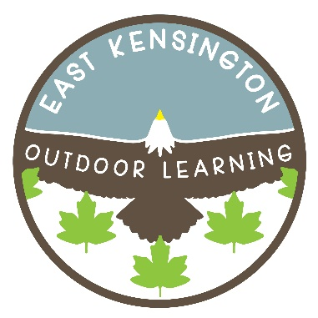
EAST KENSINGTON
OUTDOOR LEARNING
2795 – 184th Street, Surrey, BC V3Z 9V2
Phone: (604) 541-1257 Fax: (604) 531-4180
www.surreyschools.ca/schools/eastkensington
Principal: Mr. Stephen Hardy
Vice Principal: Ms. Alison Leslie

Important Notes:

Welcome to Kindergarten! We know this is an exciting time. Rest assured that we will take good care of your child and support them (and you) on this journey together. Our Kindergarten team is committed to ensuring your child has a positive first experience at school, and we look forward to working together with you.

Your child will be assigned to either Group A or B. Please email our Kindergarten teacher Ms. Turner (turner_b@surreyschools) to confirm the group your child has been placed in if you are unsure. Please wait with your child outside of the front door of the school for drop off. More information will come home in September on how and when to sign-up for a child-focused conversation with your child’s teacher.

Why do we do Gradual Entry?

This is a Provincial Ministry of Education program that is designed to allow young children the opportunity to slowly acclimatize to school. We know that many of you may feel that your child does not need a gradual entry; however, we want to emphasize how important this is for all of our early learners. There is so much to experience; new environment; new routines; new teachers; new expectations; and new friends. Gradual entry allows for a deliberate and measured introduction of school routines within an increasingly lengthy day and growing group of students. In addition, during these 2 weeks your child will be learning to be away from you and the familiar people in their life. This can be a challenging time for some. Please honour your child’s feelings and find ways to help them to keep you close when you are away from them. A small note in their snack or giving them something of yours to wear or keep in their pocket can be very helpful.

For school supplies the teachers buy supplies in bulk to share in Kindergarten. A fee of $45 for school supplies will be due in September. As we are a cashless school the fees will need to be paid online at: https://surreyschools.schoolcashonline.com/. You will not be able to do this until September.

Please also bring a pair of inside Velcro/slip on running shoes and a full change of clothes to leave at school. Ensure all items are labelled with your child’s name. Please refer to our school website for more information about outdoor clothing your child will need for learning at East Kensington Outdoor Learning.

Starting on the second day of school we will be introducing routines around snack, and outside play. As our time increases please ensure your child brings a lunch bag with a small snack and a healthy lunch on the days indicated on the calendar. As some classmates may have severe nut allergies it is important not to send nuts or nut products to school. NO NUTS PLEASE. We cannot drink the tap water in our school but we do have clean water delivery. YOUR CHILD NEEDS TO BRING A CLEAN WATER BOTTLE EVERY DAY. We also ask that children only bring water to school and save other drinks (milk, juice, etc...) for home.

• Your child should wear play appropriate clothing to school and come prepared to play outside in all weather!

• When picking up your child please be on time. This is crucial for your child’s trust in being left at school. We will only dismiss children directly to you, so please wait outside the front door. Children will not be sent to parents/caregivers in cars: you must be beside your child as they leave school each day. Please call the school office to report if your child will be absent or if you will be late picking them up, 604-541-1257.

Please subscribe to the school emails on our website for important school information, https://www.surreyschools.ca/schools/eastkensington/Pages/default.aspx

We look forward to seeing you in September!

Gradual Entry EKOLogy Kindergarten 2021

Monday | Tuesday |  | Wednesday |  | Thursday |  | Friday
 | Child-Focused Conversations with Parents –  Please sign up for a time on September 14, 15, 16, or 17 |  |  |  |  |  | 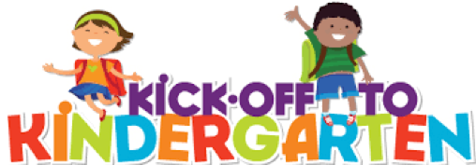
6  Labour Day  (No School) |  | 7  Confirm  Registration & Welcome Families  10:00 – 10:30 |  | 8  1.5 Hr. Class  A – 8:45 – 10:15  B – 12:45 – 2:15  Bring water bottle & Light snack |  | 9  1.5 Hr. Class  A – 8:45 – 10:15  B – 12:45 – 2:15  Bring water bottle & Light snack |  | 10  1.5 Hr. Class  A – 8:45 – 10:15  B – 12:45 – 2:15  Bring water bottle & Light snack
13  2 Hr. Class  A – 8:45 – 10:45  B – 12:15 – 2:15  Bring water bottle & Light snack |  | 14  3 Hr. Class  A & B  8:45 – 11:45  PM: Child-Focused Conversations  Bring water bottle & Light snack |  | 15  4 Hr. Class  A & B  8:45 – 12:45  PM: Child-Focused Conversations  Bring water bottle, snack & lunch |  | 16  4 Hr. Class  A & B  8:45 – 12:45  PM: Child-Focused Conversations  Bring water bottle, snack & lunch |  | 17  4 Hr. Class  A & B  8:45 – 12:45  PM: Child-Focused Conversations  Bring water bottle, snack & lunch
20  Full Day Kindergarten begins 8:35 to 2:35 pm. Bring a snack, lunch, and water bottle every day |  | 21 |  | 22 |  | 23 |  | 24
*MONDAY SEPTEMBER 20, 2021 ALL STUDENTS BEGIN FULL DAYS 8:35 am to 2:35 pm

