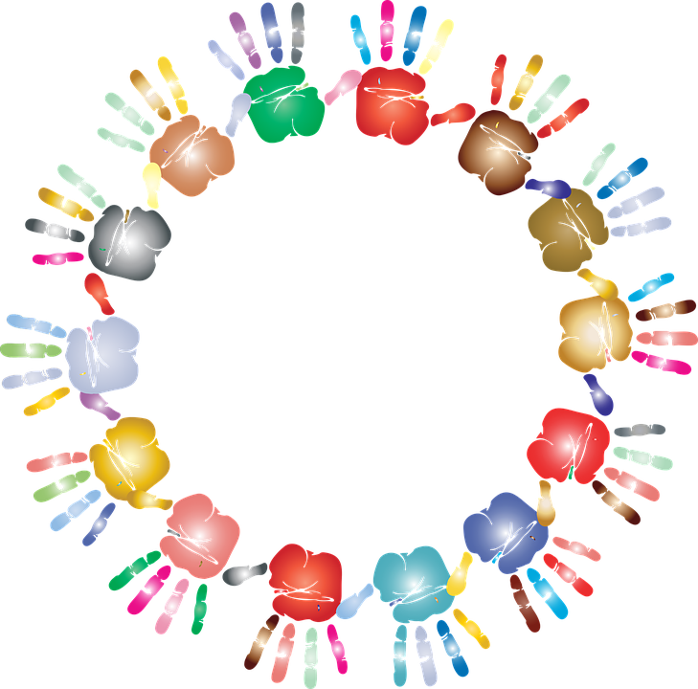

Kindergarten Registration
Begins January 11th

