Laundry Essentials Name: ____________________

Directions: Read the Laundry Essentials Handout then complete this worksheet on the space provided.
- Why should clothes be sorted before they are placed in the wash?

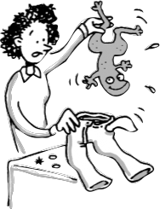
- Sort your laundry loads according to:
Color:
✔ _________________________________________________
✔ __________________________________________________
✔ __________________________________________________
Fabric and construction:
✔ ___________________________________________________
✔ ___________________________________________________
Degree of soil:
✔ ______________________________________________________________________
✔ _______________________________________________________________________
Other checks:
✔ _______________________________________________________________________
✔ _______________________________________________________________________
✔ _______________________________________________________________________
✔ _______________________________________________________________________
✔ _______________________________________________________________________
✔ _______________________________________________________________________

- When do you need extra detergent?

- When should detergents be added?

- What type of laundry detergent should you use in cold water? ________________________

- What water temperature cleans heavily soiled clothes best?__________________________

- When should you use warm water to wash the laundry? _____________________________
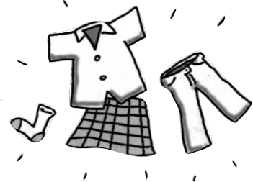
- Why is bleached used on laundry? How often can it be used?

- What type of bleach is safe to use on colored fabrics?

- What do color-safe bleaches use to keep colors brighter? Describe how they work.

- Describe the two ways bleach can be safely added to the washer when there is no automatic dispenser.
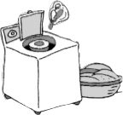
- a) clothes are already in the machine -

- b) clothes are not in the machine yet -

- Why is fabric softener sometimes added to the wash?

- How do you add fabric softener to the laundry?

- What problems can occur when laundry is washed in water temperatures below 65°F?

- Why is it important to have the correct water level for the laundry

- White fabrics and very dirty solid colors should be washed in __________ water temperatures. Warm water is recommended for ________________________________________________
___________________________________________________________________________

- What two things should be done to clothes before placing them in the dryer?

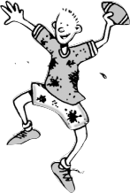
- What does over-drying do to clothes?

- What is the best way to treat unknown stains?

- How do you prevent dye transfer or bleeding from a new pair of dark jeans?

- Draw the care label symbols for washing, bleaching, drying, ironing and dry clean below.

- What is the simple temperature pattern used for the ASTM care symbol system?
Hot or High = __________________
Warm or Medium = _______________
Cool, Cold or Low = ________________

- Overall Dinginess and poor cleaning can be caused by:

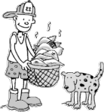
- improper __________________________ and not pretreating spots, stains and heavily soiled garments
- Not using enough _____________________________
- Not using __________________________ suitable for the fabric
- Not using the proper _______________________________________ on the washer
- Not loading the washer __________________________

- Sort the 13 stains into the following three general cleaning methods:
Mud, Ink & Felt Tip markers, Egg, Chocolate, Beverages, Blood, Juice,
Deodorant, Milk Products, Gravy, Tomato Products, Oil & Grease, Grass

Soak in cool or cold water. Pretreat and wash in hottest water safe for fabric. | Rinse in cool water and pretreat. Rinse and repeat, if necessary. Wash in cold water, using appropriate bleach. | Pretreat stains. Wash in hottest water safe for fabric, using appropriate bleach.

_______________________ ________________________ _______________________
_______________________ ________________________ _______________________
_______________________ ________________________ _______________________
_______________________ ________________________ _______________________
_______________________ ________________________ _______________________

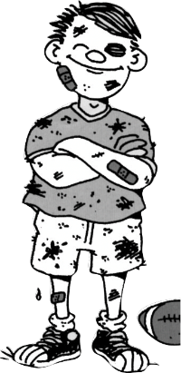
- When is the best time to treat a stain?

- Why is it important to check that stains are gone before placing clothes in the dryer?

