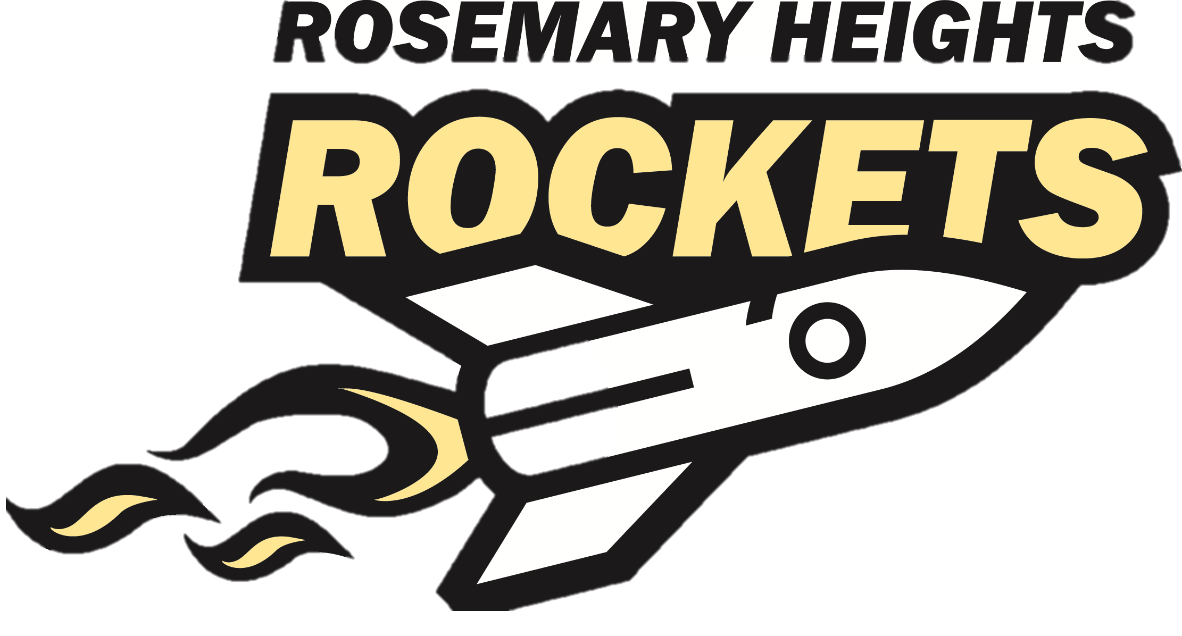 LOCAL LINKS
A Virtual Holiday Shopping Experience
Make your money go further! Shop these links and support Rosemary families, local businesses AND our school all at the same time! Feel free to share with friends and family! Please take note of the checkout instructions to ensure your purchase goes towards our fundraiser

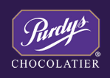 | Purchase some very sweet gifts and stocking stuffers for friends, family and yourself.  Rosemary Purdy's | 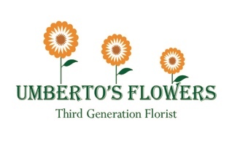 | Order your holiday poinsettias in 2 different colors, succulents and waxed amaryllis bulbs and support a neighbourhood institution.  Rosemary Umberto's
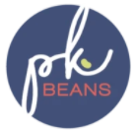 | PK Beans offers stylish playwear for your kids that is durable and will last the test of the playground. It is ethically made and offers not only new clothing, but second-hand vintage pieces, and DIY projects made from recycled materials.  Rosemary PK Beans |  | Personalized gifts for all ages and occasions. 10% of all our sales on the cutest personalized SANTA SACKS and CUTTING BOARDS will be donated to the school. Please use the promo code ROSEMARY while checking out from the website:  Rosemary HugsMugsnMore
 | Norwex provides simple, cost-effective solutions that save you time on cleaning while reducing chemicals in your home without creating unnecessary waste.  Rosemary Norwex |  | Give the gift of gorgeous, full eyelashes! Vanessa can offer you a variety of options to get you holiday zoom party ready! And for Rosemary Families she is offering 10% off gift cards, use the promo code LOCAL Rosemary Get Lashed
 | Senegence will answer all of your skincare and cosmetic needs. All products are not only long lasting but contain our anti-aging skincare without any harmful chemicals.  Click on Customer Buy Now.  Enter the distributor # 601123.  Rosemary Senegence.  OR If you want to save on shipping contact me directly: jaclyn_g8@hotmail.com |  | My name is David Jones - I am a Chef, teacher and Rosemary Dad to four kids. We have a BUSY family and when I’m limited in time for cooking, I always reach for Epicure.  All products are low/no salt, no MSG, artificial colour, sweeteners, flavours, peanuts/tree nuts, hydrogenated oils, gluten, corn/glucose syrup, nitrites- over 40 items that are never in Epicure products. All backed by a 90-day money-back guarantee. Rosemary Epicure
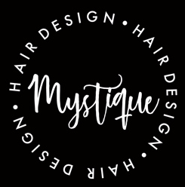 | Shop for all your hair care needs. Tools, products and accessories! Gift cards are available too for the salon and store! Use promo code: Rosemary2020 at checkout  Rosemary Mystique |  | Silver Icing is about inspiring confidence through fashion. We use the expertise of our vast community of women from across the country, who represent all different body shapes and sizes, to provide fit advice. Rosemary Silver Icing
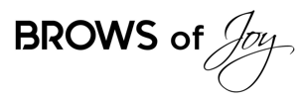 | Brows of Joy offers premium eyebrow services including, microblading, waxing & tinting, brow lamination, brow henna and lash lifts! Use coupon code LOCAL to get a free gift with your purchase!!  Rosemary Brows of Joy | 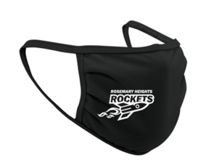 | We have a limited number of Rosemary Heights masks available. $10 each. Adult and Child sizes.  To order, send us an EMAIL

