English 10 Course Outline: Creative Writing & Composition

# Content & Objectives

In this course we will grow our creative writing skills, study literature, develop our reading skills, cultivate our paragraph and essay skills, finesse our presentations, hone our critical thinking, and work both individually and within groups. Our goals: think carefully about what we see in the world and communicate our ideas with creativity and purpose.

# Essential Question

How do writers affect audiences?

# Our Creative Writing Credo

I am a growing and discerning writer, reader, and editor who has a voice and shares that voice in my school community and with a larger audience.

# Elements

* Creative writing
* Writing workshops
* Inquiry
* Composition
* Reading long and short texts
* Lit circles

# Supplies Required

* A three-ring binder
* Looseleaf paper
* Blue or black pens
* Enthusiasm
* Awesomeness

# Attendance

Attendance is success: the classroom is meant to be a place where students take great strides forward. Please be in class. If you can’t be here, please tell me in advance or contact me via email. Note that you must pass English 10 in order to move into grade 11 English classes.

# Plagiarism

Plagiarism means copying without giving credit: copying an assignment from a student, a sentence from a website, or even an *idea* from a book. How to fix this: “Most cases of plagiarism can be avoided…by citing sources” (Plagiarism.com). Use quotation marks and give credit if your idea comes from somewhere else. Plagiarized work will not be accepted. Please see a teacher or librarian if you are unsure.

# Assessment and Evaluation

This class emphasizes self-understanding and inquiry-based learning. Using the core competencies and the curricular competencies, students engage in regular goal setting and self-assessment and the teacher provides constructive feedback to guide growth.

This class will be gradeless until your final report card. You have all semester to work on your skills. In the end, your mark will come from the evidence in your portfolio and from your teacher’s observations. Your final mark is based on the best work you produce; you must pass each section of the learning map to pass this course.

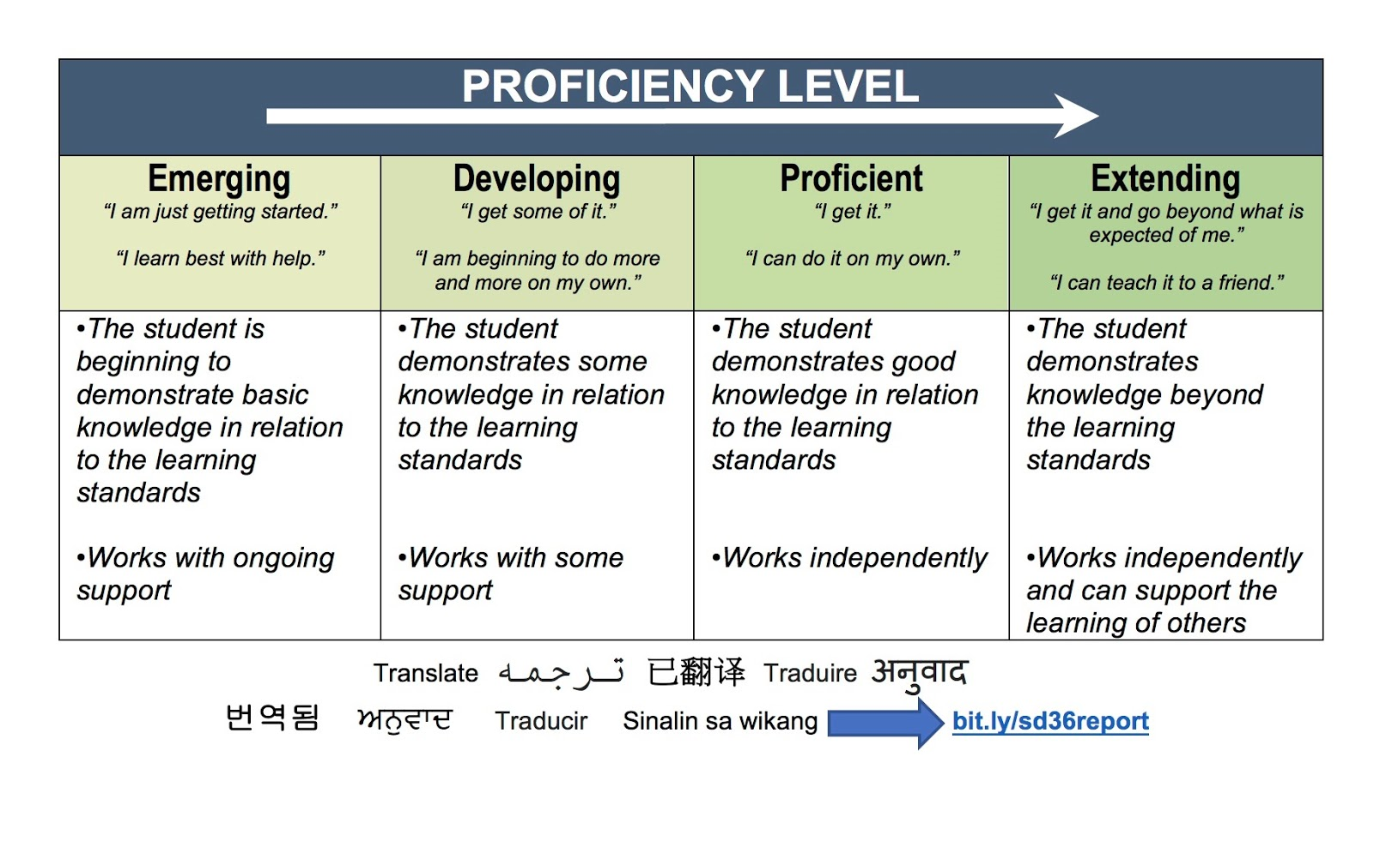

|  |  |  |
| --- | --- | --- |
| ***Rubric Level*** | ***Letter Grade Equivalent*** | ***Report Card Percent*** |
| Extending | A+ | ~95% |
| A | ~90% |
| A- | ~86% |
| Proficient | B+ | ~82% |
| B | ~78% |
| B- | ~73% |
| Developing | C+ | ~67% |
| C | ~60% |
| Emerging | C- | ~50% |
| I/F | varies |

We use rubric criteria to give performance feedback in this class. These show the quality of your current work while giving you a pathway to improve. We will use the grid here to establish percentages based on a rubric’s more general categories.

I conference with each student as I return work. Sometimes it takes several classes to return everyone’s assignment, but I want the opportunity to talk to you and look at how we can push your learning forward—that’s our goal in this class!

Please note that the mark given in your final conference is your final mark and will not be changed later, for any reason. Your opportunity for improving your skills starts now and ends with the course. Be wise and be focused.

**Good luck!**