English Studies 12 Course Outline

# Content & Objectives

In this course, we build on all of your previous experience in English. We refine our communication, think critically, and have fun with language. We explore diverse texts, deepening our understanding of ourselves and of others. And we contribute to Reconciliation by building greater understanding of the knowledge and perspectives of First Peoples. It’s engaging; it’s thoughtful; it’s centred on you and the skills you need to be an educated member of Canadian society.

# Essential Questions

What’s the best way for me to contribute to Reconciliation?  
What does happiness mean to me?

# Elements

* Reading long and short texts
* Writing in different forms
* Discussion
* Inquiry
* Lit circles
* Indigenous Book Club

# Supplies Required

* A three-ring binder
* Looseleaf paper
* Blue or black pens
* Enthusiasm
* Awesomeness

# Attendance

Attendance is success: the classroom is a place where students take great strides forward. Please be in class. If you can’t, communicate in advance or contact via email.

# Plagiarism

Plagiarism means copying without giving credit: copying an assignment from a student, a sentence from a website, or even an *idea* from a book. How to fix this: “Most cases of plagiarism can be avoided…by citing sources” (Plagiarism.com). Use quotation marks and give credit if your idea comes from somewhere else. Plagiarized work will not be accepted. Please see a teacher or librarian if you are unsure.

# Cultural Appropriation

It is vital to honour and respect traditions and cultures that are not our own. Some parts of culture are not meant to be consumed by those outside of that culture, despite popularity in mainstream media. For example, some stories or even certain words should not be used outside of their home culture. We can draw inspiration from other cultures, but be mindful that there are some parts that are untouchable.

# Assessment and Evaluation

This class emphasizes self-understanding and inquiry-based learning. Using the core competencies and the curricular competencies, students engage in regular goal setting and self-assessment, and the teacher provides constructive feedback to guide growth.

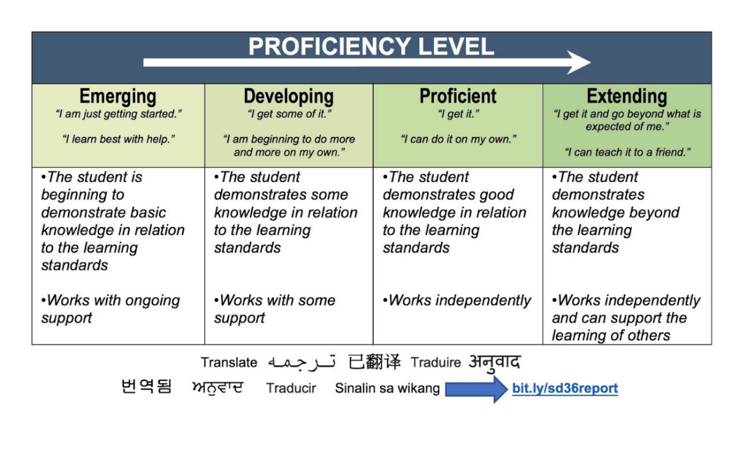What matters here, then, is growth. You have all semester to work on your skills. In the end, your mark will come from the evidence in your portfolio and from your teacher’s observations. Your final mark is based on the best work you produce; you must pass each section of the learning map to pass this course.

|  |  |  |
| --- | --- | --- |
| ***Rubric Level*** | ***Letter Grade Equivalent*** | ***Report Card Percent*** |
| Extending | A+ | ~95% |
| A | ~90% |
| A- | ~86% |
| Proficient | B+ | ~82% |
| B | ~78% |
| B- | ~73% |
| Developing | C+ | ~67% |
| C | ~60% |
| Emerging | C- | ~50% |
| I/F | varies |

We use rubric criteria to give performance feedback in this class. These show the quality of your current work while giving you a pathway to improve. We will use the grid here to establish percentages based on a rubric’s more general categories.

I conference with each student as I return work. Sometimes it takes several classes to return everyone’s assignment, but I want the opportunity to talk to you and look at how we can push your learning forward—that’s our goal in this class!

Please note that the mark given in your final conference is your final mark and will not be changed later, for any reason. Your opportunity for improving your skills starts now and ends with the course. Be wise and be focused.

**Good luck!**