Arts Integrated Module 9 Course Outline

**Overview**

The Arts Integrated Module is an exciting course that combines Drama, English, and Social Studies. It’s a chance to explore literacy, critical thinking, and creative thinking, all framed within concepts of drama. We’re going to examine the themes of place, power, and identity, exploring our community and ourselves. Our experiences will include neighbourhood walks and other field studies.

|  |
| --- |
| ***Big Ideas for Drama, English, & Social Studies 9***   1. Exploring stories and other texts helps us understand ourselves and make connections to others and to the world. 2. Texts are socially, culturally, and historically constructed. 3. People create art to express who they are as individuals and community. 4. Disparities in power alter the balance of relationships between individuals and between societies. 5. Collective identity is constructed and can change over time. |

|  |  |
| --- | --- |
| **Attendance**  Being present and participating joyfully will lead to success! | **Supplies Required**   * A 2” three-ring binder with three dividers * Looseleaf paper * Blue or black pens * Enthusiasm & awesomeness |

**Plagiarism**

Plagiarism means copying without giving credit: copying an assignment from a student, a sentence from a website, or even an *idea* from a book. How to fix this: “Most cases of plagiarism can be avoided…by citing sources” (Plagiarism.com). If your idea comes from somewhere else, use quotation marks and give credit; this makes you look smarter because it shows your research skills. Plagiarized work may result in sanctions including failure, office referral, and meetings with parents. Please see us or the librarian for help if you are unsure.

**Cultural Appropriation**

It is gravely important to honour and respect the traditions and cultures that are not our own. There are some parts of a person’s culture that are not meant to be consumed by those outside of that culture, even though it may be popular in mainstream media. For example, some stories or even certain words should not be used outside of their home culture. So remember this when you are creating your own work. It is okay to draw inspiration from other cultures but be mindful that there are some parts that are untouchable.

**Late Assignments**

Deadlines are motivating and help learners progress. Work should be completed by the due date. Please see us if you have reason to believe that an assignment will be late.

**Assessment and Evaluation**

This class emphasizes self-understanding and inquiry-based learning. Using the core competencies and the curricular competencies, students engage in regular goal setting and self-assessment and the teacher provides constructive feedback to guide growth.

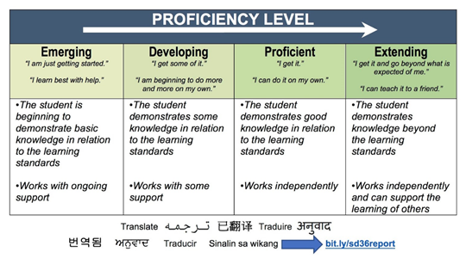This class will be gradeless until your final report card. You have all semester to work on and improve your skills. In the end, your classroom mark comes from your teacher’s observations as well as your portfolio, which gathers evidence of your abilities in the curricular competencies. Your final mark is based on the best work you produce; you must pass in each aspect of your portfolio in order to pass this course.

Please note that the mark given in your final conference is your final mark and will not be changed later, for any reason. Be wise and be focused.

Good luck this semester!

|  |  |
| --- | --- |
| **Kessey Jemmott** | jemmott_k@surreyschools.ca |
| **Manvir Mander** | mander_m@surreyschools.ca |
| **Kyle McKillop** | mckillop_k@surreyschools.ca |
|  | mistermckillop.wordpress.com |
| **Neelam Brach** *(student teacher)* | neelambrach@gmail.com |

Please Return This Sheet!

Please read and sign below to acknowledge seeing the AIM 9 course outline and our plan for curriculum-related community walks. Students will be accompanied by three teachers on those walks, which will explore the landmarks of the school’s immediate surroundings. Thank you!

Name of child: ________________________

____________________________________                   _____________________________   
Parent/Guardian signature                                                  Date

____________________________________   
Parent phone number