MunchaLunch (How to Register for an account.)

1. Go to: [www.munchalunch.com/schools/hollysurrey](http://www.munchalunch.com/schools/hollysurrey)
2. Select “Register Here”

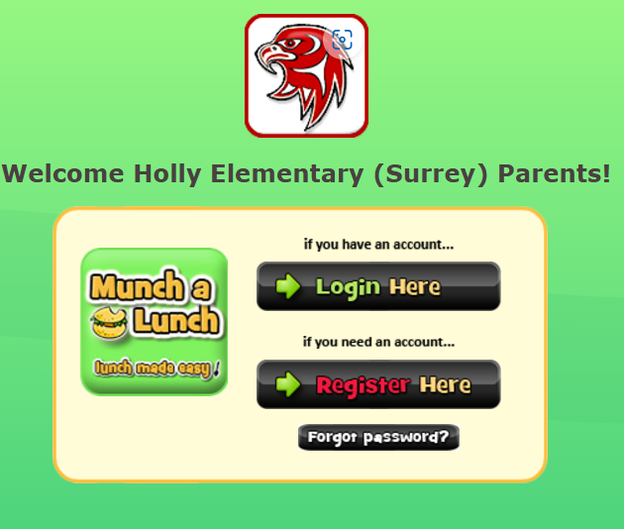

1. Select “Yes”

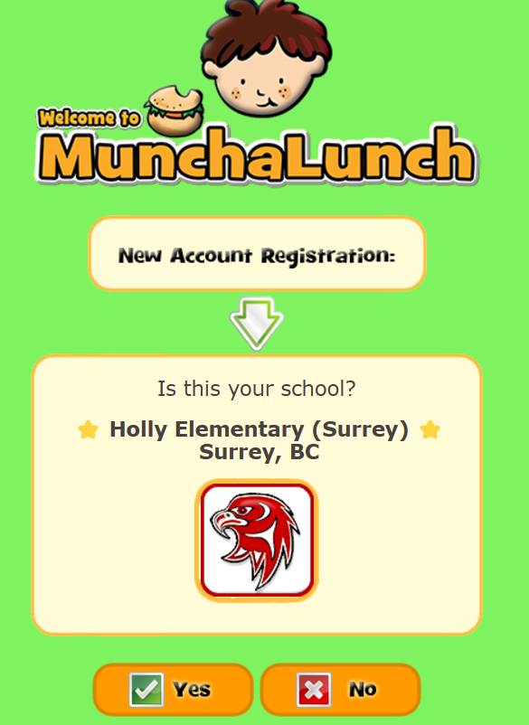

1. Fill in your information (Parent Info) First/Last name, Email, Create a password.

1. Press Save and Continue

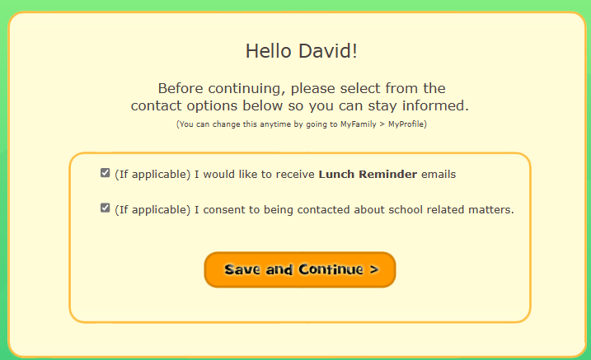

1. Press “Add a Child”

1. Fill in your CHILDS info. First/Last name, Grade and Div. (Teachers name will show)
2. Then select “Save”

1. To add a Second Or Third Child repeat step 7 and 8. Once you hit SAVE you can fill in another child’s information. Then again select Save. Now you’re ready to Order.