MunchaLunch (How to order lunch for Multiple Students at Holly)
- At the top select “Order Lunch!”
- Select “Lunch Session” IN BLUE (It will show what is for lunch Example Fresh Slice Pizza)
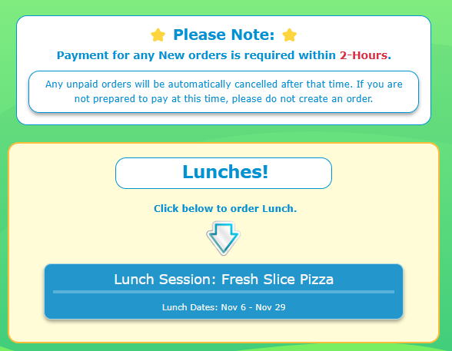
- Select the Student you are ordering for.
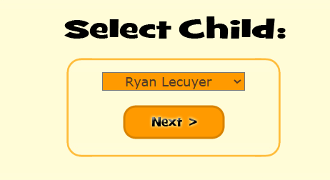
- Read the “Note to parents” then select “Next”
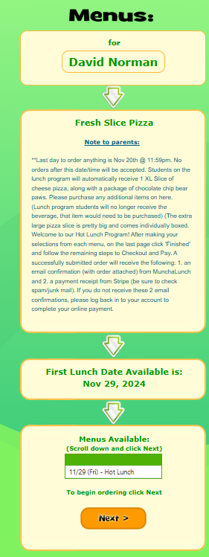

- This Screen will Now pop up. Select what you would like to order
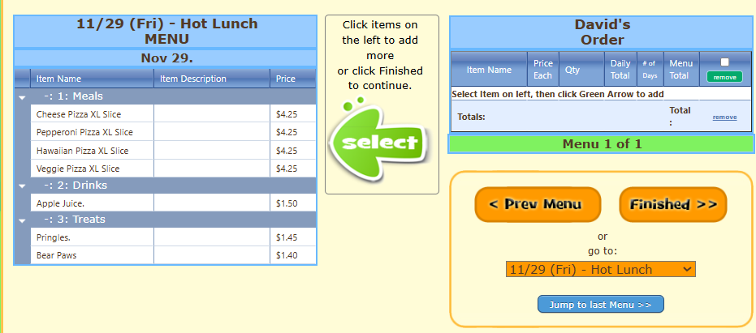
- Select “Add”
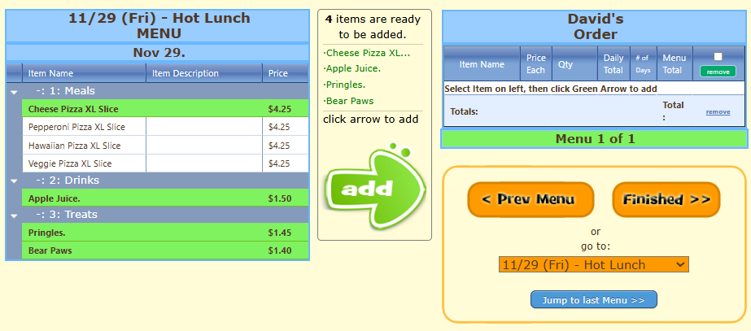
- Select the Quantity you want to order then select “Finished”
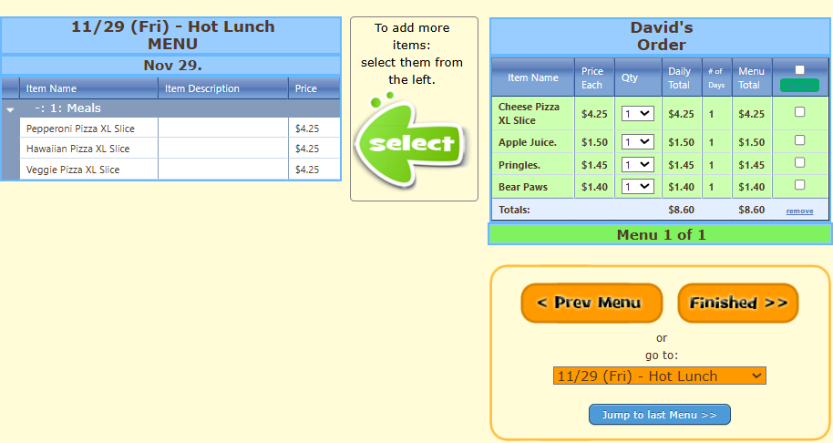
- If all is correct select “Next”
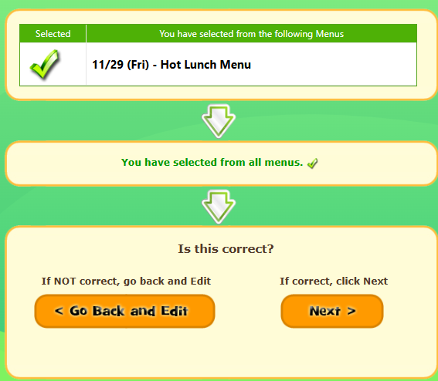
- If all looks good select “Yes, this is correct” Otherwise you can go back and correct it.
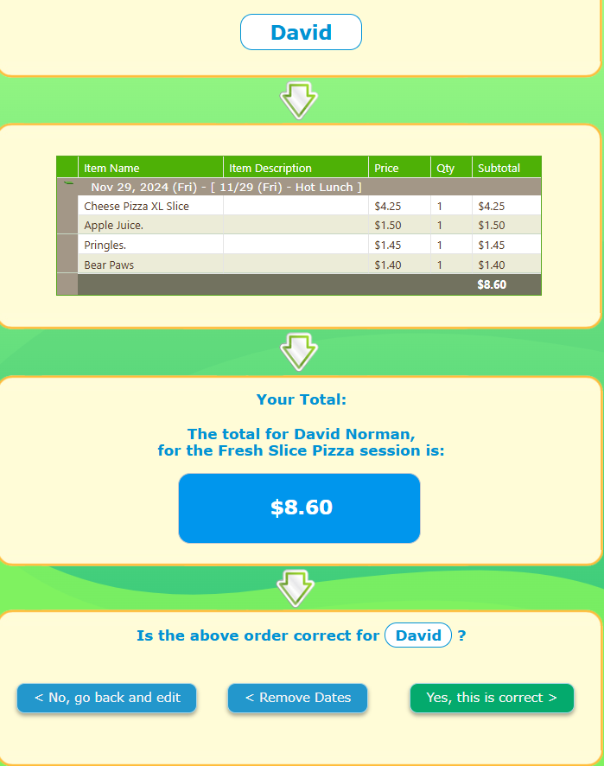
- Press the Blue “Lunch session: Fresh Slice Pizza (May be different depending on the hotlunch)
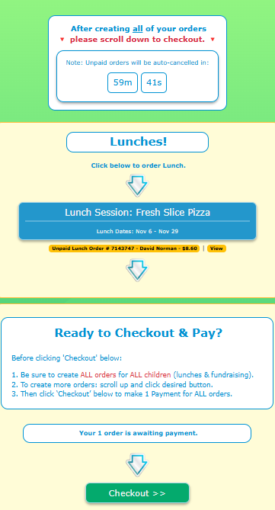

- Select the second, Third , Fourth ect… Childs name
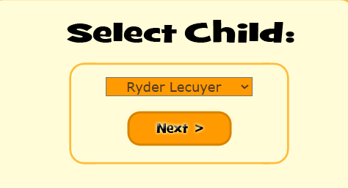
- Then Repeat Steps 4 to 10 … Order this child’s items.
- Once you have ordered for all your children you will select “Checkout”
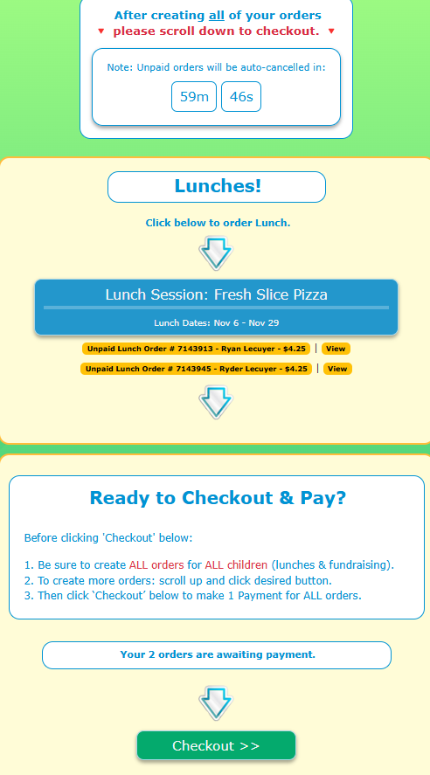
- Make your payment
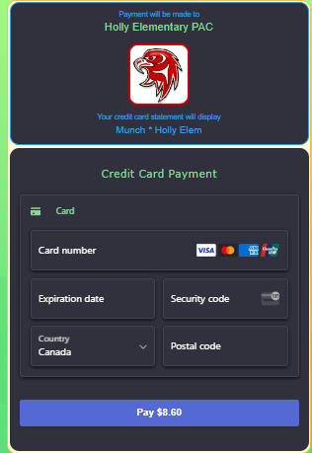
- You will receive a receipt and are now done. If payment isn’t made your order will be cancelled.

