MunchaLunch (How to Order Lunch for 1 Holly Student)
- At the top select “Order Lunch!”
- Select “Lunch Session” IN BLUE (It will show what is for lunch Example Fresh Slice Pizza)
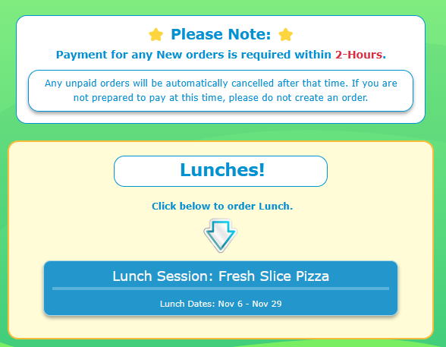
- Read the “Note to parents” then select “Next”
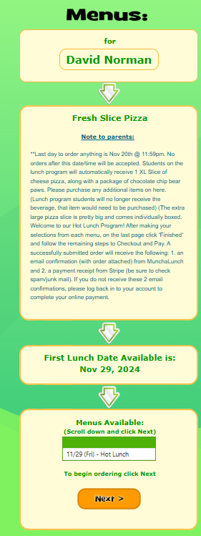
- This Screen will Now pop up. Select what you would like to order
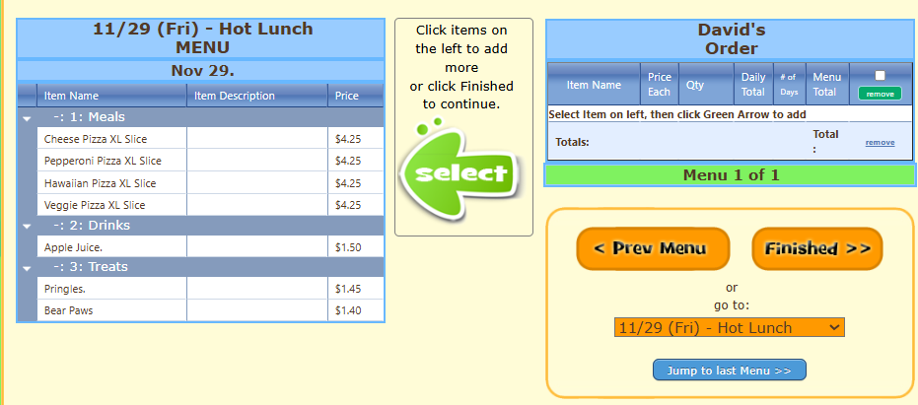
- Select “Add”
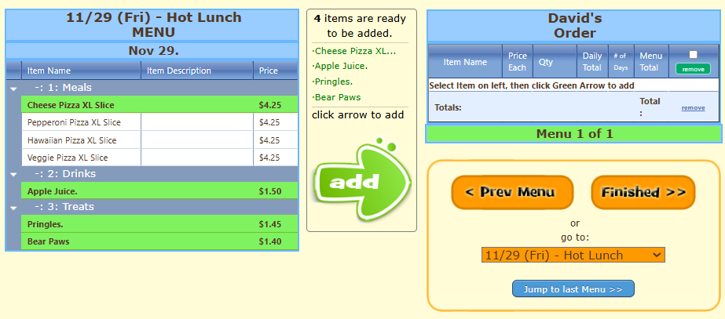
- Select the Quantity you want to order then select “Finished”
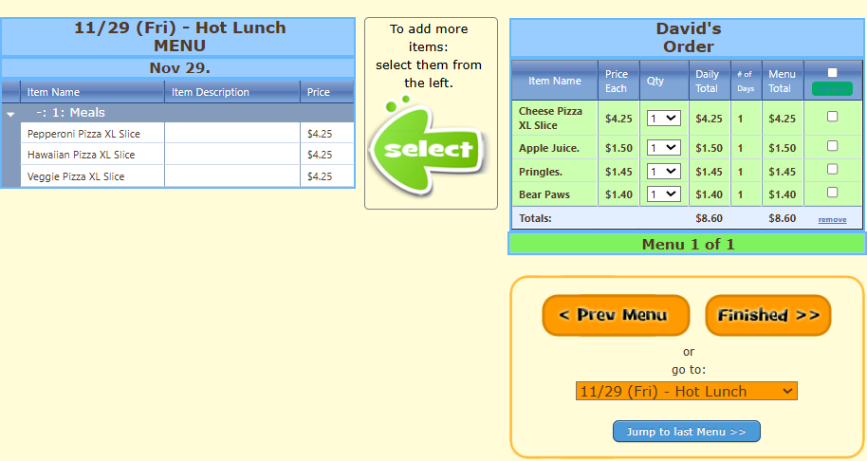
- If all is correct select “Next”
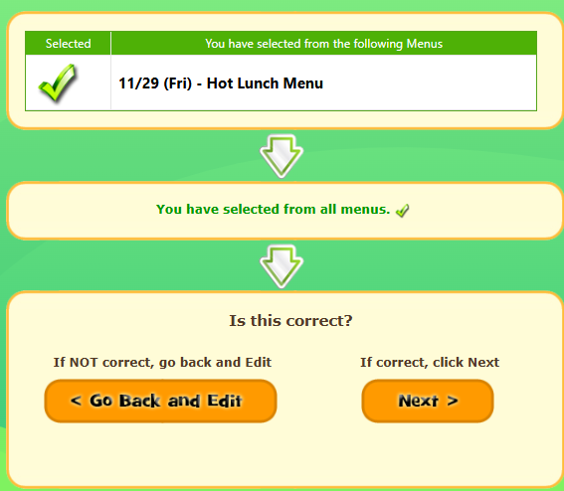
- If all looks good select “Yes, this is correct” Otherwise you can go back and correct it.
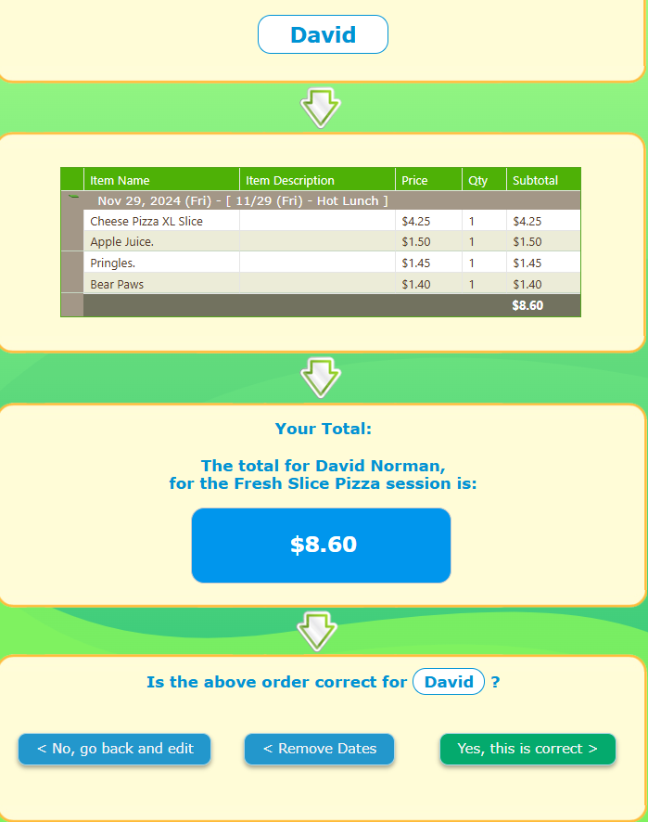
- Select “Checkout”
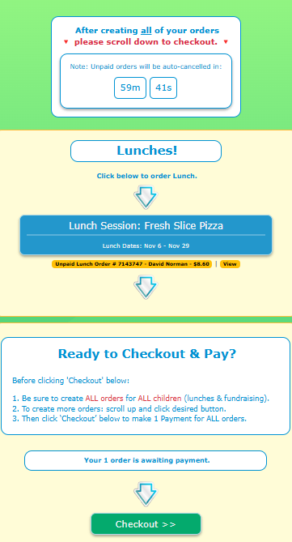

- Make your payment
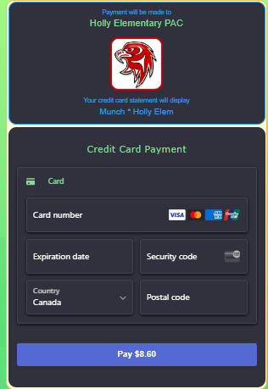
- You will receive a receipt and are now done.

