Evidence Gathering and Reflections for Core Competencies Goals - MyBlueprint instructions
(time frame June 10-15)
Steps:
- Go to myBlueprint (http://myBlueprint.ca)
- Click Login (Remind them to access their district account when logging in)
- Click School account login
- Enter Surrey to get to sd36 Surrey
- Click Surrey account login
- Enter surrey schools user name Click next
- Enter surrey schools password Click sign in
- You will be on your dashboard. Click Goals. Review Goals from November.
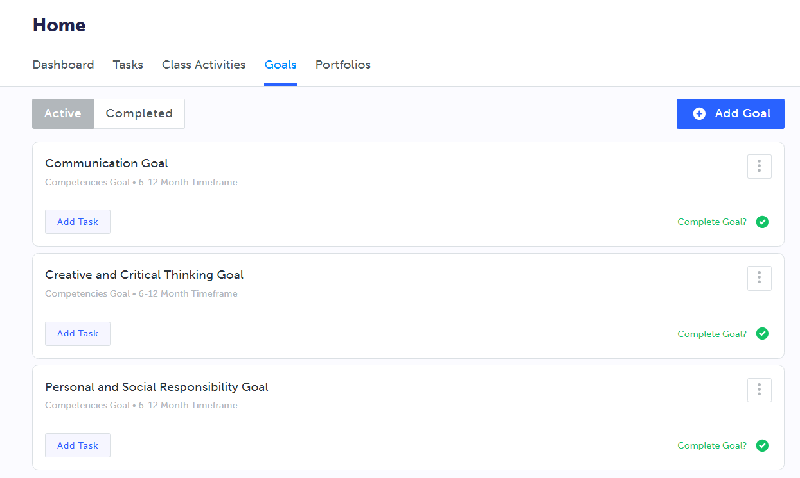
Goals from November screenshot

- Click Portfolio
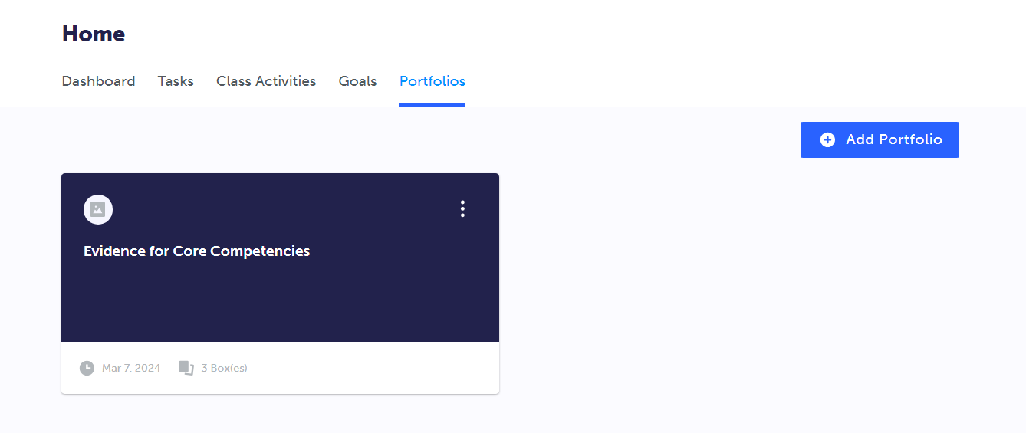
Evidence from April screenshot
Portfolio Screenshot
- Click Evidence for Core Competencies. Review Evidence from April.

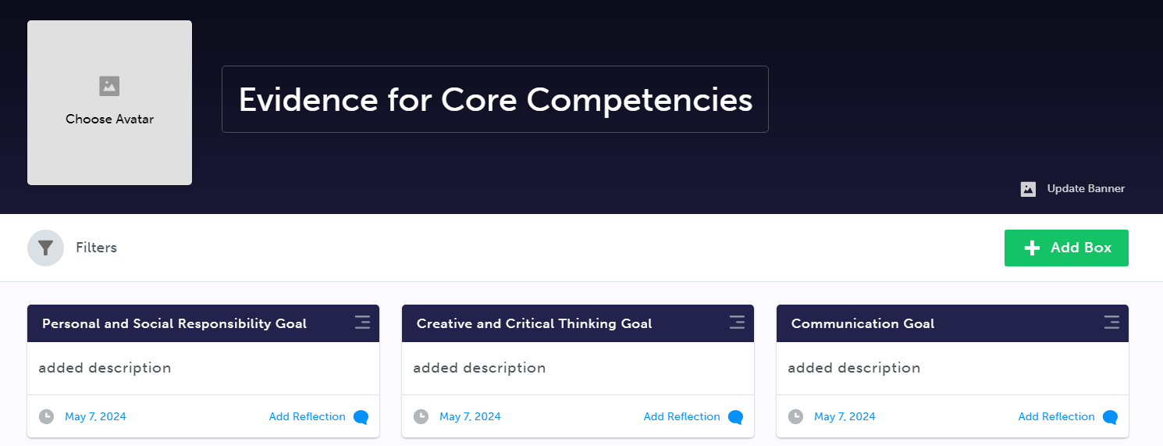

- Click Add Reflection for your first goal.
Reflection
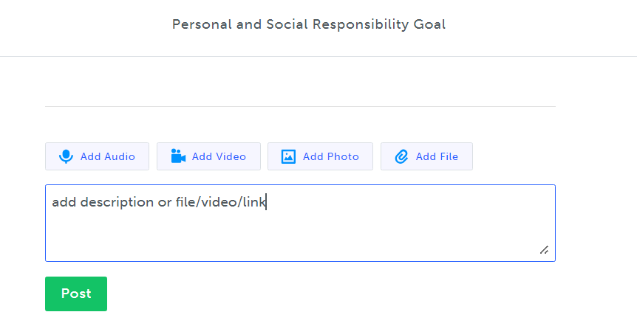
- Add description of another piece of evidence
There are 2 ways to add
  - Write in the description box.
  - Attach a file/link/image. Click add file.
    - If using a phone,. Go into google drive or camera. Add file.
    - If using a laptop. Select files to upload or drag photos.
- Click Post
- Add another reflection. In description, state if you would like to continue with this goal next year. If not, what are your initial thoughts of what type of goal you would like to set for next year in this competency.
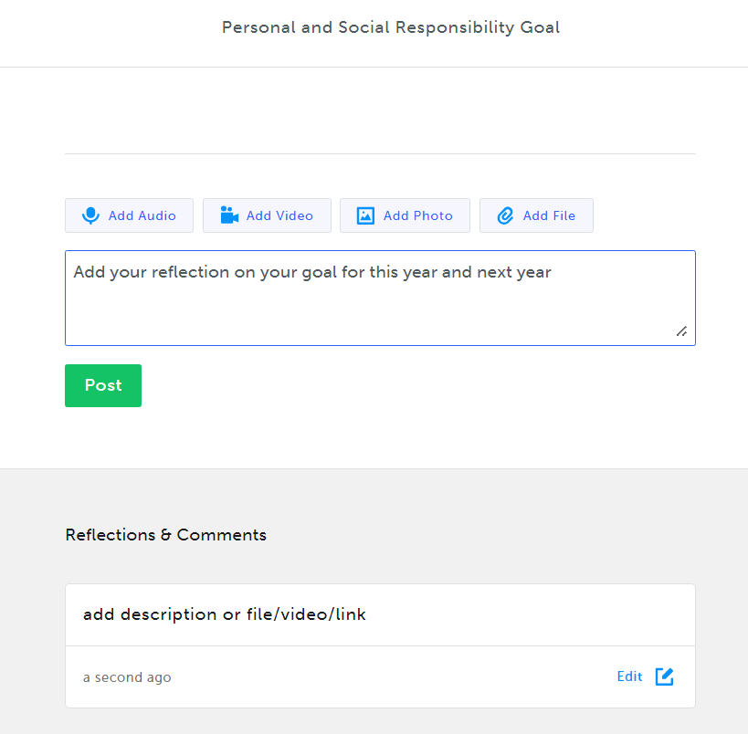
Add goal reflection
- Click Post
- Click x button to go back to your other goals.
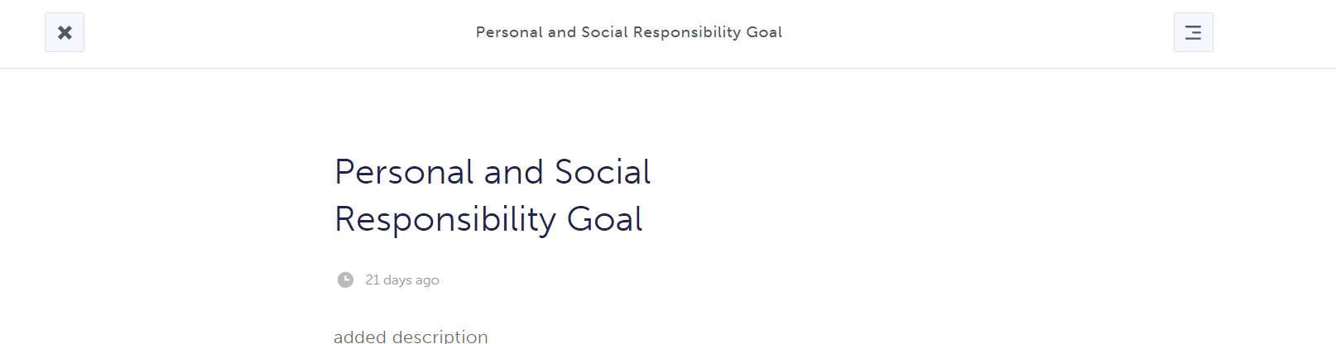
- Repeat steps 11-15 for your other two goals.
- Congratulations you have completed your reflections for three goals entered on my blueprint.
It should look like this when you have finished:
Final Product
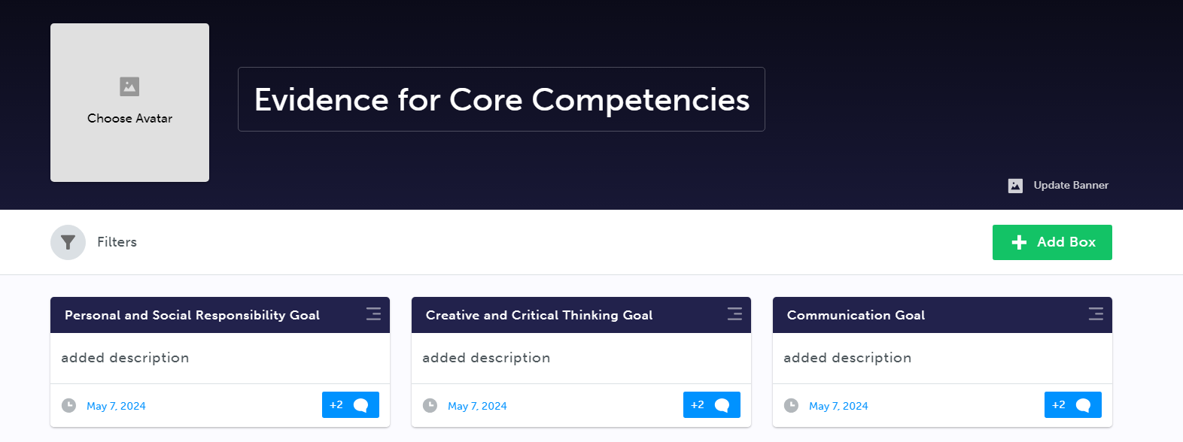
Now it is time to share with your classmates or your teacher(s). At home, you can share your success with your caregivers.
(There is an instructional video provided if needed)
Recording-20240528_140748.webm
***********************************
MY BLUEPRINT LOGIN INFORMATION
https://surreyschoolsone.ca/resources/my-blueprint - ACCESS STEPS
Information:
There will be a comment on MyEd report card that lets parent/guardians know that they can look at their child’s competency goals and evidence on myBlueprint.

